1. Am proiectat baza de date pentru Jocurile Olimpice desfasurate dupa anul 1990. Aceasta conține informații despre sportivii care au participat măcar într-un an la Jocurile Olimpice,acestia putand participa la doar un sport, precum și despre antrenorii acestora,baza de date mai contine informatii despre sponsorii Jocurilor Olimpice,unde au fost cazati sportivii,am mai introdus informatii despre probele din cadrul fiecarui sport,dar si despre cum sunt impartie probele in functie de varsta sau kg.Baza de date mai prezinta si nationalitatea fiecarui sportiv dar si tara unde s-a desfasurat fiecare editie a acestor jocuri

In cadrul bazei de date am mai tinut minte si antrenorii acestia putand antrena mai multi sportivi,antrenorii pot fi in cadrul mai multor sporturi de asemenea.

Cazarile din cadrul Jocurilor Olimpice sunt fac parte doar din tara desfasuratoare a jocurilor din acel an,acestea fiind impartite pe camere in functie de sex,nr locuri.Aceasta baza de date poate fi folosita cu usurinta pentru a gestiona participantii fiecarei editii din jocurile olimpice,unde s-a desfasurat aceasta editie,dar si pentru a cunoaste premiile in bani acordate de fiecare proba in functie de locul castigat de catre un participant,putem vedea antrenorii care au sustinut sportivii in calificarea la Jocurile Olimpice,dar si sponsorii fiecarei editii si suma oferita pentru desfasurarea acestora.

2.Diagrama ER(ERD) 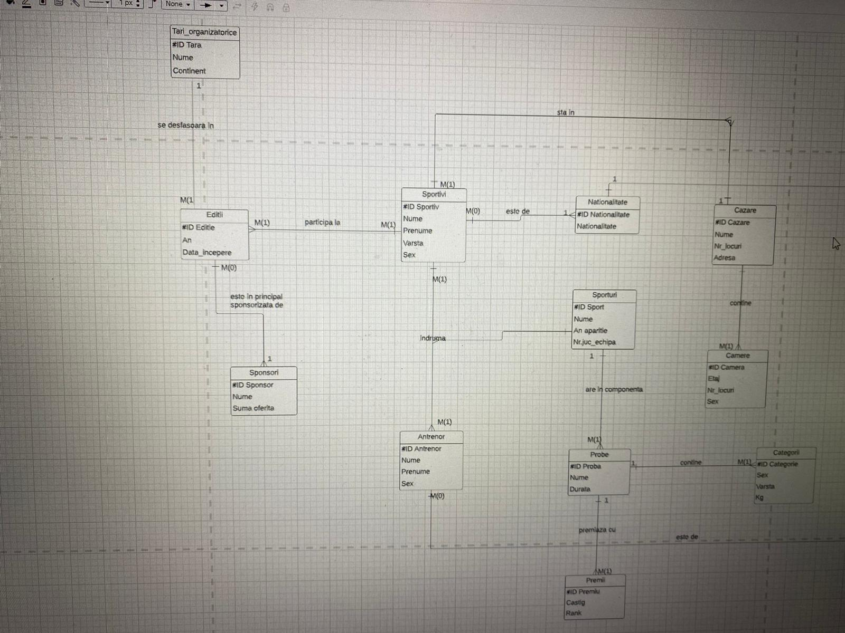

3.Diagrama conceptuala

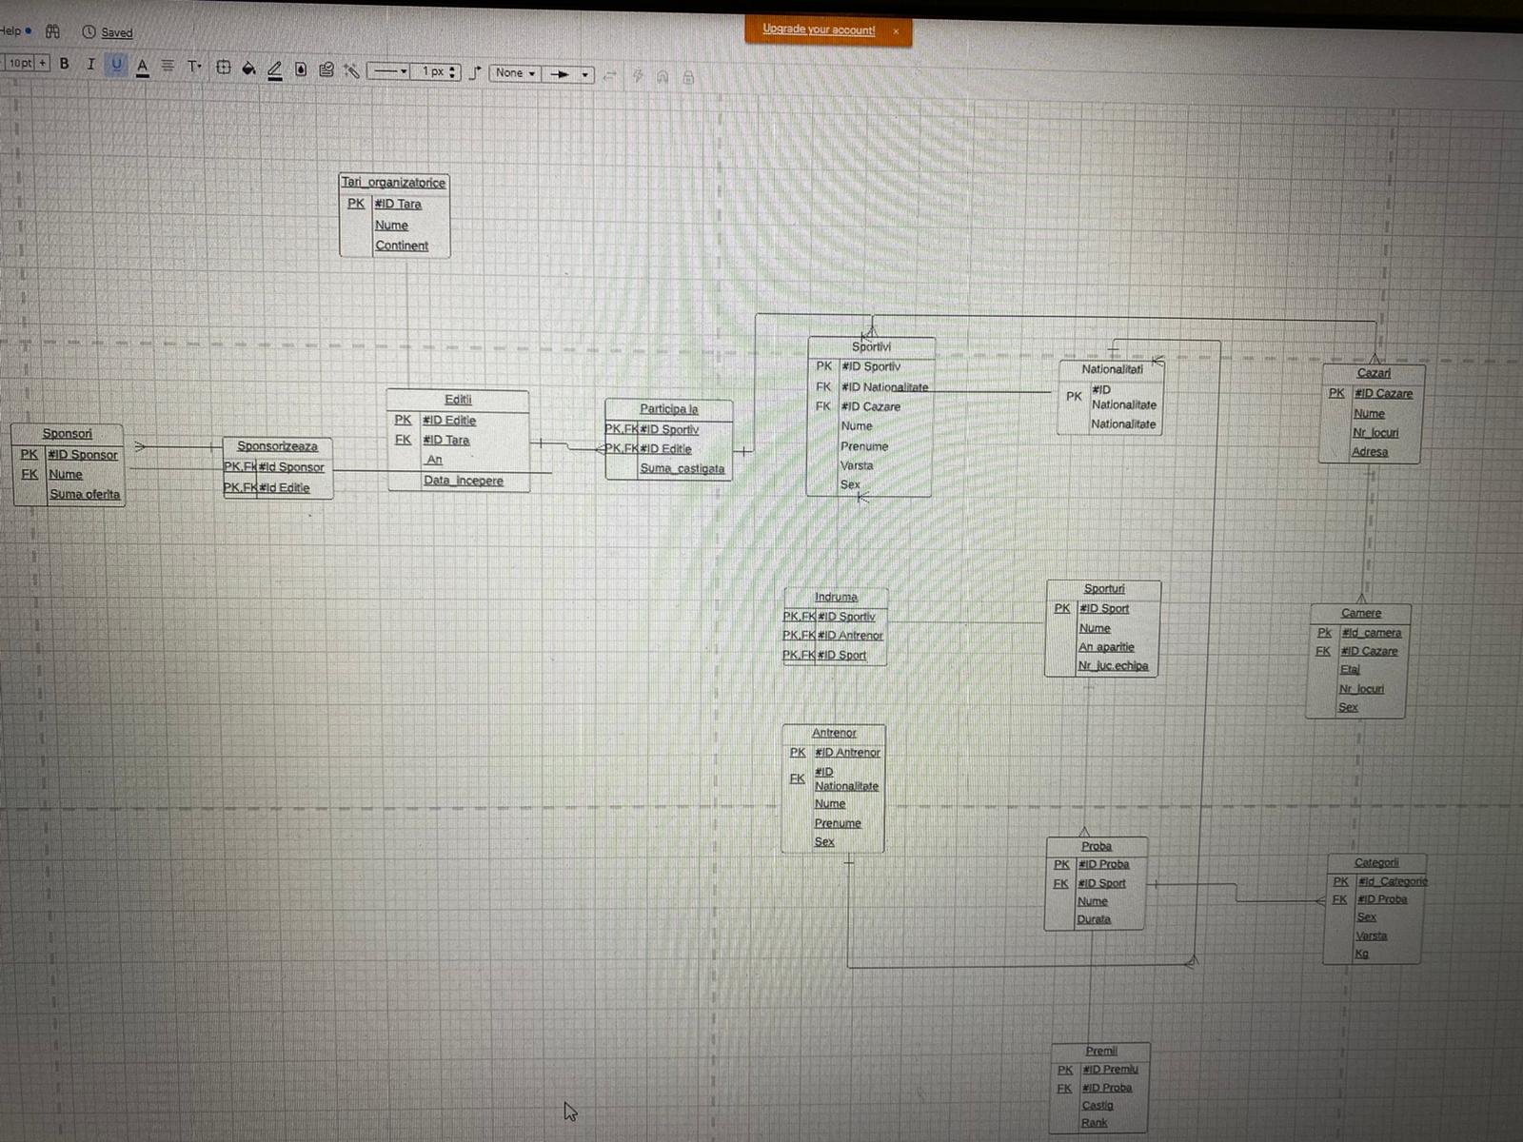

4.

Create table Nationalitati(

Id_Nationalitate int ,

Nationalitate varchar(255),

Primary key(Id_Nationalitate)

);

Create table Sponsori(

Id_Sponsor int,

Nume varchar(255) Not Null,

Suma_oferita int,

primary key(Id_Sponsor)

);

create table Tari_organizatorice(

Id_Tara int ,

Nume varchar(255) Not Null,

Continent varchar(255) Not Null,

primary key(Id_Tara)

);

create table Sporturi(

Id_Sport int,

Nume varchar(255) Not Null,

An_aparitie int,

Juc_echipa int,

primary key(Id_Sport)

);

create table Cazari(

Id_Cazare int,

Nume varchar(255) Not Null,

Nr_locuri int Not Null,

Adresa varchar(255),

primary key(Id_Cazare)

);

create table Camere(

Id_Camera int,

Id_Cazare int not null,

Sex varchar(255),

Etaj int ,

Nr_locuri int Not Null,

primary key(Id_Camera),

foreign key(Id_Cazare) references Cazari(Id_Cazare)

);

create table Editii(

Id_Editie int,

Id_Tara int not null,

An int not null,

Data_incepere date,

primary key(Id_Editie),

foreign key(Id_Tara) references Tari_organizatorice(Id_Tara)

);

create table Indruma(

Id_Sportiv int not null,

Id_Antrenor int not null,

Id_Sport int not null,

Primary key(Id_Sportiv,Id_Antrenor,Id_Sport),

foreign key(Id_Sportiv) references Sportivi(Id_Sportiv),

foreign key(Id_Antrenor) references Antrenori(Id_Antrenor),

foreign key(Id_Sport) references Sporturi(Id_Sport)

);

select * from Antrenori;

create table Antrenori(

Id_Antrenor int,

Id_Nationalitate int not null,

Nume varchar(255) not null,

Prenume varchar(255) not null,

Varsta int,

primary key(Id_Antrenor),

foreign key(Id_Nationalitate) references Nationalitati(Id_Nationalitate)

);

create table Probe(

Id_Proba int,

Id_Sport int not null,

Nume varchar(255),

Durata_min int,

primary key(Id_Proba),

foreign key(Id_Sport) references Sporturi(Id_Sport)

);

create table Premii(

Id_Premiu int,

Id_Proba int not null,

Castig int not null ,

Pozitie int,

primary key(Id_Premiu),

foreign key(Id_Proba) references Probe(Id_Proba)

);

create table Categorii(

Id_Categorie int,

Id_Proba int not null,

Sex varchar(255),

Varsta int,

Kg int,

primary key(Id_Categorie),

foreign key(Id_Proba) references Probe(Id_Proba)

);

create table Participa_la(

Id_Sportiv int not null,

Id_Editie int not null,

Primary key(Id_Editie,Id_Sportiv),

foreign key(Id_Editie) references Editii(Id_Editie),

foreign key(Id_Sportiv) references Sportivi(Id_Sportiv)

);

Create table Sponsorizeaza(

Id_Sponsor int not null,

Id_Editie int not null,

Primary key(Id_Editie,Id_Sponsor),

foreign key(Id_Sponsor) references Sponsori(Id_Sponsor),

foreign key(Id_Editie) references Editii(Id_Editie)

);

CREATE TABLE Sportivi (

Id_Sportiv int Not NULL,

Id_Nationalitate int Not Null ,

Id_Cazare int Not Null ,

Nume varchar(200) Not Null,

Prenume varchar(255) Not Null,

Varsta int Not Null,

Sex varchar(255),

Primary Key(Id_Sportiv),

foreign key(Id_Nationalitate) references Nationalitati(Id_Nationalitate),

foreign key(Id_Cazare) references Cazari(Id_Cazare)

);

5.

insert into Sponsori(id_sponsor,nume,Suma_oferita)

values(1,'Adidas',100);

insert into Sponsori(id_sponsor,nume,Suma_oferita)

values(2,'Nike',160);

insert into Sponsori(id_sponsor,nume,Suma_oferita)

values(3,'Heineken',320);

insert into Sponsori(id_sponsor,nume,Suma_oferita)

values(4,'Amazon',220);

insert into Sponsori(id_sponsor,nume,Suma_oferita)

values(5,'Rolex',205);

insert into Tari_organizatorice(Id_Tara,nume,Continent)

values(11,'Anglia','Europa');

insert into Tari_organizatorice(Id_Tara,nume,Continent)

values(13,'Brazilia','America de Sud');

insert into Tari_organizatorice(Id_Tara,nume,Continent)

values(12,'China','Asia');

insert into Tari_organizatorice(Id_Tara,nume,Continent)

values(14,'Qatar','Asia');

insert into Tari_organizatorice(Id_Tara,nume,Continent)

values(15,'Egipt','Africa');

insert into Editii(Id_Editie,Id_Tara,An,Data_incepere)

values(101,13,2002,TO_DATE('17/06/2012', 'DD/MM/YYYY'));

insert into Editii(Id_Editie,Id_Tara,An,Data_incepere)

values(102,14,1998,TO_DATE('01/07/1998', 'DD/MM/YYYY'));

insert into Editii(Id_Editie,Id_Tara,An,Data_incepere)

values(103,11,2006,TO_DATE('04/06/2006', 'DD/MM/YYYY'));

insert into Editii(Id_Editie,Id_Tara,An,Data_incepere)

values(104,13,2014,TO_DATE('01/08/2014', 'DD/MM/YYYY'));

insert into Editii(Id_Editie,Id_Tara,An,Data_incepere)

values(106,15,2018,TO_DATE('05/07/2018', 'DD/MM/YYYY'));

insert into Editii(Id_Editie,Id_Tara,An,Data_incepere)

values(105,12,1994,TO_DATE('31/05/1994', 'DD/MM/YYYY'));

insert into Sponsorizeaza(id_Sponsor,id_Editie)

values(1,101);

insert into Sponsorizeaza(id_Sponsor,id_Editie)

values(1,103);

insert into Sponsorizeaza(id_Sponsor,id_Editie)

values(1,104);

insert into Sponsorizeaza(id_Sponsor,id_Editie)

values(2,103);

insert into Sponsorizeaza(id_Sponsor,id_Editie)

values(2,105);

insert into Sponsorizeaza(id_Sponsor,id_Editie)

values(3,101);

insert into Sponsorizeaza(id_Sponsor,id_Editie)

values(3,102);

insert into Sponsorizeaza(id_Sponsor,id_Editie)

values(3,104);

insert into Sponsorizeaza(id_Sponsor,id_Editie)

values(4,101);

insert into Sponsorizeaza(id_Sponsor,id_Editie)

values(4,104);

insert into Sponsorizeaza(id_Sponsor,id_Editie)

values(5,103);

insert into Sponsorizeaza(id_Sponsor,id_Editie)

values(5,105);

insert into Sponsorizeaza(id_Sponsor,id_Editie)

values(5,102);

insert into Cazari(id_Cazare,Nume,Nr_locuri,Adresa)

values(1001,'Bravlia',10,'Wohank_Street');

insert into Cazari(id_Cazare,Nume,Nr_locuri,Adresa)

values(1002,'Kahia',10,'Sun_Flowers');

insert into Cazari(id_Cazare,Nume,Nr_locuri,Adresa)

values(1003,'Donghi',8,'Bulandri_Street');

insert into Cazari(id_Cazare,Nume,Nr_locuri,Adresa)

values(1004,'Rin_Grand',6,'May_nr_9');

insert into Cazari(id_Cazare,Nume,Nr_locuri,Adresa)

values(1005,'Samfri',5,'Dembley_Street');

insert into Cazari(id_Cazare,Nume,Nr_locuri,Adresa)

values(1006,'DunKhao',7,'Al-Azhar');

Insert into Camere(Id_Camera,Id_Cazare,Etaj,Nr_locuri,Sex)

values(10001,1001,1,3,'Masculin');

Insert into Camere(Id_Camera,Id_Cazare,Etaj,Nr_locuri,Sex)

values(10002,1001,2,4,'Feminin');

Insert into Camere(Id_Camera,Id_Cazare,Etaj,Nr_locuri,Sex)

values(10003,1001,4,3,'Masculin');

Insert into Camere(Id_Camera,Id_Cazare,Etaj,Nr_locuri,Sex)

values(10004,1002,2,2,'Masculin');

Insert into Camere(Id_Camera,Id_Cazare,Etaj,Nr_locuri,Sex)

values(10005,1002,5,3,'Feminin');

Insert into Camere(Id_Camera,Id_Cazare,Etaj,Nr_locuri,Sex)

values(10006,1002,1,3,'Masculin');

Insert into Camere(Id_Camera,Id_Cazare,Etaj,Nr_locuri,Sex)

values(10007,1003,2,5,'Masculin');

Insert into Camere(Id_Camera,Id_Cazare,Etaj,Nr_locuri,Sex)

values(10008,1003,4,2,'Masculin');

Insert into Camere(Id_Camera,Id_Cazare,Etaj,Nr_locuri,Sex)

values(10009,1003,6,1,'Feminin');

Insert into Camere(Id_Camera,Id_Cazare,Etaj,Nr_locuri,Sex)

values(10010,1004,3,2,'Feminin');

Insert into Camere(Id_Camera,Id_Cazare,Etaj,Nr_locuri,Sex)

values(10011,1004,2,4,'Masculin');

Insert into Camere(Id_Camera,Id_Cazare,Etaj,Nr_locuri,Sex)

values(10013,1005,1,3,'Feminin');

Insert into Camere(Id_Camera,Id_Cazare,Etaj,Nr_locuri,Sex)

values(10012,1005,4,2,'Feminin');

Insert into Camere(Id_Camera,Id_Cazare,Etaj,Nr_locuri,Sex)

values(10014,1006,1,4,'Feminin');

Insert into Camere(Id_Camera,Id_Cazare,Etaj,Nr_locuri,Sex)

values(10015,1006,4,3,'Feminin');

insert into Nationalitati(Id_Nationalitate,nationalitate)

values(id_seq_nat1,'romanian');

insert into Nationalitati(Id_Nationalitate,nationalitate)

values(id_seq_nat1.nextval,'english');

insert into Nationalitati(Id_Nationalitate,nationalitate)

values(id_seq_nat1.nextval,'german');

insert into Nationalitati(Id_Nationalitate,nationalitate)

values(id_seq_nat1.nextval,'chinese');

insert into Nationalitati(Id_Nationalitate,nationalitate)

values(id_seq_nat1.nextval,'suedez');

insert into Nationalitati(Id_Nationalitate,nationalitate)

values(id_seq_nat1.nextval,'brazilian');

insert into Nationalitati(Id_Nationalitate,nationalitate)

values(id_seq_nat1.nextval,'argentine');

insert into Sportivi(Id_Sportiv,Id_Nationalitate,Id_Cazare,Nume,Prenume,Varsta,Sex)

values(201,21,1003,'Adam','Emanuel',22,'Masculin');

insert into Sportivi(Id_Sportiv,Id_Nationalitate,Id_Cazare,Nume,Prenume,Varsta,Sex)

values(202,21,1002,'Spliciu','Dan',27,'Masculin');

insert into Sportivi(Id_Sportiv,Id_Nationalitate,Id_Cazare,Nume,Prenume,Varsta,Sex)

values(203,22,1005,'White','Ben',19,'Masculin');

insert into Sportivi(Id_Sportiv,Id_Nationalitate,Id_Cazare,Nume,Prenume,Varsta,Sex)

values(204,22,1004,'Stones','Emma',25,'Feminin');

delete from Sportivi

where Sportivi.prenume='Emma';

insert into Sportivi(Id_Sportiv,Id_Nationalitate,Id_Cazare,Nume,Prenume,Varsta,Sex)

values(205,23,1005,'Reus','Marco',31,'Masculin');

insert into Sportivi(Id_Sportiv,Id_Nationalitate,Id_Cazare,Nume,Prenume,Varsta,Sex)

values(206,23,1006,'Stokal','Ana',29,'Feminin');

insert into Sportivi(Id_Sportiv,Id_Nationalitate,Id_Cazare,Nume,Prenume,Varsta,Sex)

values(207,24,1003,'Dima','Rahonld',25,'Masculin');

insert into Sportivi(Id_Sportiv,Id_Nationalitate,Id_Cazare,Nume,Prenume,Varsta,Sex)

values(208,25,1001,'Parker','Andreea',35,'Feminin');

insert into Sportivi(Id_Sportiv,Id_Nationalitate,Id_Cazare,Nume,Prenume,Varsta,Sex)

values(209,26,1001,'Deny','Shark',28,'Masculin');

insert into Sportivi(Id_Sportiv,Id_Nationalitate,Id_Cazare,Nume,Prenume,Varsta,Sex)

values(210,27,1005,'Sara','Corina',17,'Feminin');

insert into Sportivi(Id_Sportiv,Id_Nationalitate,Id_Cazare,Nume,Prenume,Varsta,Sex)

values(211,27,1003,'Dora','Karl',32,'Masculin');

insert into Participa_la(Id_Sportiv,Id_Editie)

values(201,101);

insert into Participa_la(Id_Sportiv,Id_Editie)

values(201,103);

insert into Participa_la(Id_Sportiv,Id_Editie)

values(202,102);

insert into Participa_la(Id_Sportiv,Id_Editie)

values(202,104);

insert into Participa_la(Id_Sportiv,Id_Editie)

values(203,103);

insert into Participa_la(Id_Sportiv,Id_Editie)

values(203,106);

insert into Participa_la(Id_Sportiv,Id_Editie)

values(204,104);

insert into Participa_la(Id_Sportiv,Id_Editie)

values(204,106);

insert into Participa_la(Id_Sportiv,Id_Editie)

values(205,101);

insert into Participa_la(Id_Sportiv,Id_Editie)

values(205,106);

insert into Participa_la(Id_Sportiv,Id_Editie)

values(206,102);

insert into Participa_la(Id_Sportiv,Id_Editie)

values(206,103);

insert into Participa_la(Id_Sportiv,Id_Editie)

values(207,104);

insert into Participa_la(Id_Sportiv,Id_Editie)

values(207,105);

insert into Participa_la(Id_Sportiv,Id_Editie)

values(208,102);

insert into Participa_la(Id_Sportiv,Id_Editie)

values(209,103);

insert into Participa_la(Id_Sportiv,Id_Editie)

values(209,106);

insert into Participa_la(Id_Sportiv,Id_Editie)

values(210,101);

insert into Participa_la(Id_Sportiv,Id_Editie)

values(211,104);

insert into Participa_la(Id_Sportiv,Id_Editie)

values(211,102);

insert into Antrenori(Id_Antrenor,Id_Nationalitate,Nume,Prenume,Varsta)

values(301,21,'Guardiola','Pep',45);

insert into Antrenori(Id_Antrenor,Id_Nationalitate,Nume,Prenume,Varsta)

values(302,23,'Pop','Karles',59);

insert into Antrenori(Id_Antrenor,Id_Nationalitate,Nume,Prenume,Varsta)

values(304,26,'Dangu','Ross',37);

insert into Antrenori(Id_Antrenor,Id_Nationalitate,Nume,Prenume,Varsta)

values(303,27,'Dica','Nicolae',43);

insert into Antrenori(Id_Antrenor,Id_Nationalitate,Nume,Prenume,Varsta)

values(305,22,'Salah','Korai',48);

insert into Sporturi(Id_Sport,Nume,An_aparitie,Juc_echipa)

values(2001,'Atletism',NULL,NULL);

insert into Sporturi(Id_Sport,Nume,An_aparitie,Juc_echipa)

values(2002,'Inot',730,NULL);

insert into Sporturi(Id_Sport,Nume,An_aparitie,Juc_echipa)

values(2003,'Baschet',NULL,Null);

insert into Sporturi(Id_Sport,Nume,An_aparitie,Juc_echipa)

values(2004,'Karate',1912,NULL);

insert into Sporturi(Id_Sport,Nume,An_aparitie,Juc_echipa)

values(2005,'Volei',NULL,6);

insert into Indruma(Id_Sportiv,Id_Antrenor,Id_Sport)

values (201,301,2001);

insert into Indruma(Id_Sportiv,Id_Antrenor,Id_Sport)

values(202,301,2001);

insert into Indruma(Id_Sportiv,Id_Antrenor,Id_Sport)

values(203,302,2002);

insert into Indruma(Id_Sportiv,Id_Antrenor,Id_Sport)

values(204,302,2002);

insert into Indruma(Id_Sportiv,Id_Antrenor,Id_Sport)

values(205,303,2003);

insert into Indruma(Id_Sportiv,Id_Antrenor,Id_Sport)

values(206,303,2003);

insert into Indruma(Id_Sportiv,Id_Antrenor,Id_Sport)

values(207,304,2004);

insert into Indruma(Id_Sportiv,Id_Antrenor,Id_Sport)

values(208,304,2004);

insert into Indruma(Id_Sportiv,Id_Antrenor,Id_Sport)

values(209,305,2005);

insert into Indruma(Id_Sportiv,Id_Antrenor,Id_Sport)

values(210,305,2005);

insert into Indruma(Id_Sportiv,Id_Antrenor,Id_Sport)

values(211,302,2002);

insert into Probe(Id_Proba,Id_Sport,Nume,Durata_min)

values (3001,2001,'Alergare_100m',Null);

insert into Probe(Id_Proba,Id_Sport,Nume,Durata_min)

values(3002,2001,'Saritura_lungime',Null);

insert into Probe(Id_Proba,Id_Sport,Nume,Durata_min)

values(3003,2002,'Fluture',Null);

insert into Probe(Id_Proba,Id_Sport,Nume,Durata_min)

values(3004,2002,'Spate',Null);

insert into Probe(Id_Proba,Id_Sport,Nume,Durata_min)

values(3005,2003,'Streetball',10);

insert into Probe(Id_Proba,Id_Sport,Nume,Durata_min)

values(3006,2003,'Normal_baschetball',40);

insert into Probe(Id_Proba,Id_Sport,Nume,Durata_min)

values(3007,2004,'Kata',Null);

insert into Probe(Id_Proba,Id_Sport,Nume,Durata_min)

values(3008,2004,'Kumite',Null);

insert into Probe(Id_Proba,Id_Sport,Nume,Durata_min)

values(3009,2005,'Volei_normal',Null);

insert into Probe(Id_Proba,Id_Sport,Nume,Durata_min)

values(3010,2005,'Volei_pe_plaja',Null);

insert into Premii(Id_Premiu,Id_Proba,Castig,Pozitie)

values(4002,3001,8021,1);

insert into Premii(Id_Premiu,Id_Proba,Castig,Pozitie)

values(4001,3001,8562,2);

insert into Premii(Id_Premiu,Id_Proba,Castig,Pozitie)

values(4003,3002,9800,1);

insert into Premii(Id_Premiu,Id_Proba,Castig,Pozitie)

values(4004,3002,8900,2);

insert into Premii(Id_Premiu,Id_Proba,Castig,Pozitie)

values(4005,3003,6920,1);

insert into Premii(Id_Premiu,Id_Proba,Castig,Pozitie)

values(4006,3003,5802,2);

insert into Premii(Id_Premiu,Id_Proba,Castig,Pozitie)

values(4008,3004,5600,1);

insert into Premii(Id_Premiu,Id_Proba,Castig,Pozitie)

values(4007,3004,5210,2);

insert into Premii(Id_Premiu,Id_Proba,Castig,Pozitie)

values(4009,3005,8300,1);

insert into Premii(Id_Premiu,Id_Proba,Castig,Pozitie)

values(4010,3005,7998,2);

insert into Premii(Id_Premiu,Id_Proba,Castig,Pozitie)

values(4012,3006,6254,1);

insert into Premii(Id_Premiu,Id_Proba,Castig,Pozitie)

values(4011,3006,5660,2);

insert into Premii(Id_Premiu,Id_Proba,Castig,Pozitie)

values(4013,3007,8100,1);

insert into Premii(Id_Premiu,Id_Proba,Castig,Pozitie)

values(4014,3007,7000,2);

insert into Premii(Id_Premiu,Id_Proba,Castig,Pozitie)

values(4015,3008,5700,1);

insert into Premii(Id_Premiu,Id_Proba,Castig,Pozitie)

values(4016,3008,6200,1);

insert into Premii(Id_Premiu,Id_Proba,Castig,Pozitie)

values(4017,3009,6000,1);

insert into Premii(Id_Premiu,Id_Proba,Castig,Pozitie)

values(4018,3009,5600,2);

insert into Premii(Id_Premiu,Id_Proba,Castig,Pozitie)

values(4019,3010,5500,1);

insert into Premii(Id_Premiu,Id_Proba,Castig,Pozitie)

values(4020,3010,4000,2);

insert into Categorii

values(5001,3001,'Masculin',Null,Null);

insert into Categorii

values (5002,3001,'Feminin',Null,Null);

insert into Categorii

values (5003,3002,'Masculin',Null,Null);

insert into Categorii

values (5004,3002,'Feminin',Null,Null);

insert into Categorii

values (5005,3003,'Feminin',Null,Null);

insert into Categorii

values (5006,3003,'Masculin',Null,Null);

insert into Categorii

values (5008,3004,'Feminin',Null,Null);

insert into Categorii

values (5007,3004,'Masculin',Null,Null);

insert into Categorii

values (5009,3005,'Masculin',Null,Null);

insert into Categorii

values (5010,3005,'Feminin',Null,Null);

insert into Categorii

values (5011,3006,'Feminin',Null,Null);

insert into Categorii

values (5012,3006,'Masculin',Null,Null);

insert into Categorii

values (5013,3007,'Feminin',Null,Null);

insert into Categorii

values (5014,3007,'Masculin',Null,Null);

insert into Categorii

values (5015,3008,'Masculin',Null,Null);

insert into Categorii

values (5016,3008,'Feminin',Null,Null);

insert into Categorii

values (5017,3009,'Feminin',Null,Null);

insert into Categorii

values (5018,3009,'Masculin',Null,Null);

insert into Categorii

values (5020,3001,'Masculin',Null,Null);

insert into Categorii

values (5019,3001,'Feminin',Null,Null);

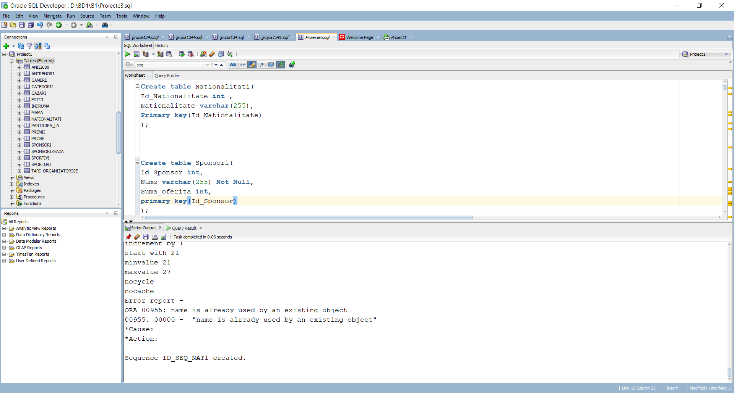

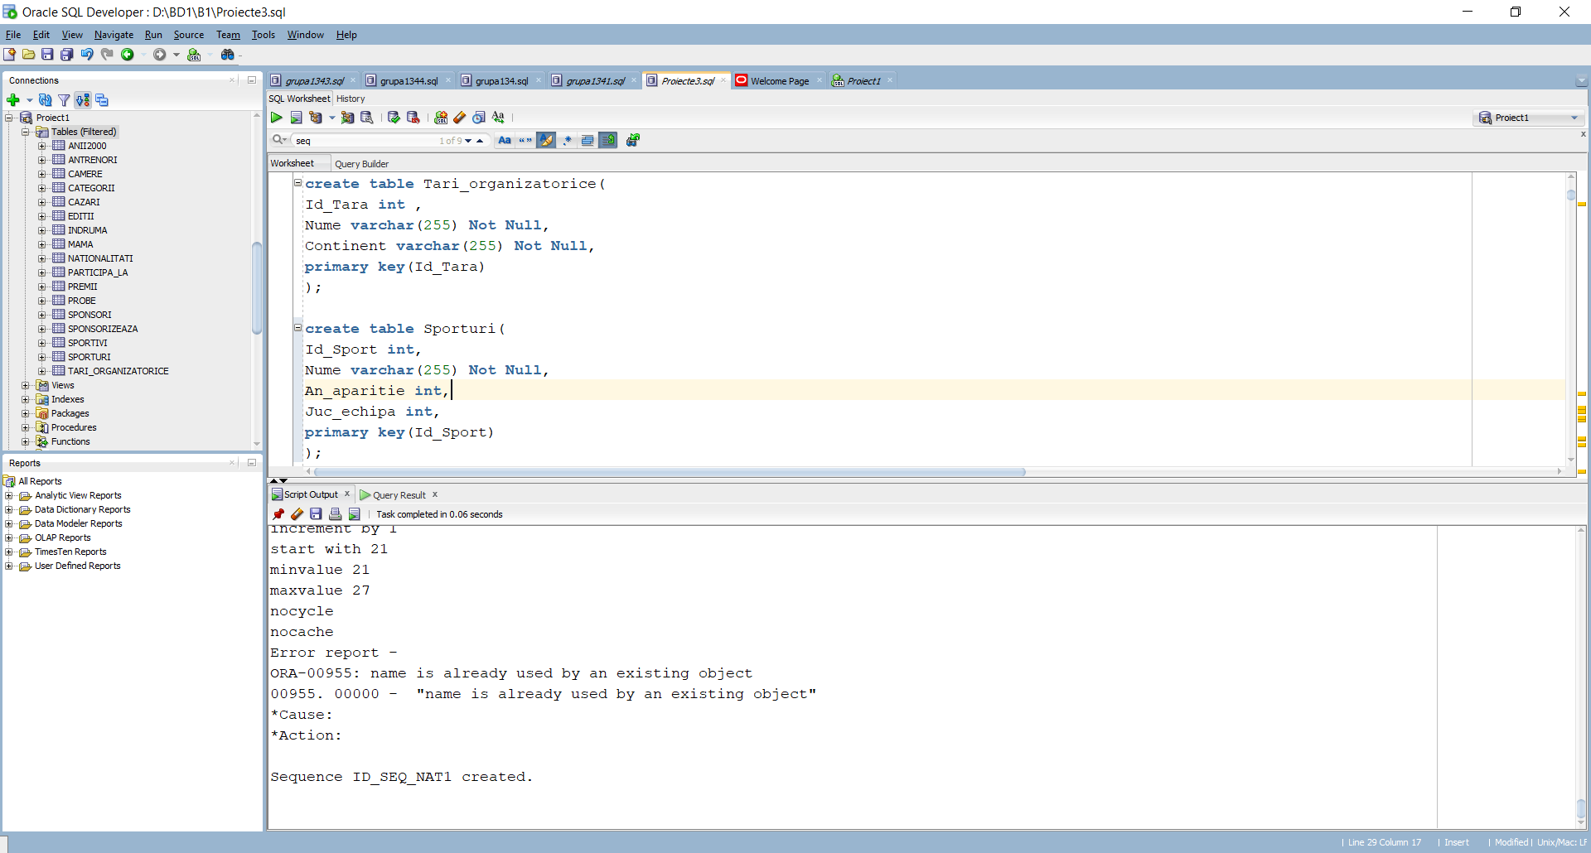

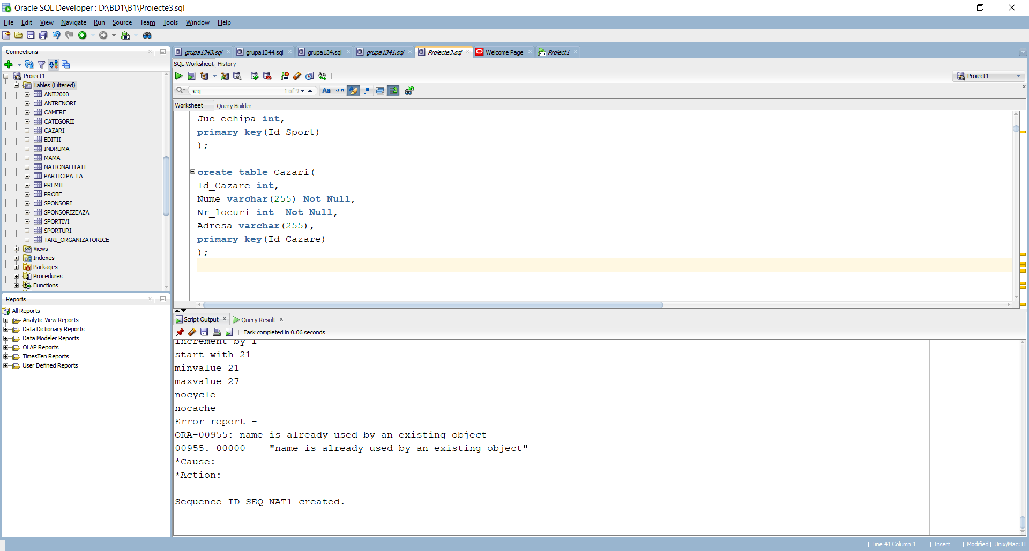

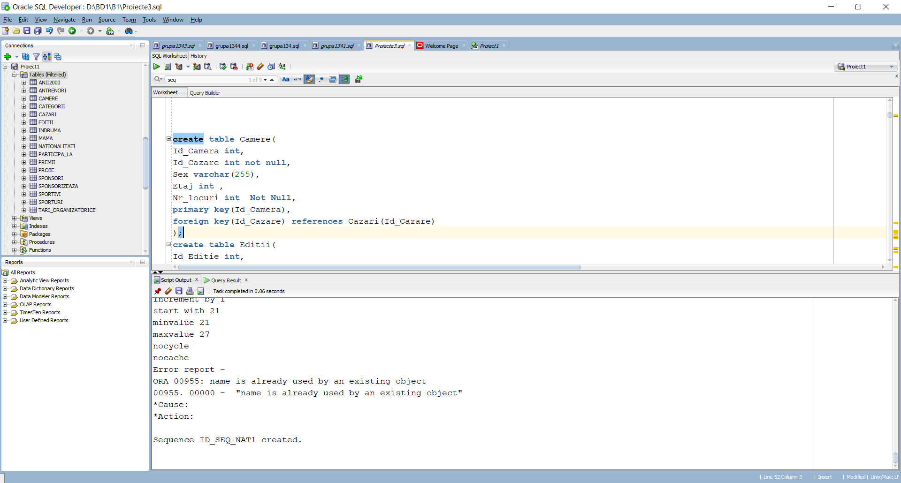

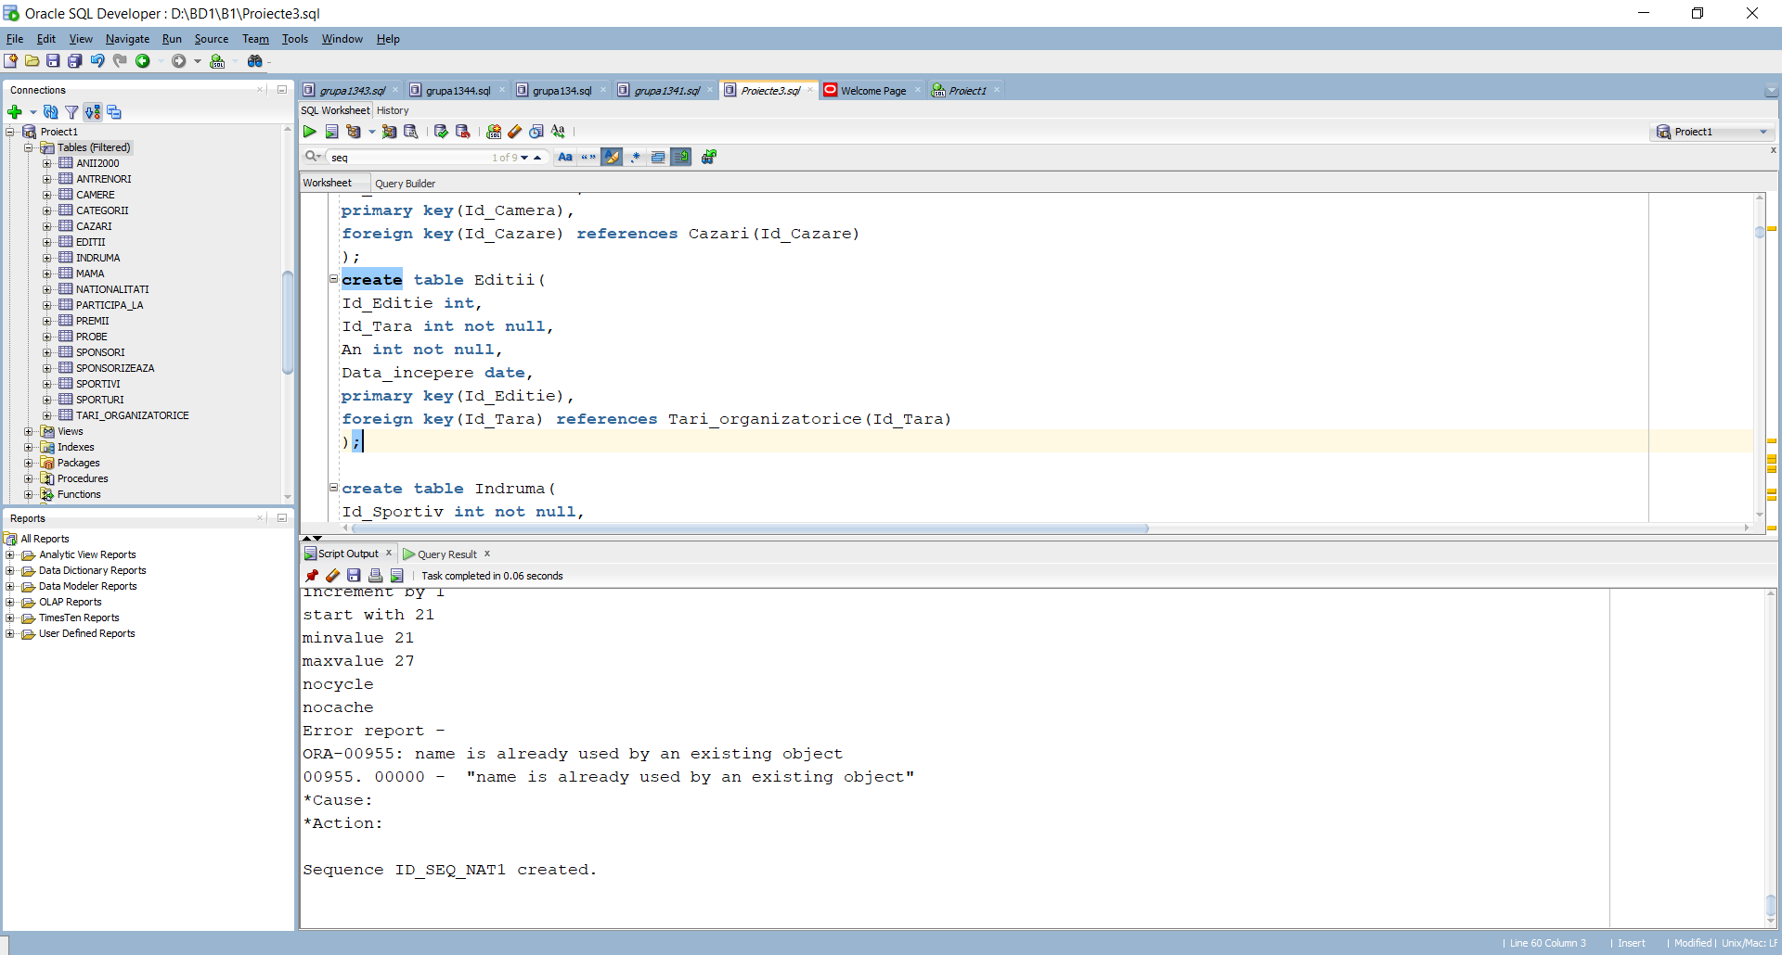

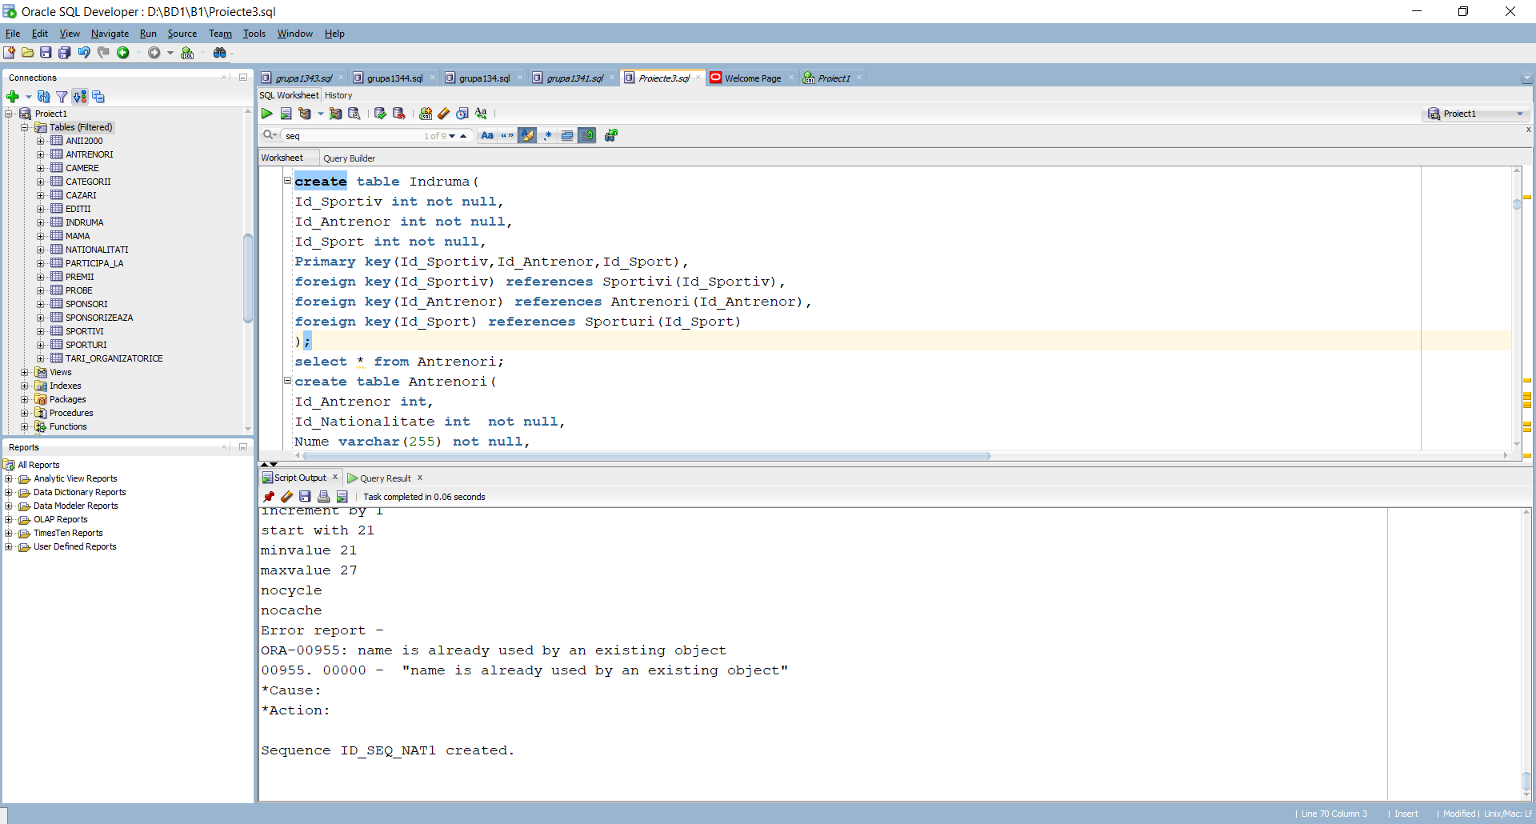

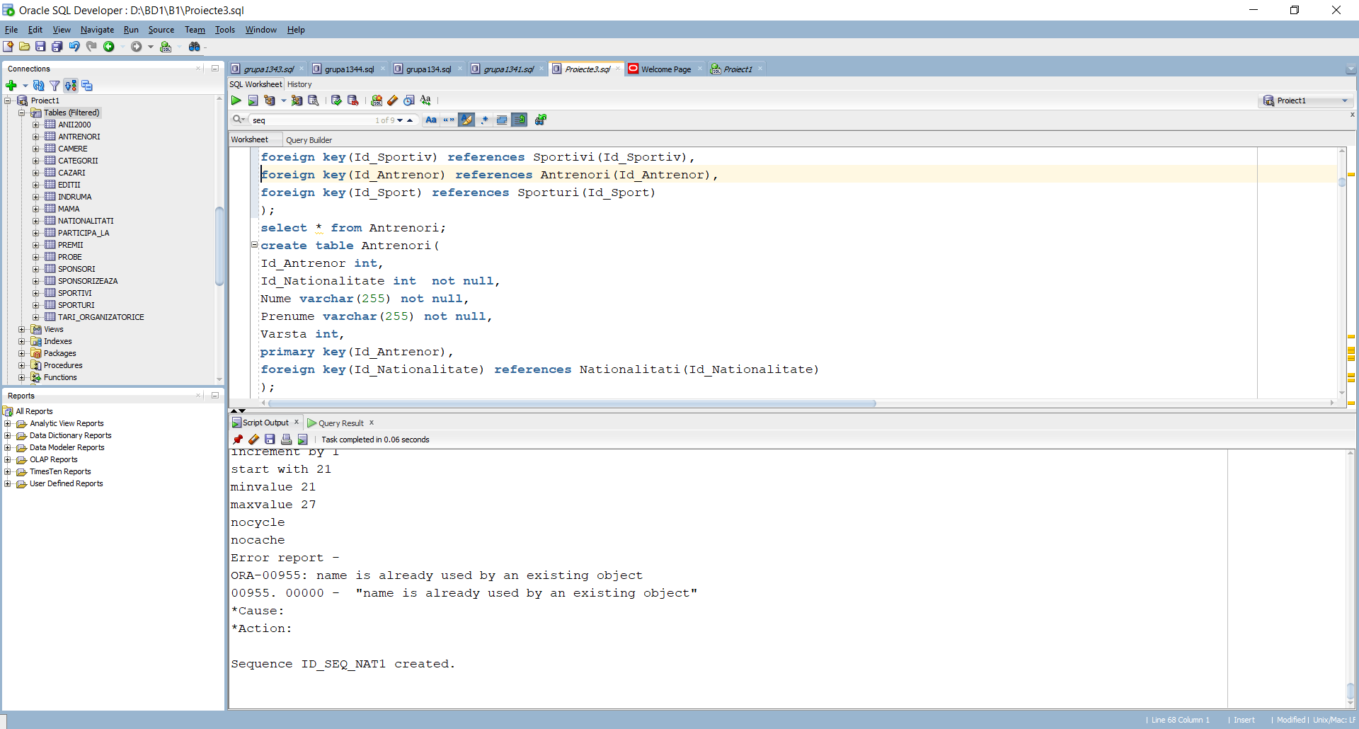

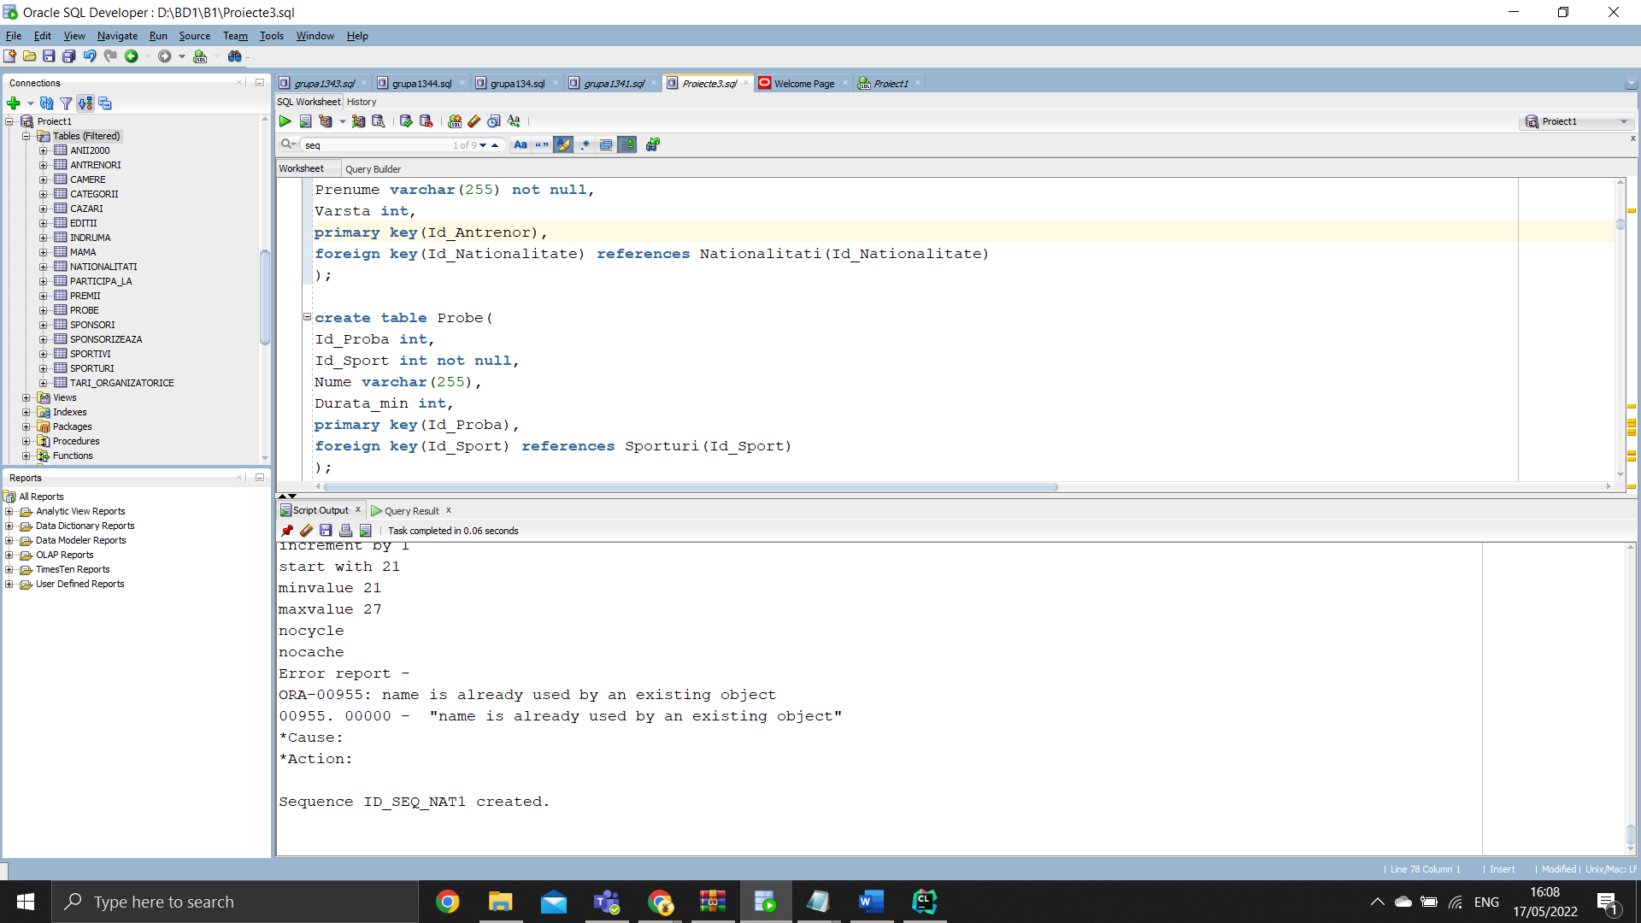

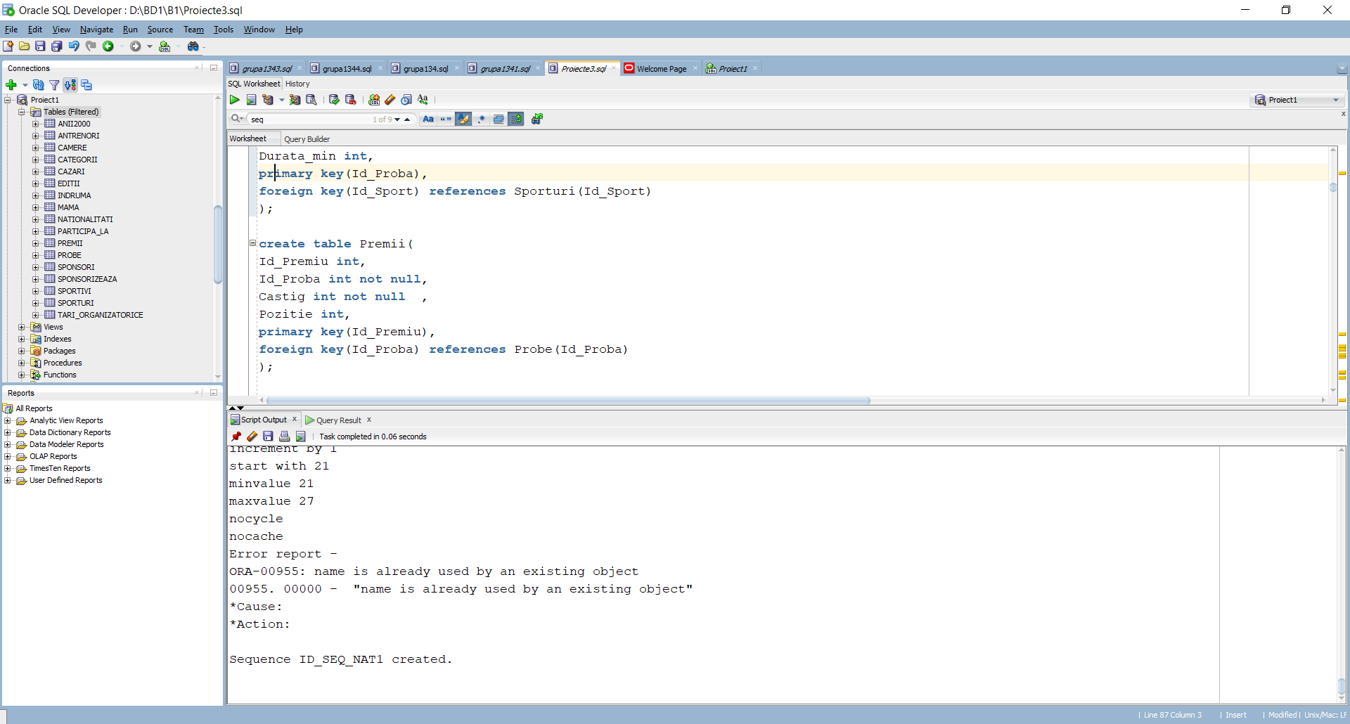

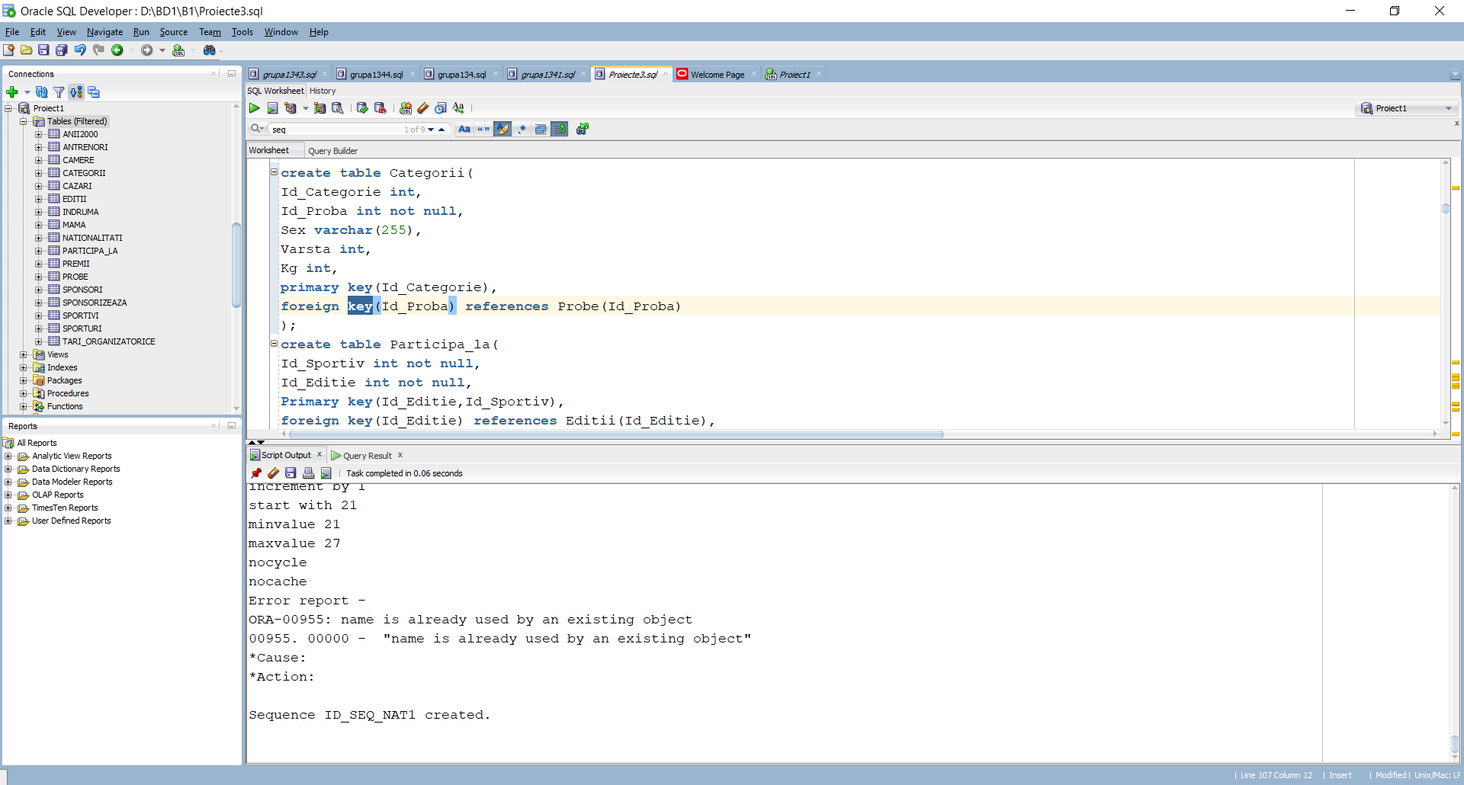

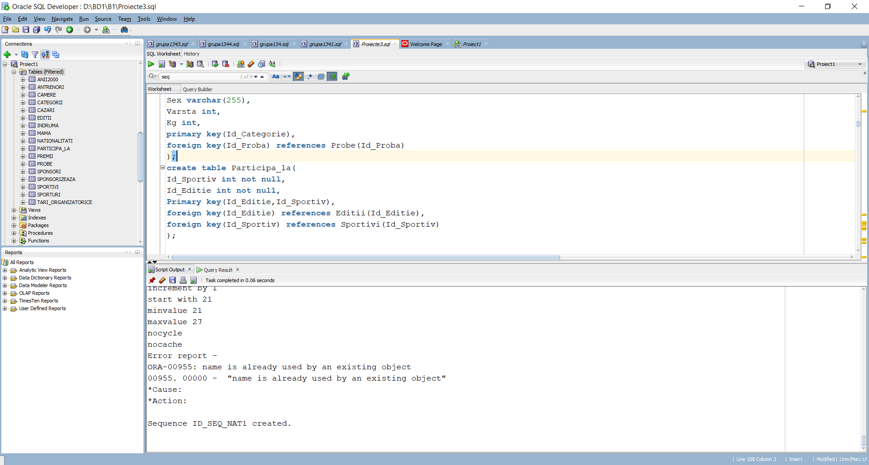

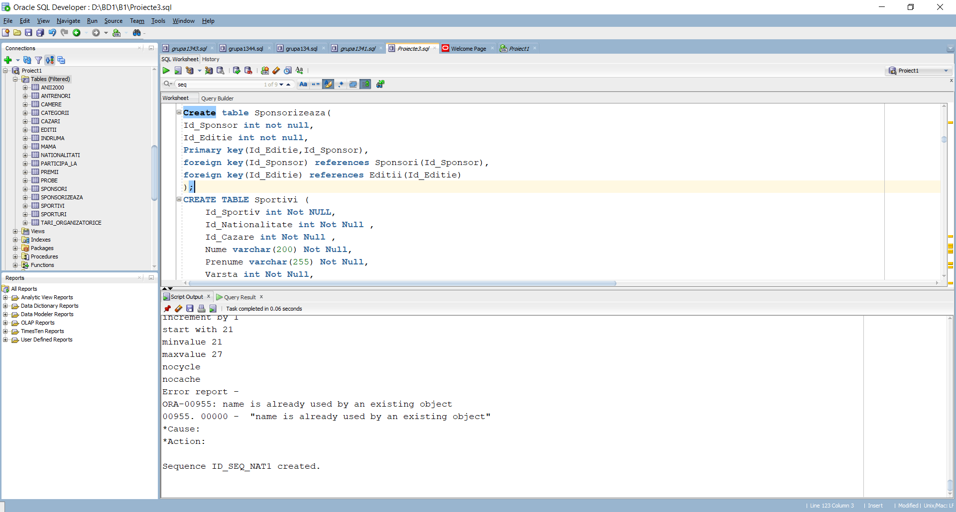

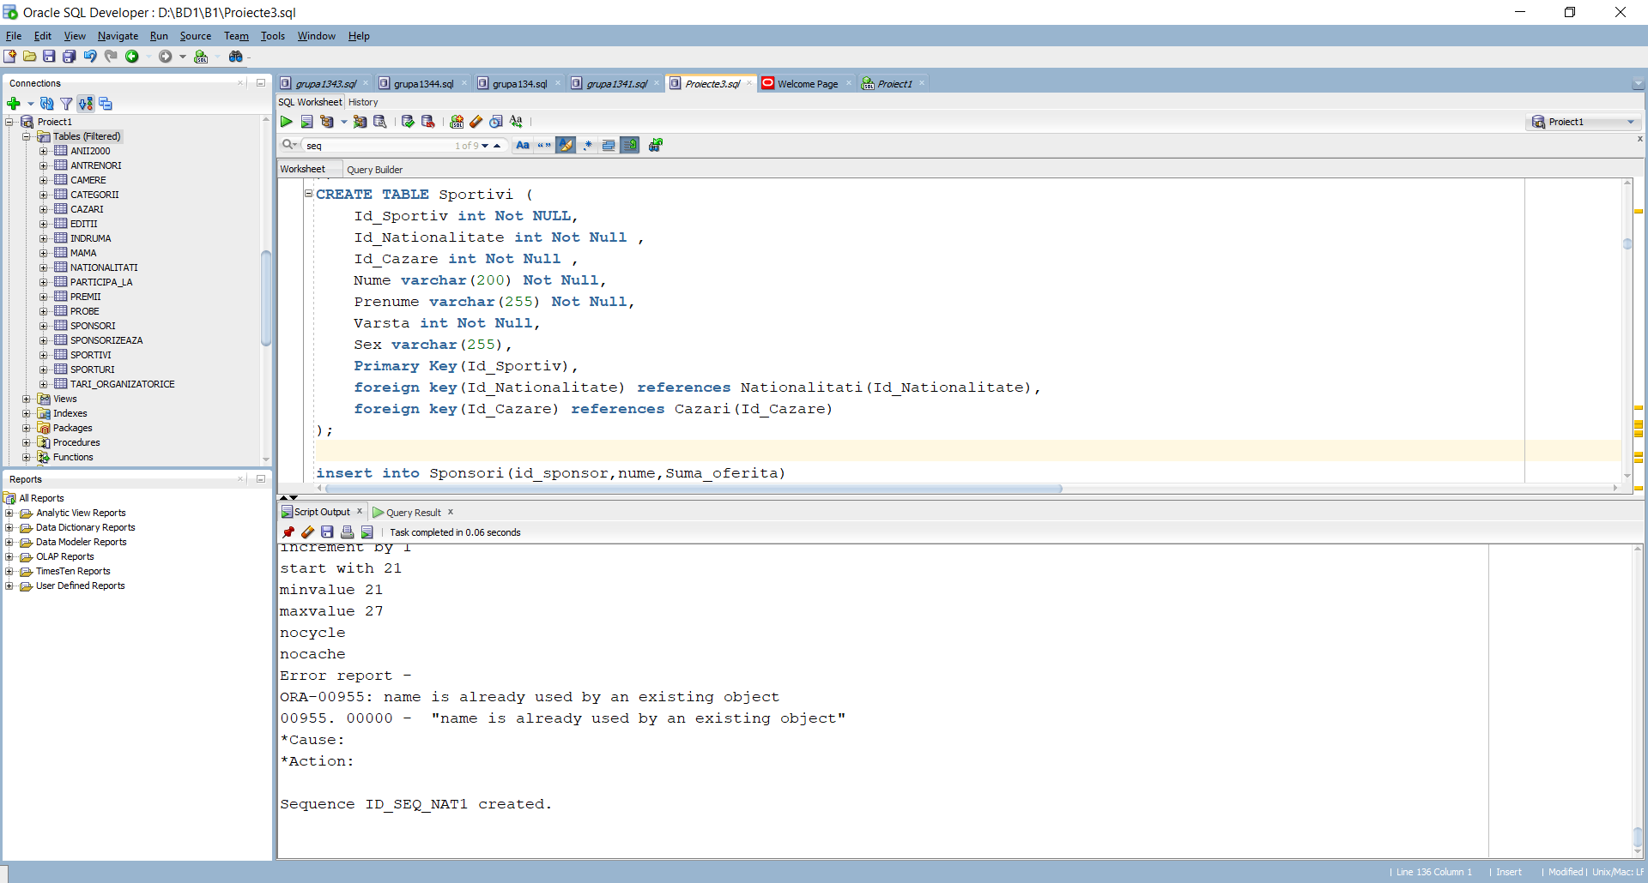

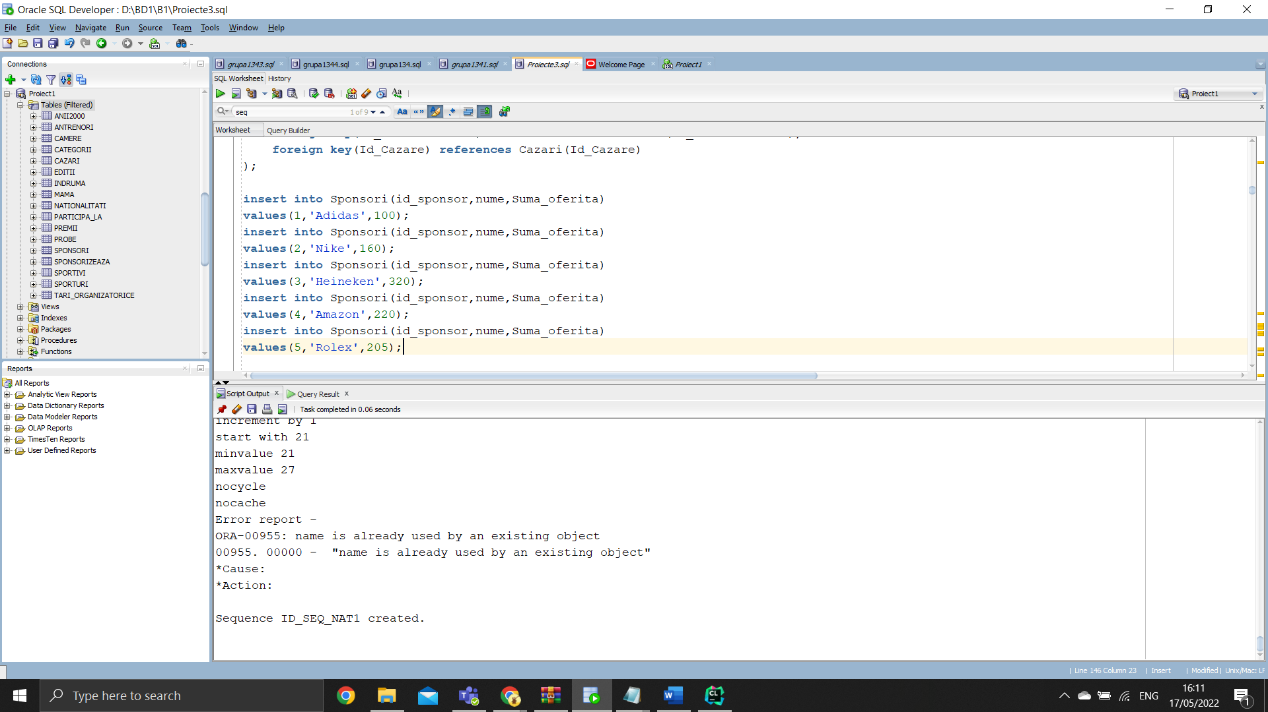

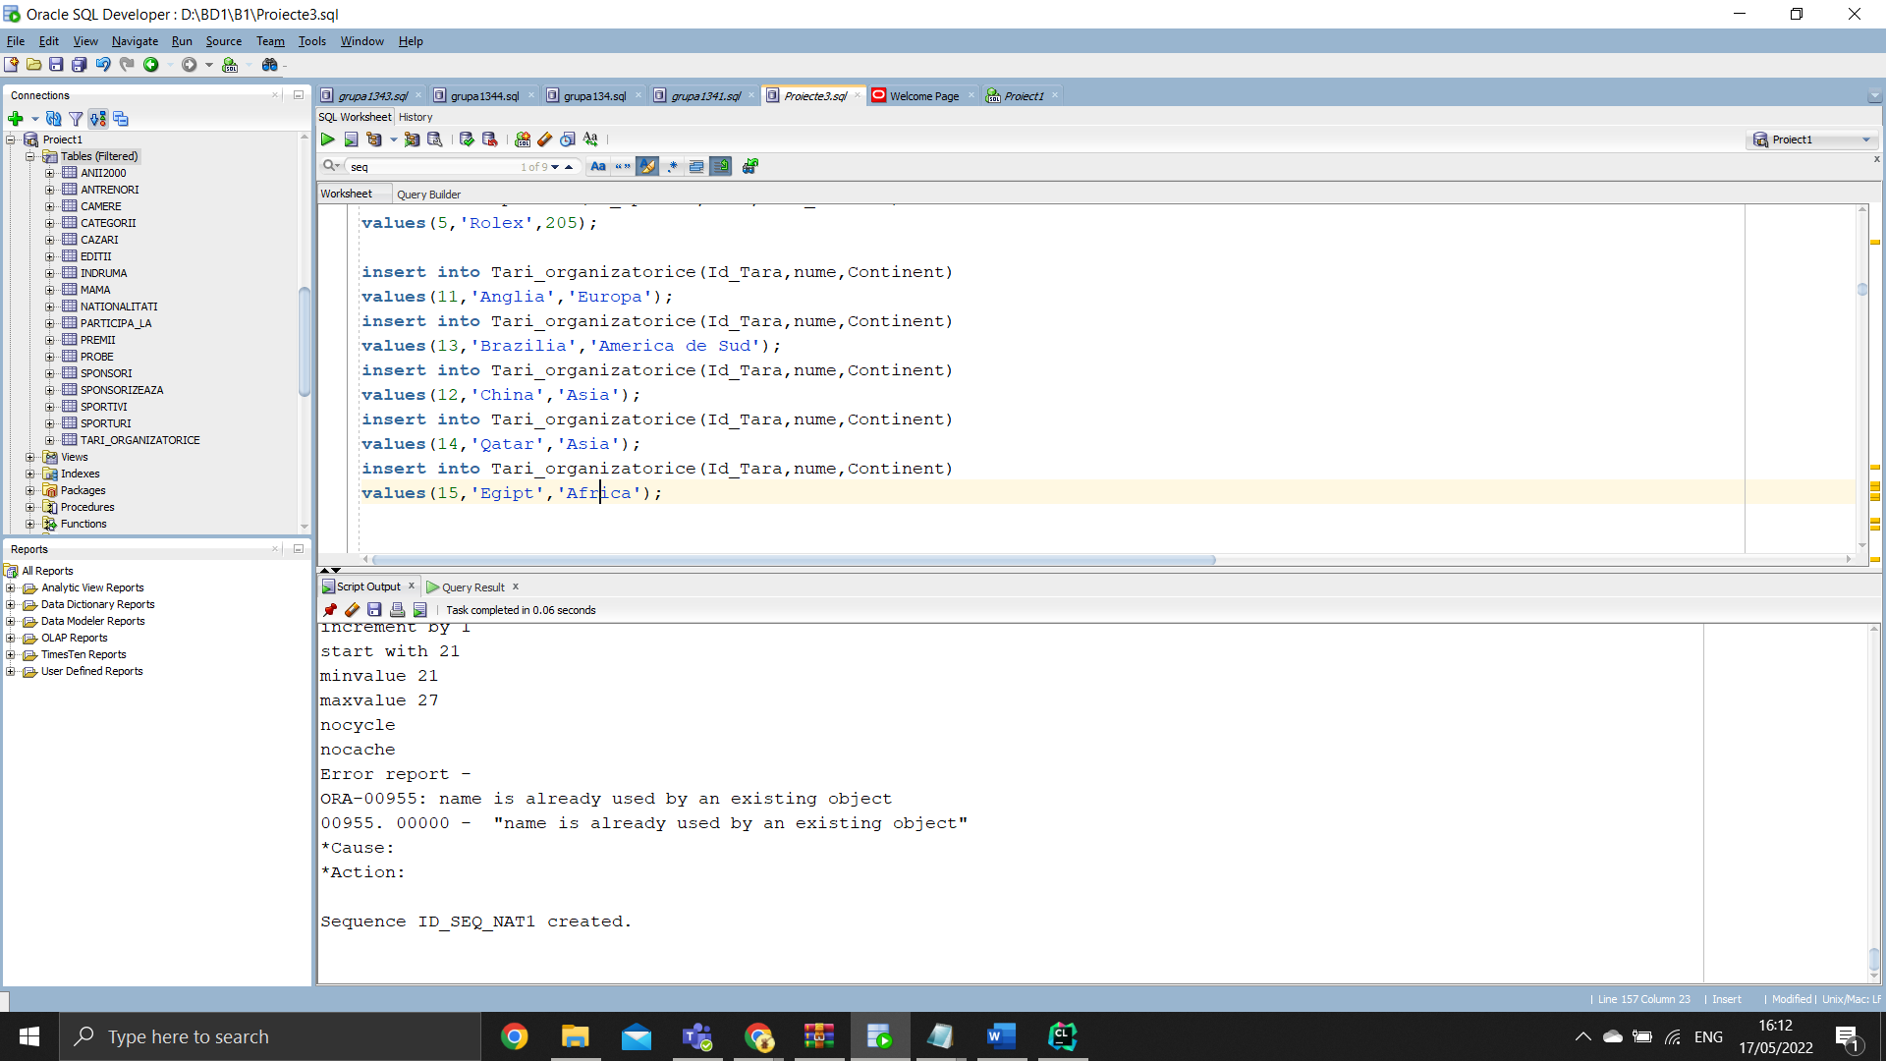

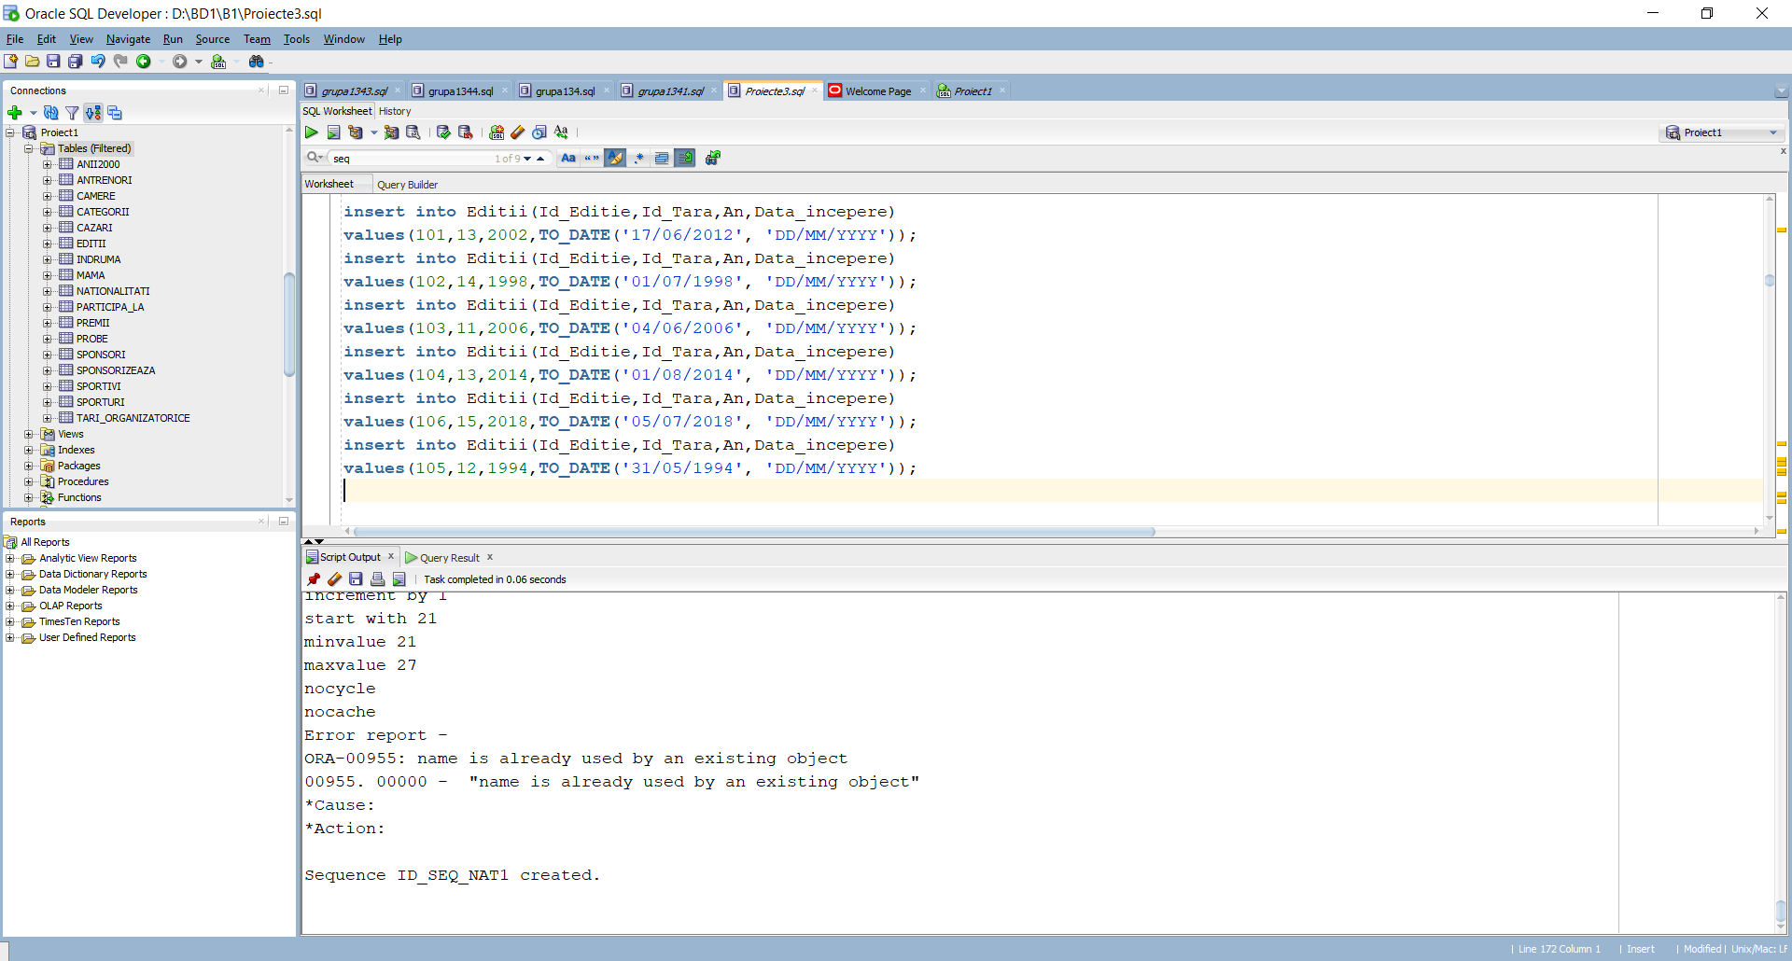

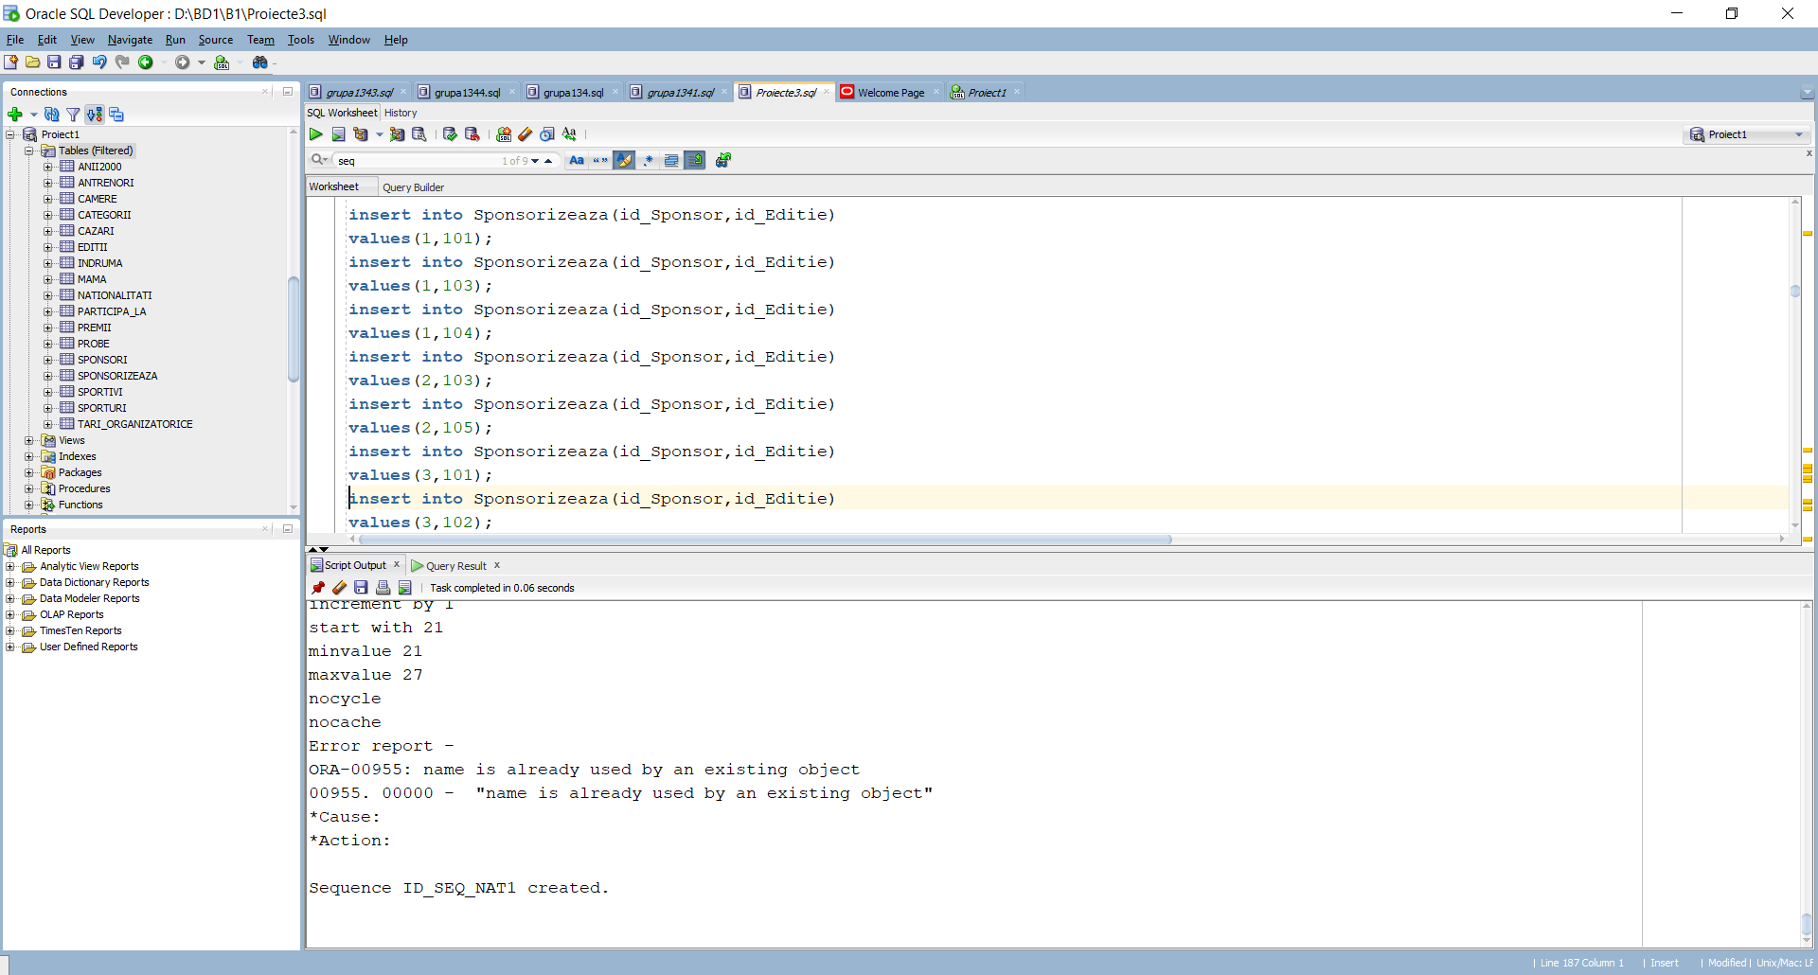

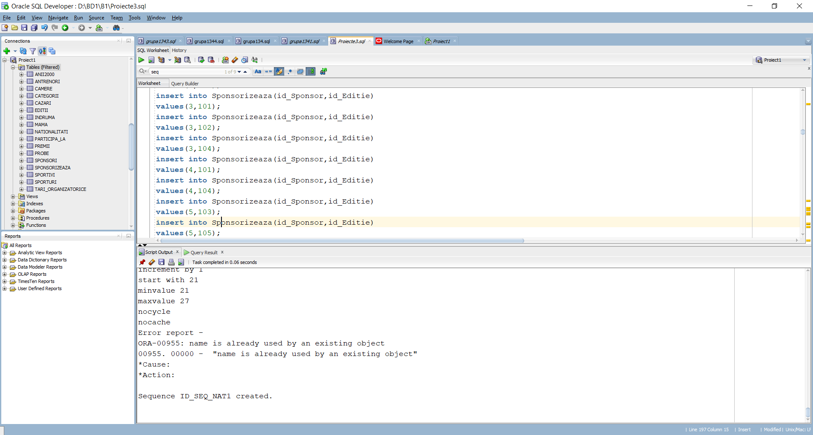

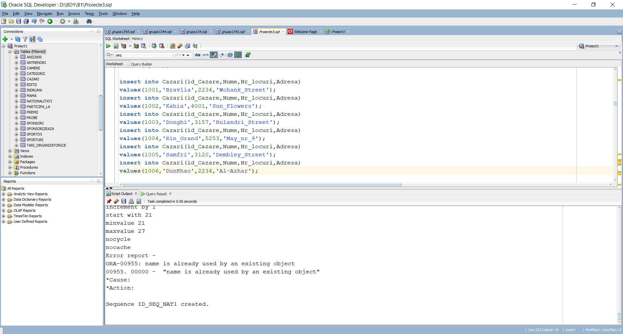

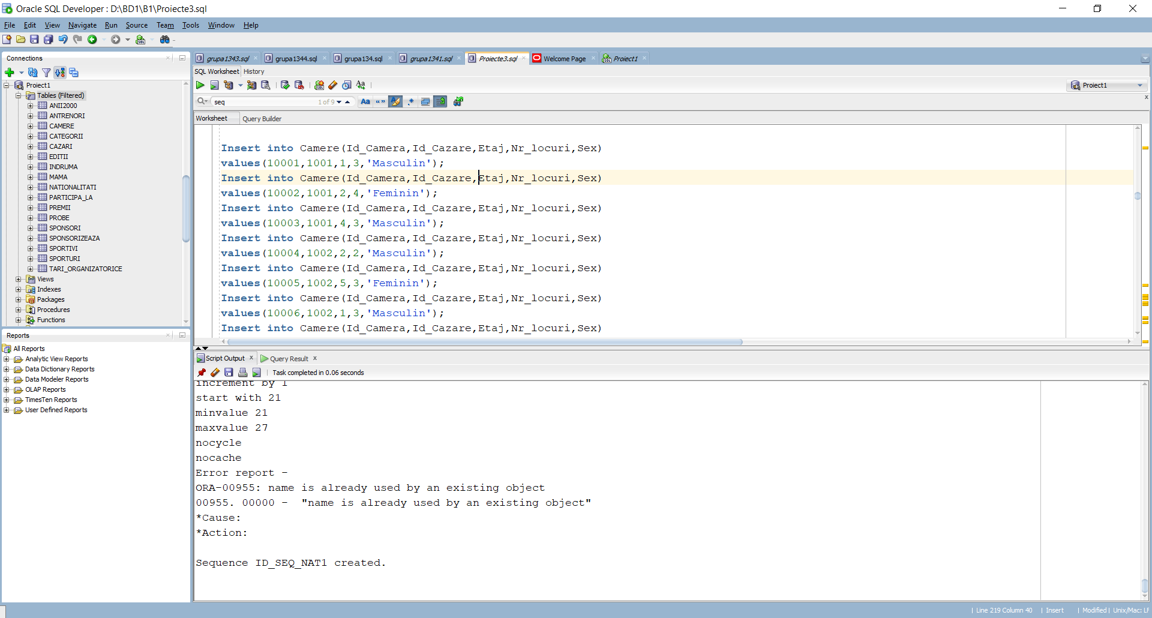

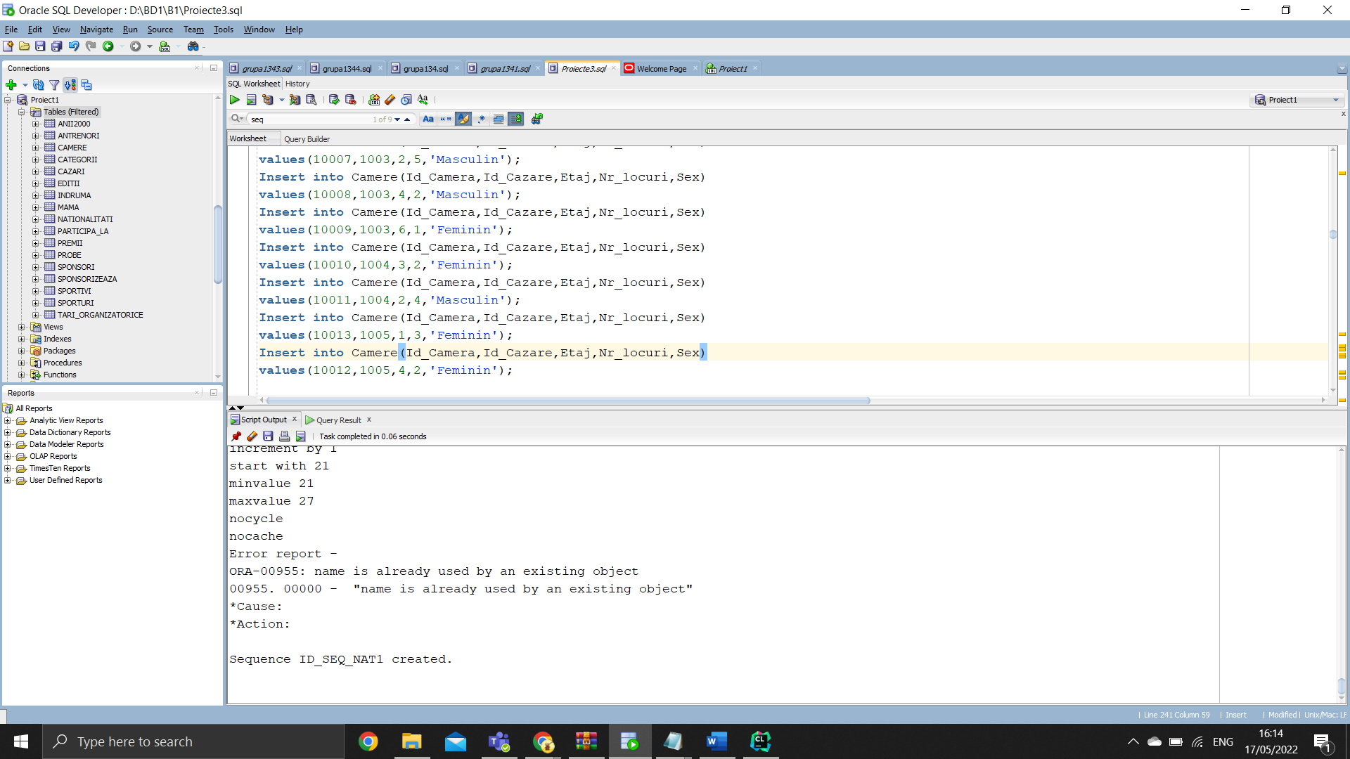

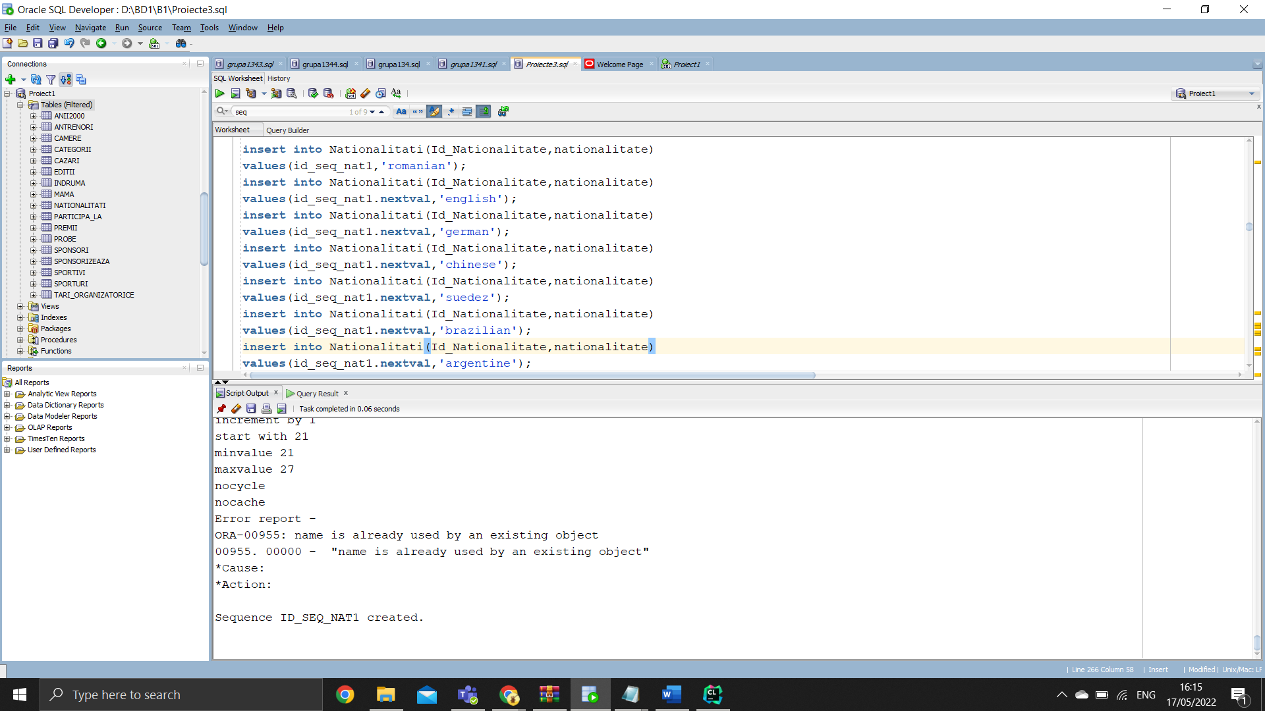

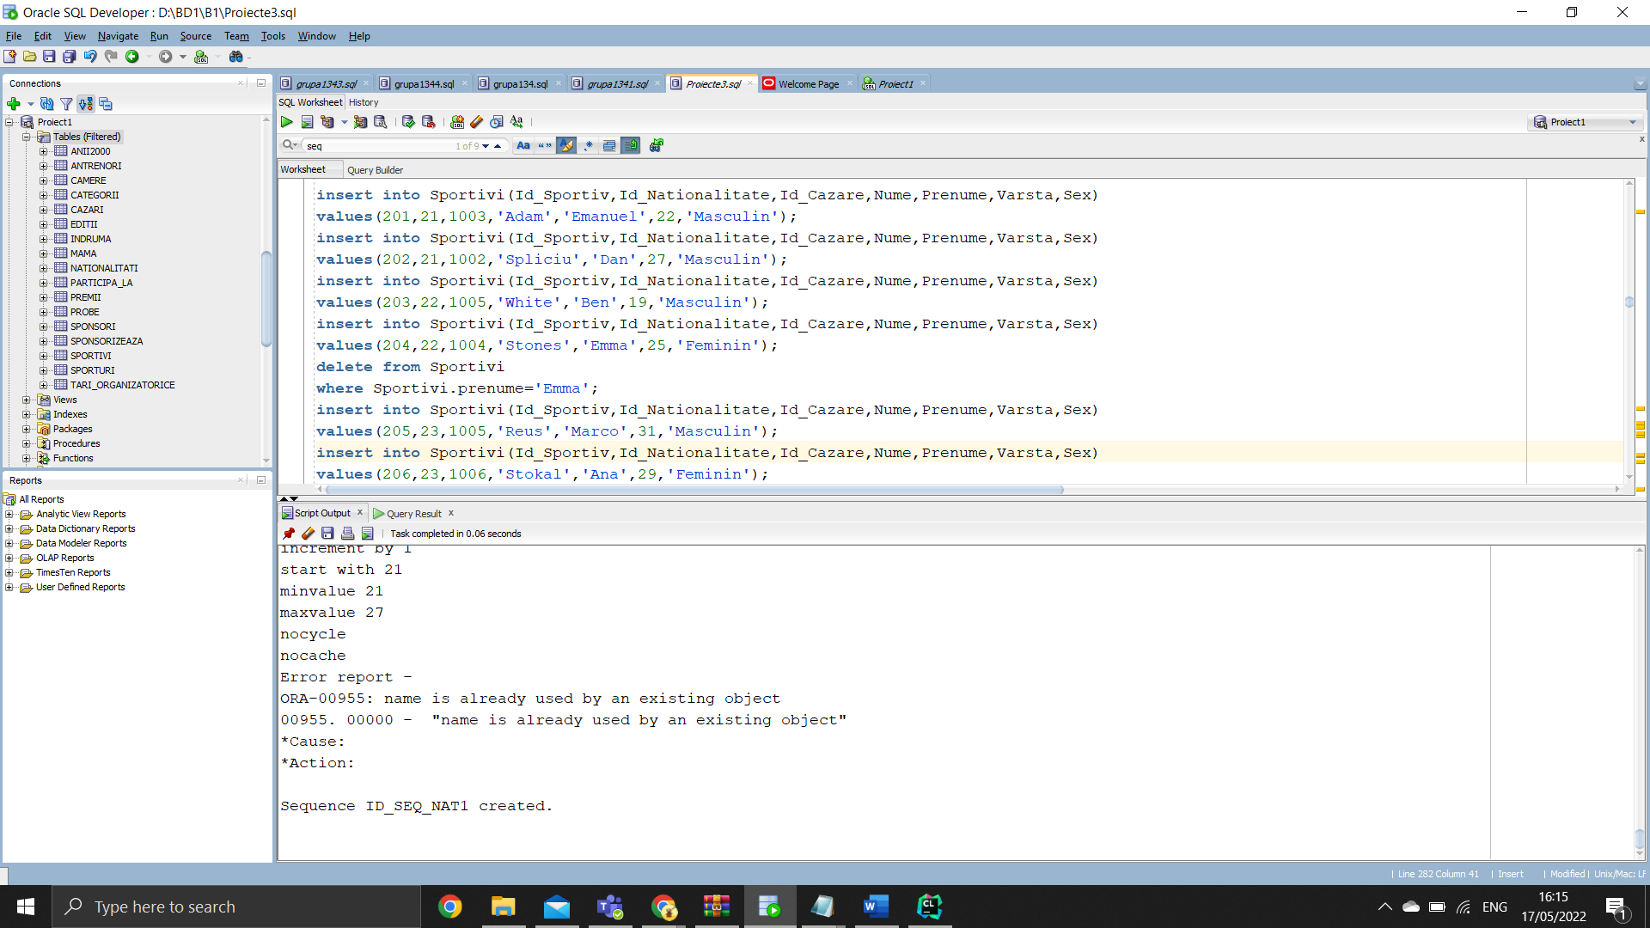

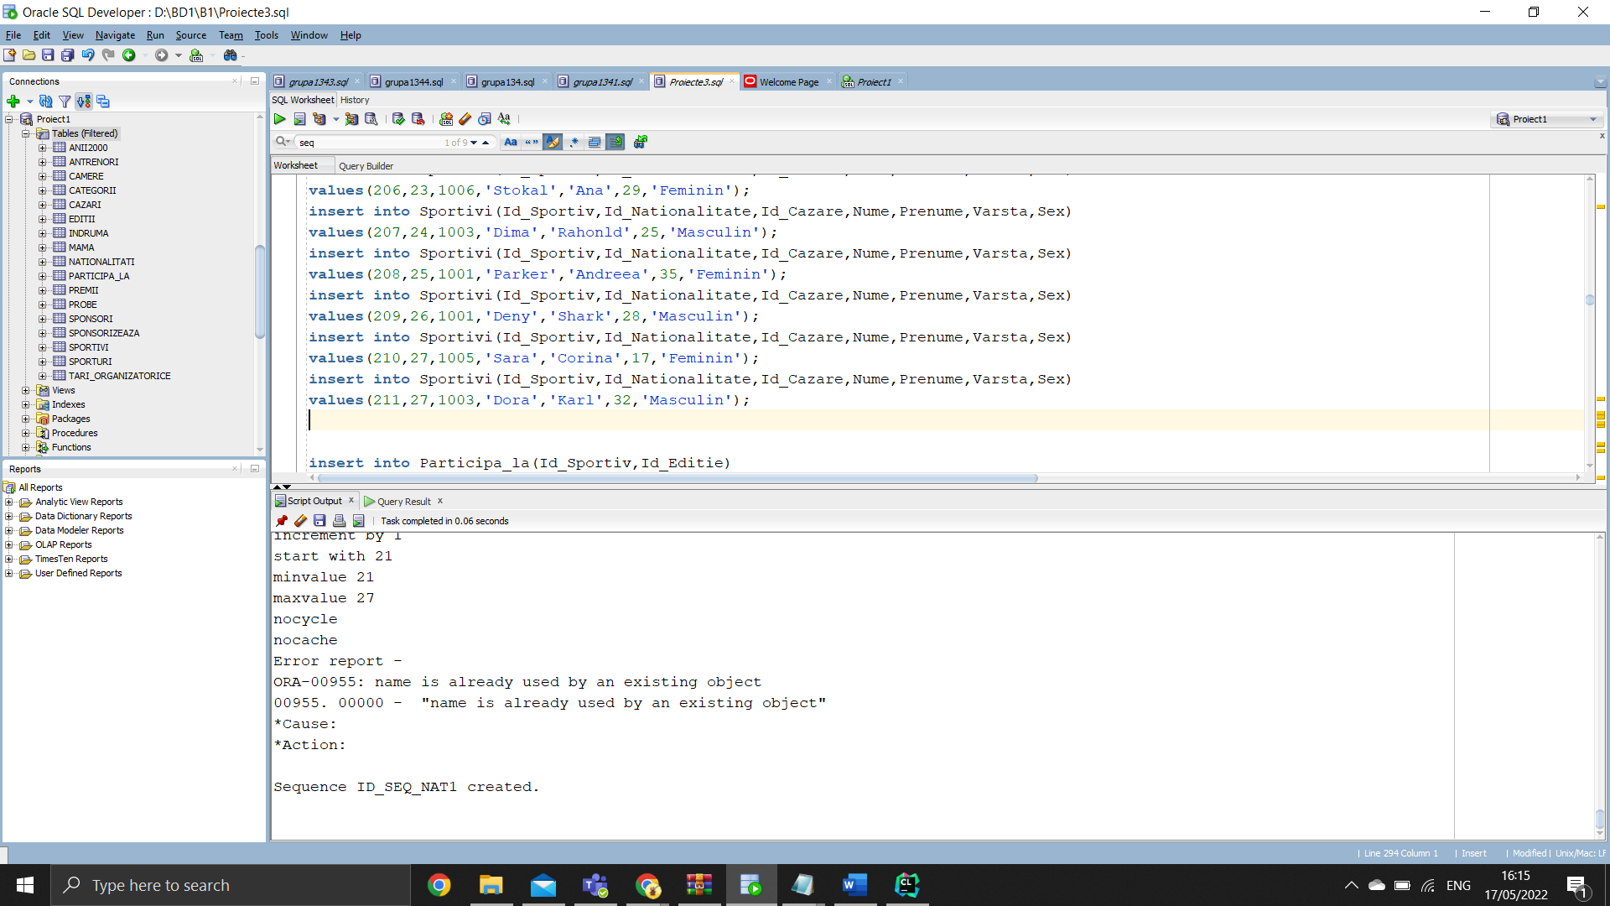

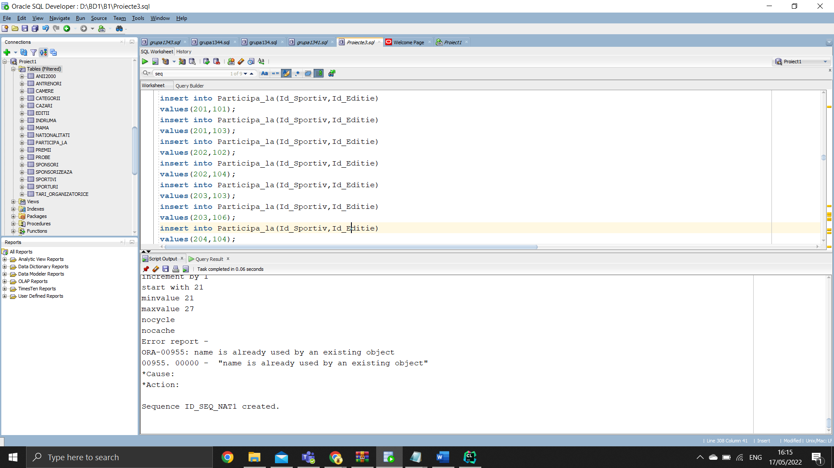

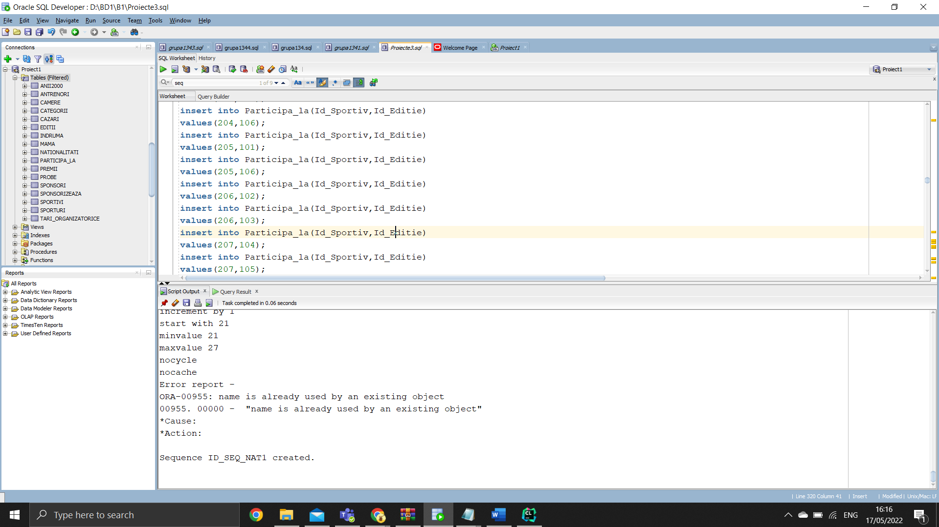

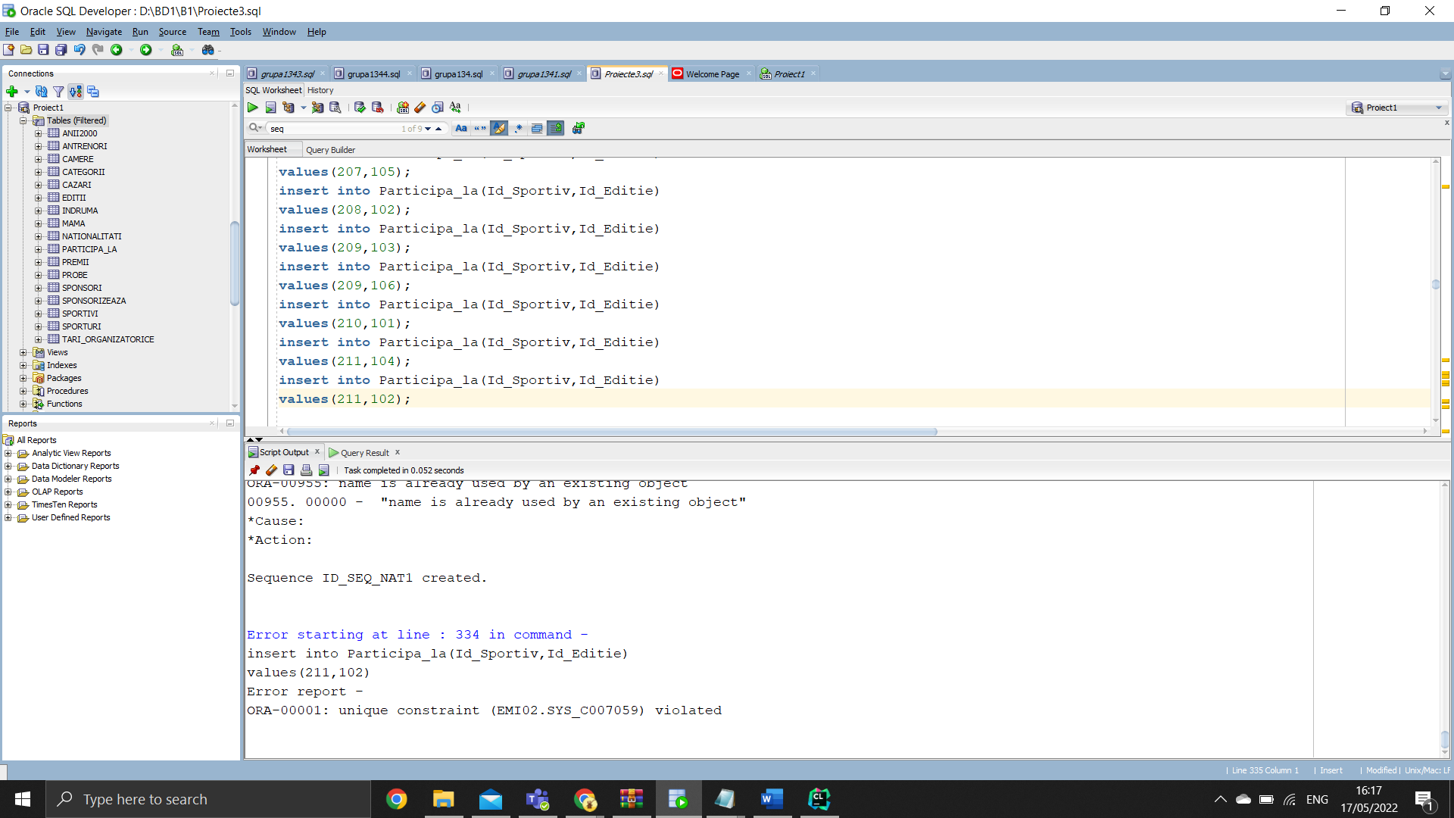

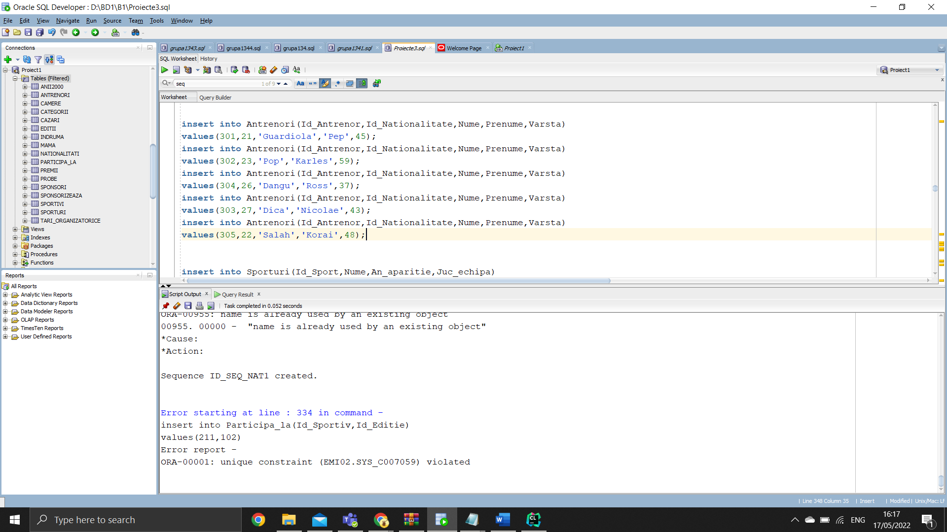

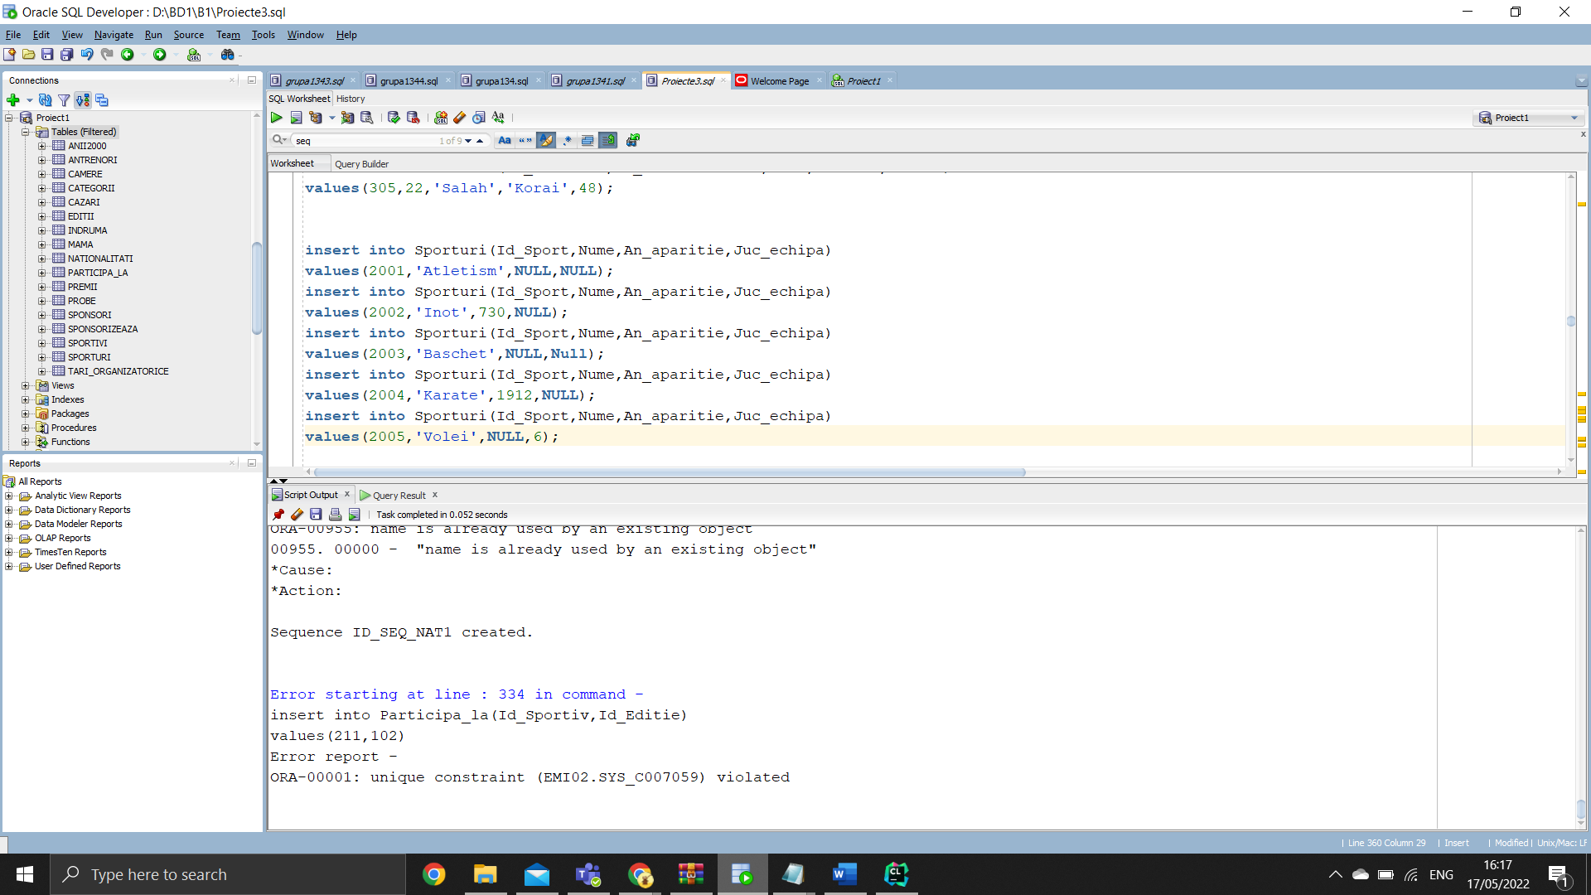

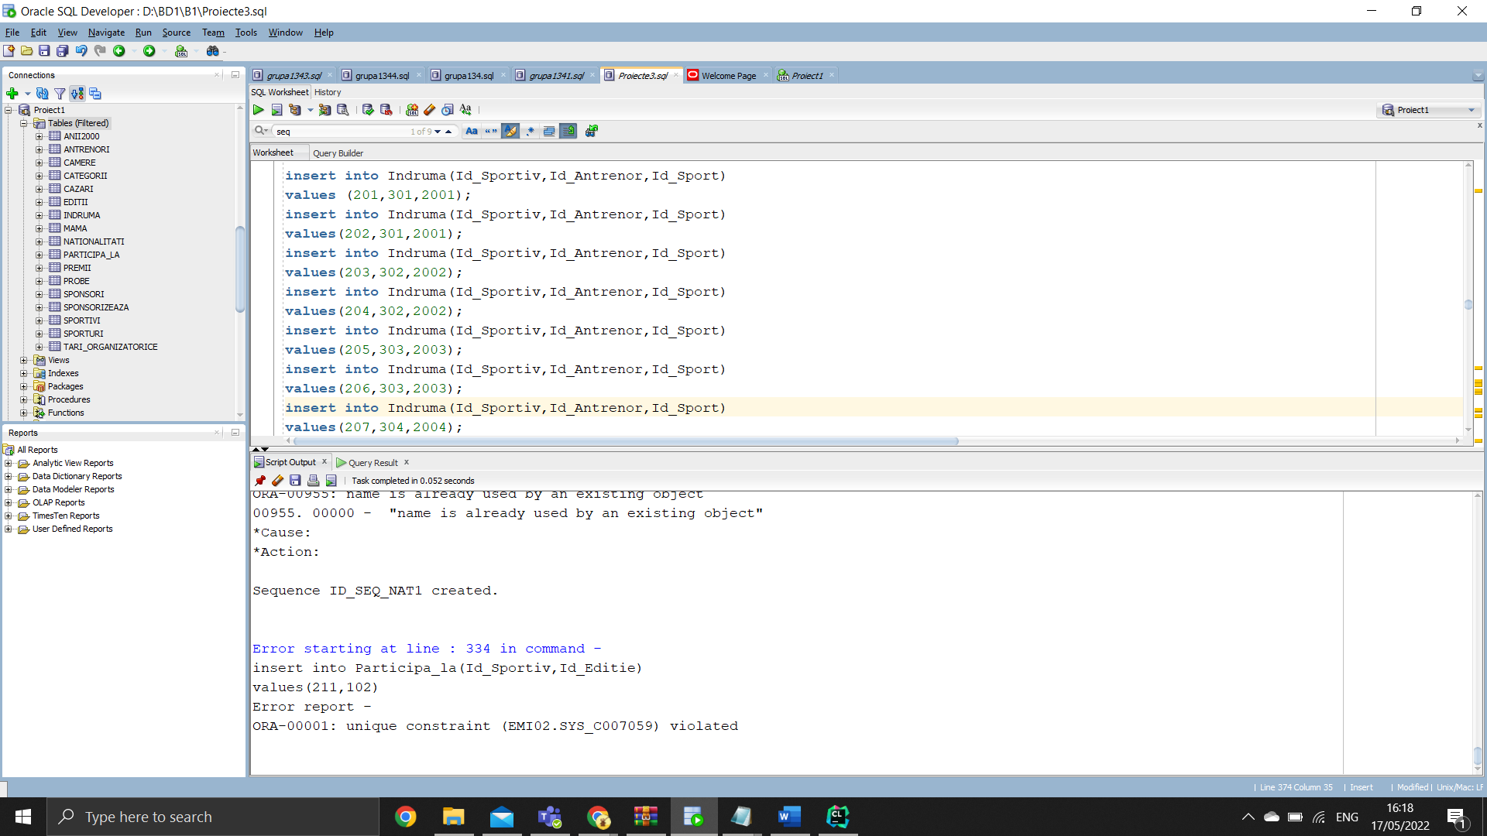

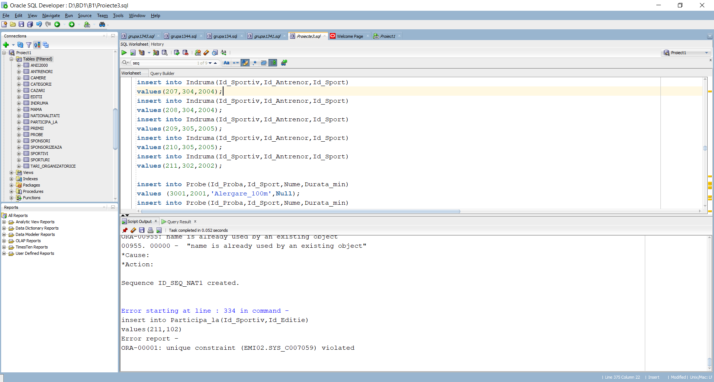

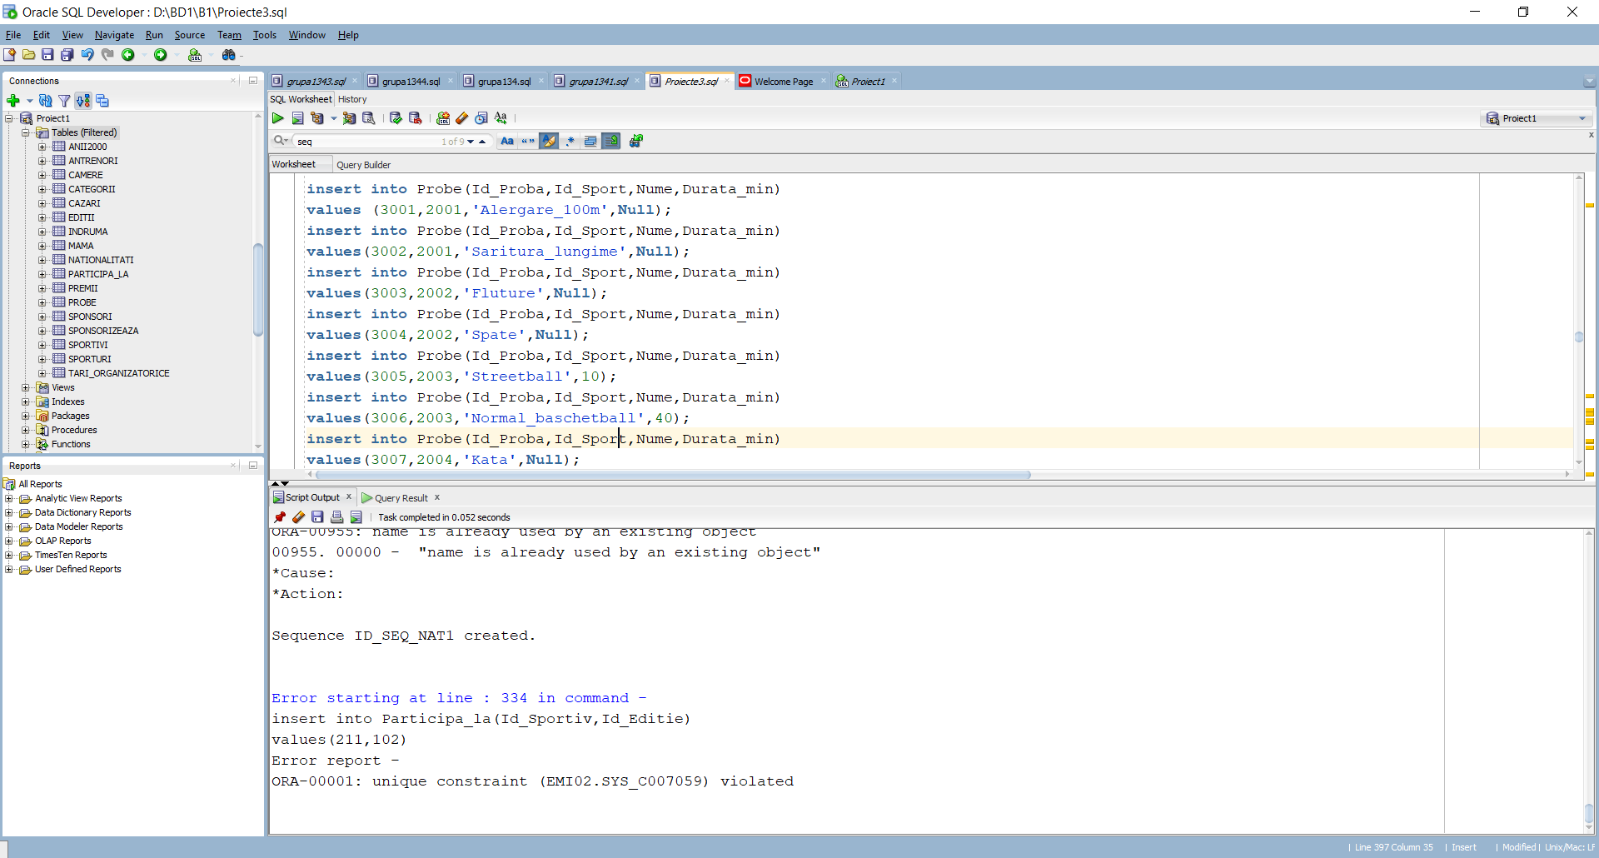

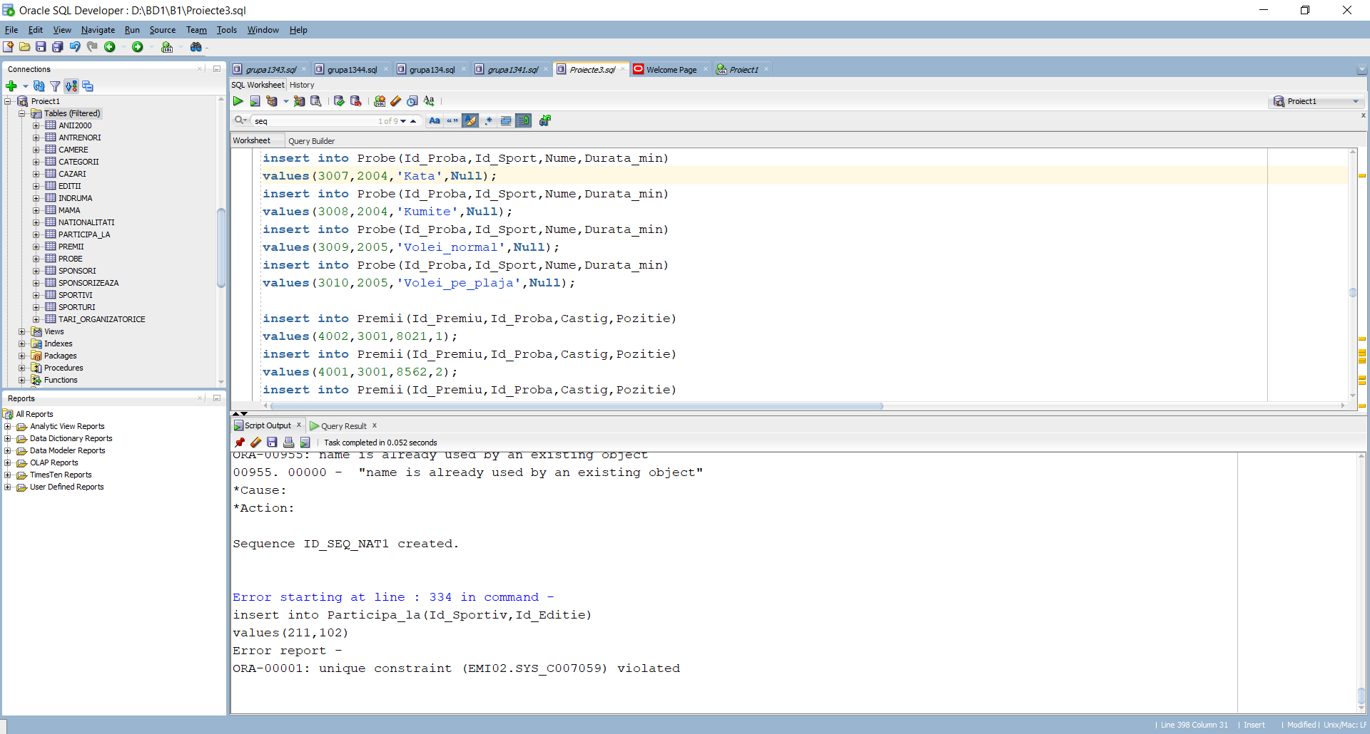

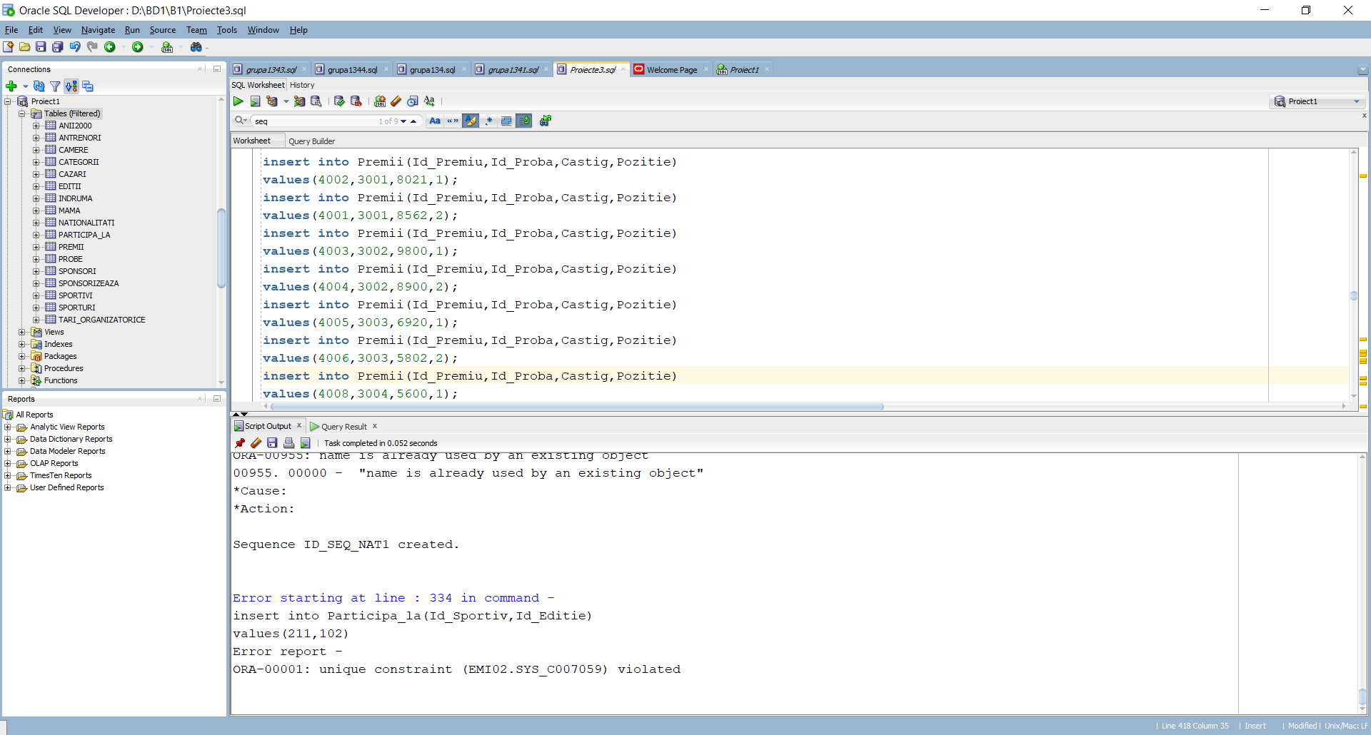

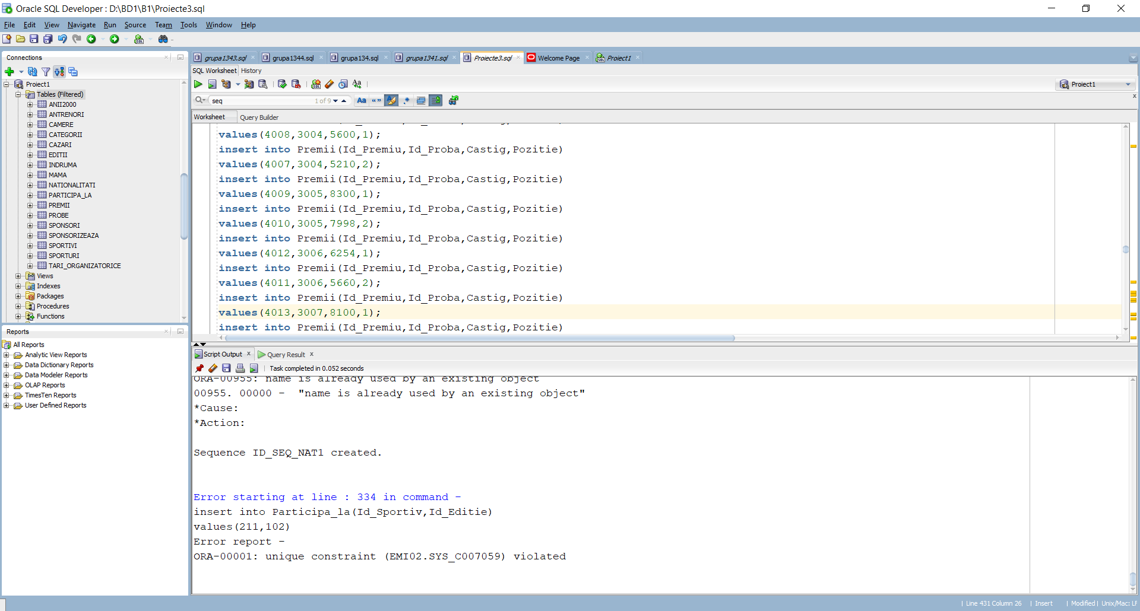

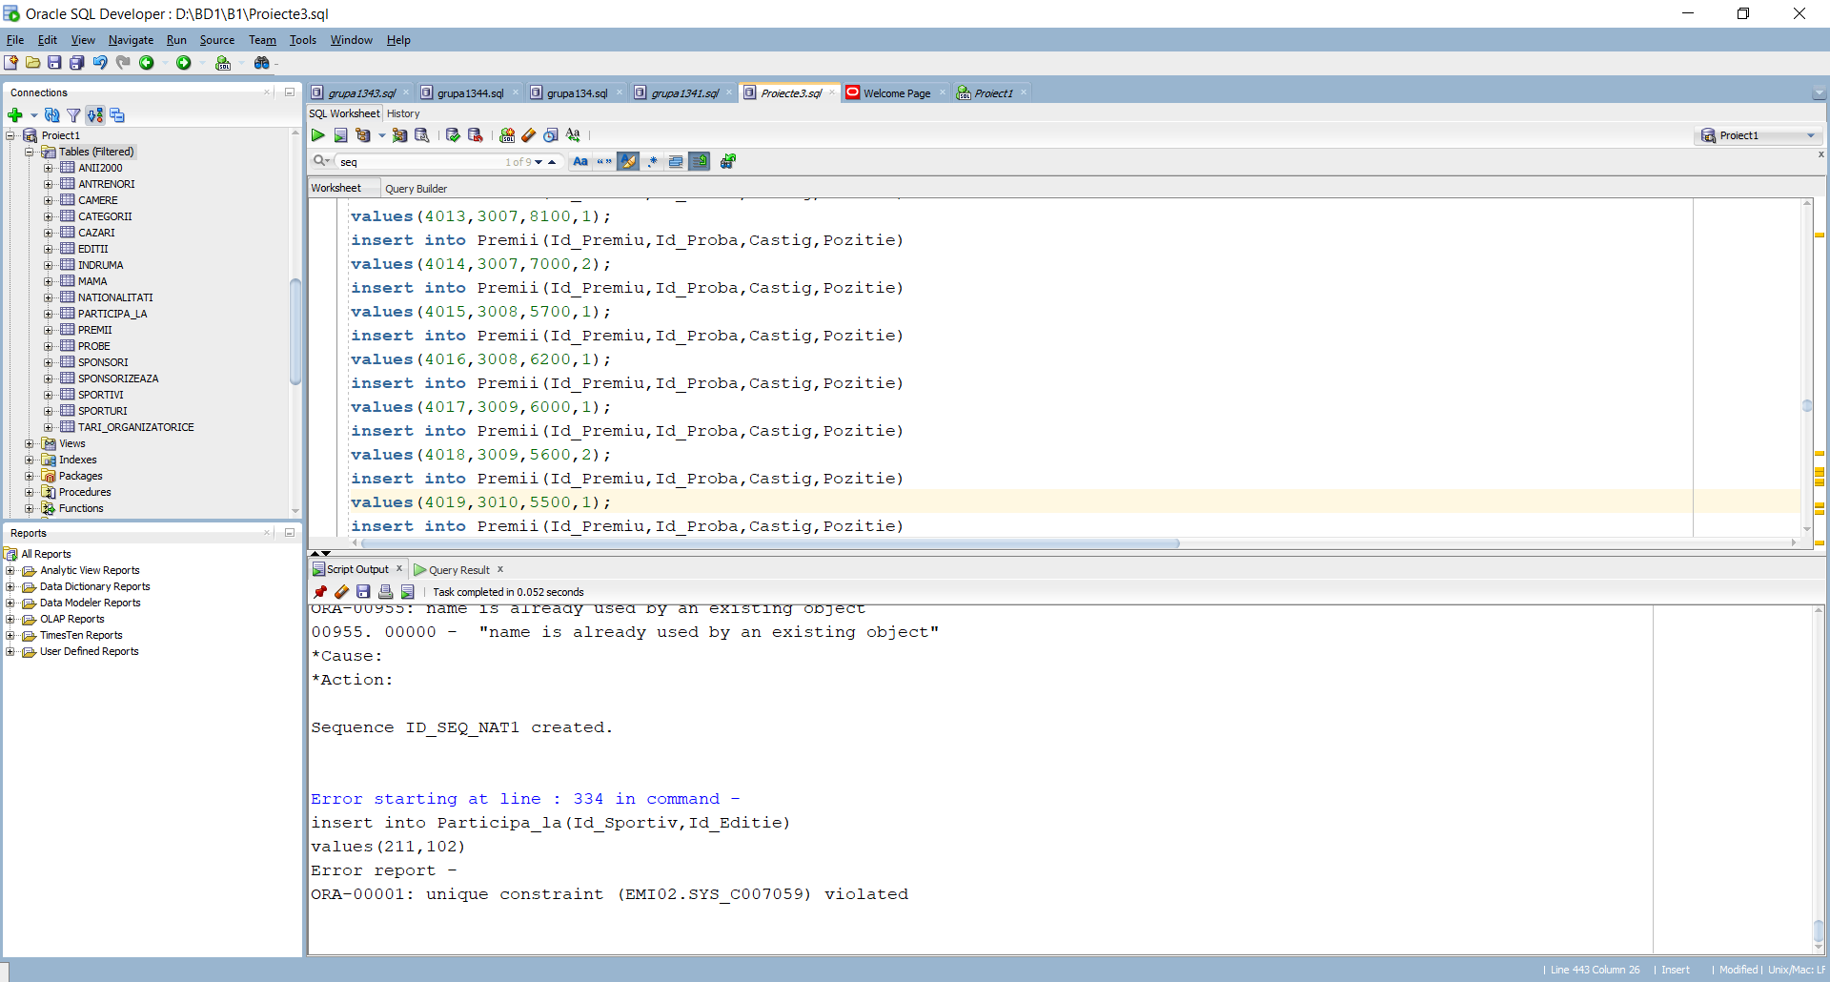

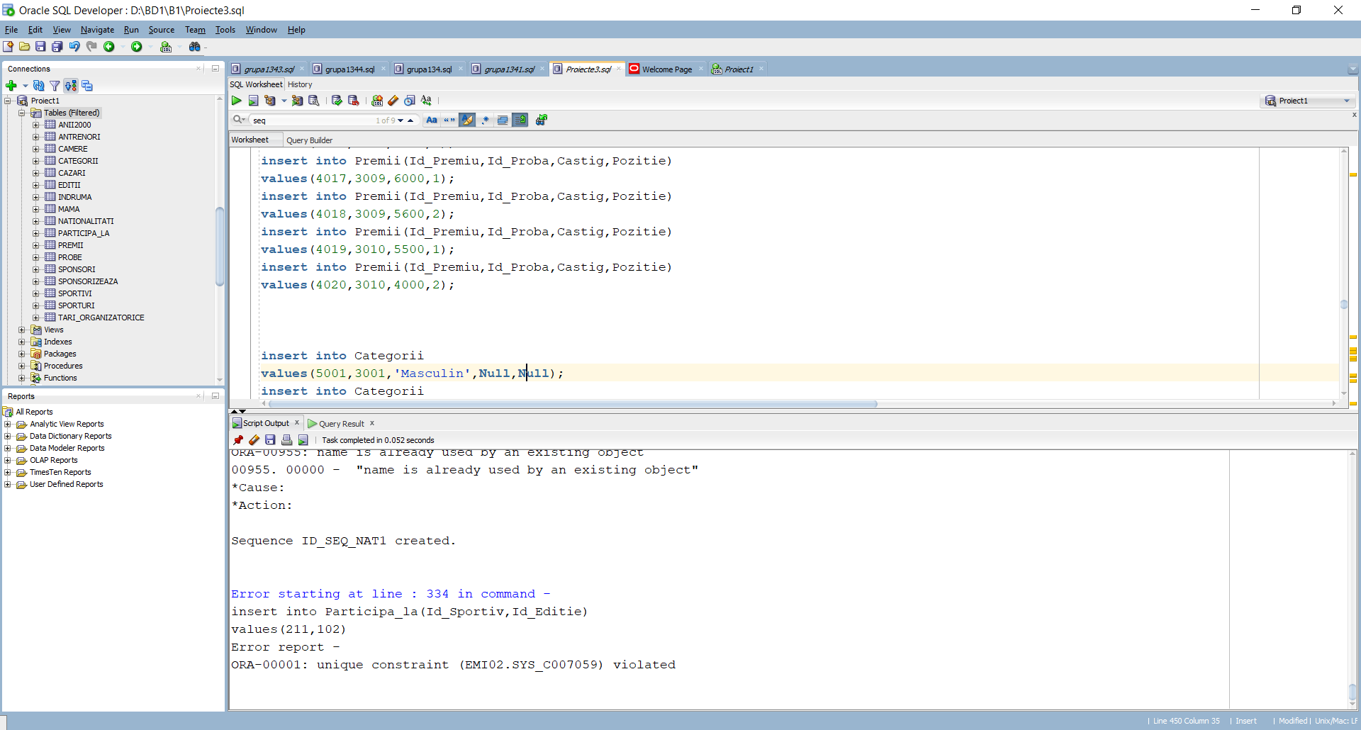

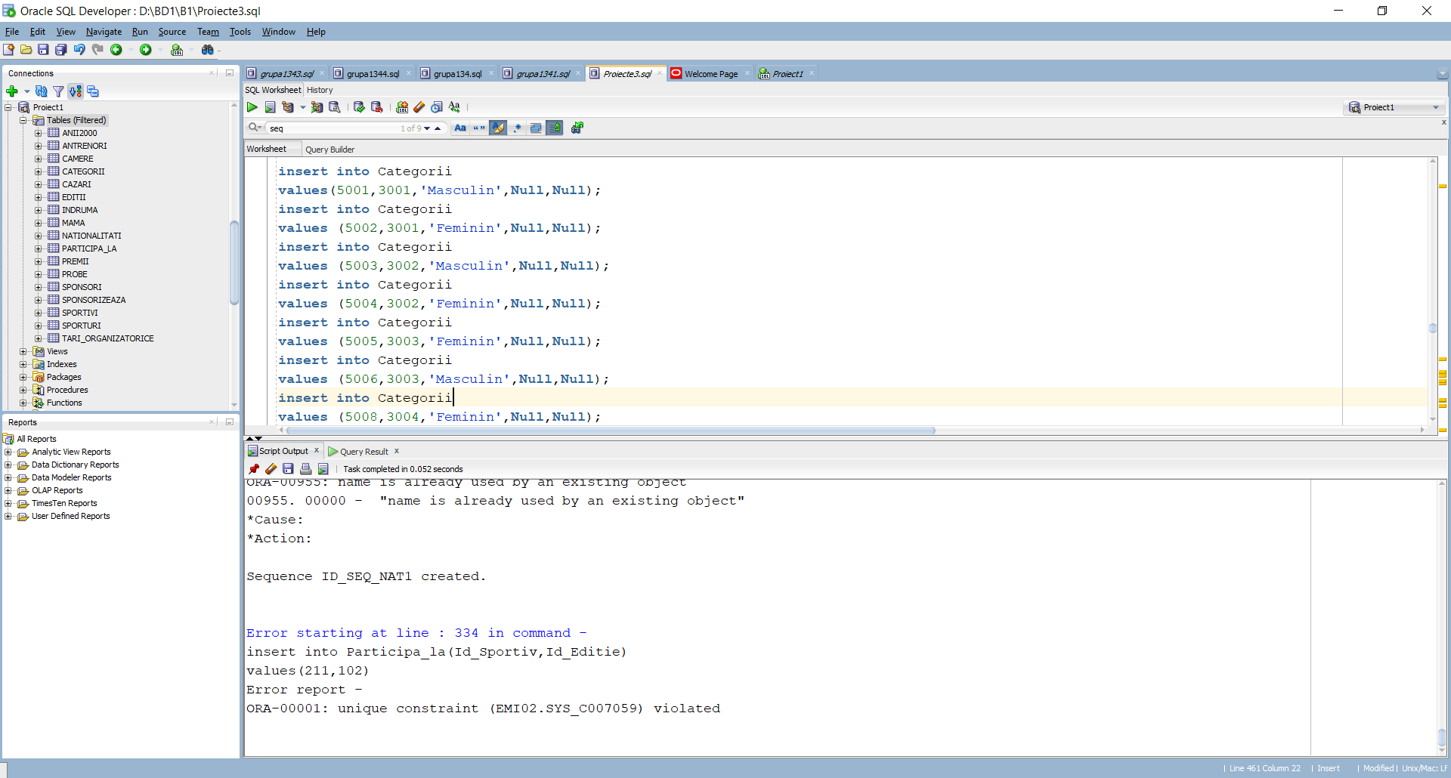

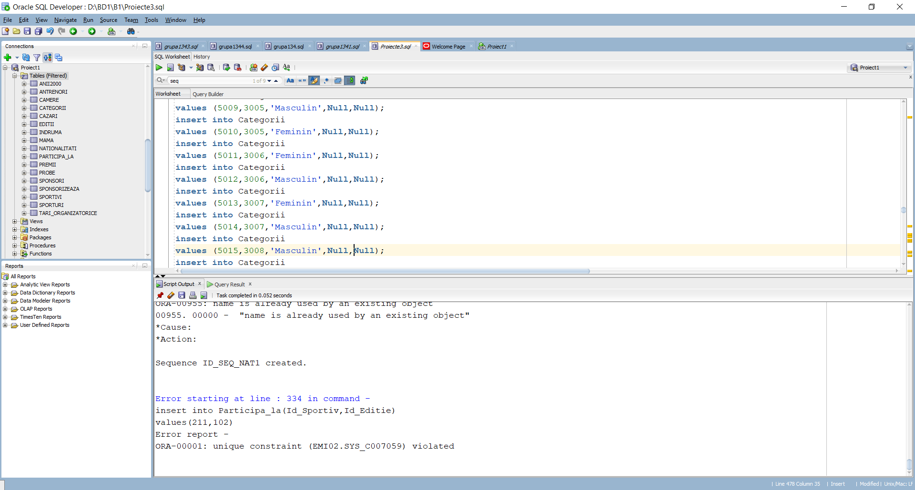

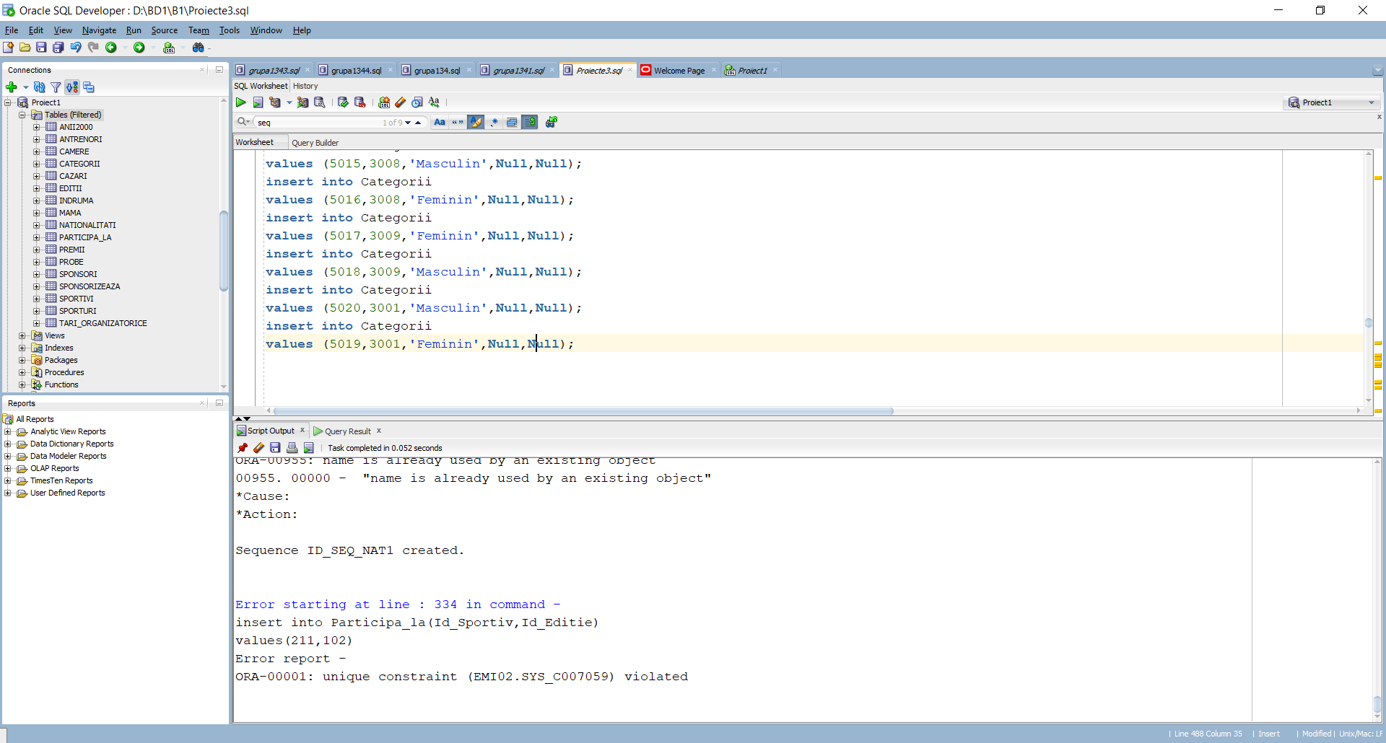

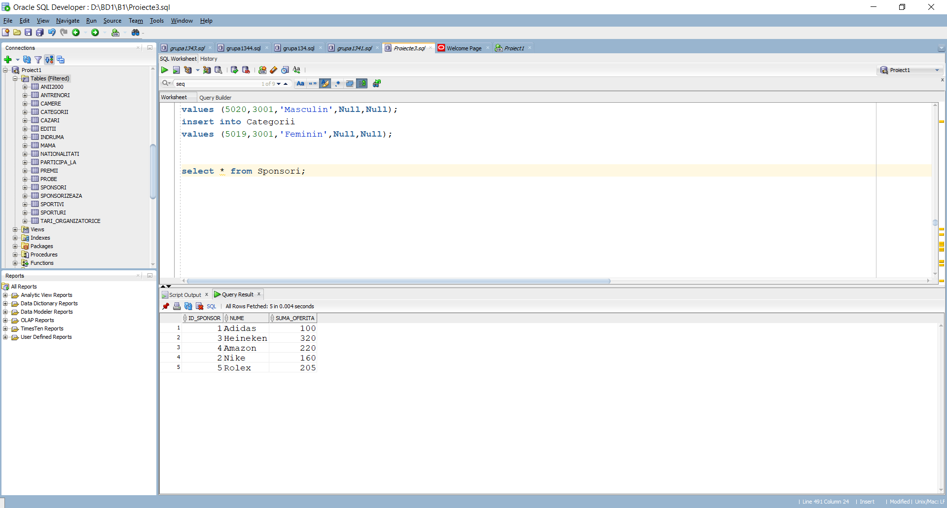

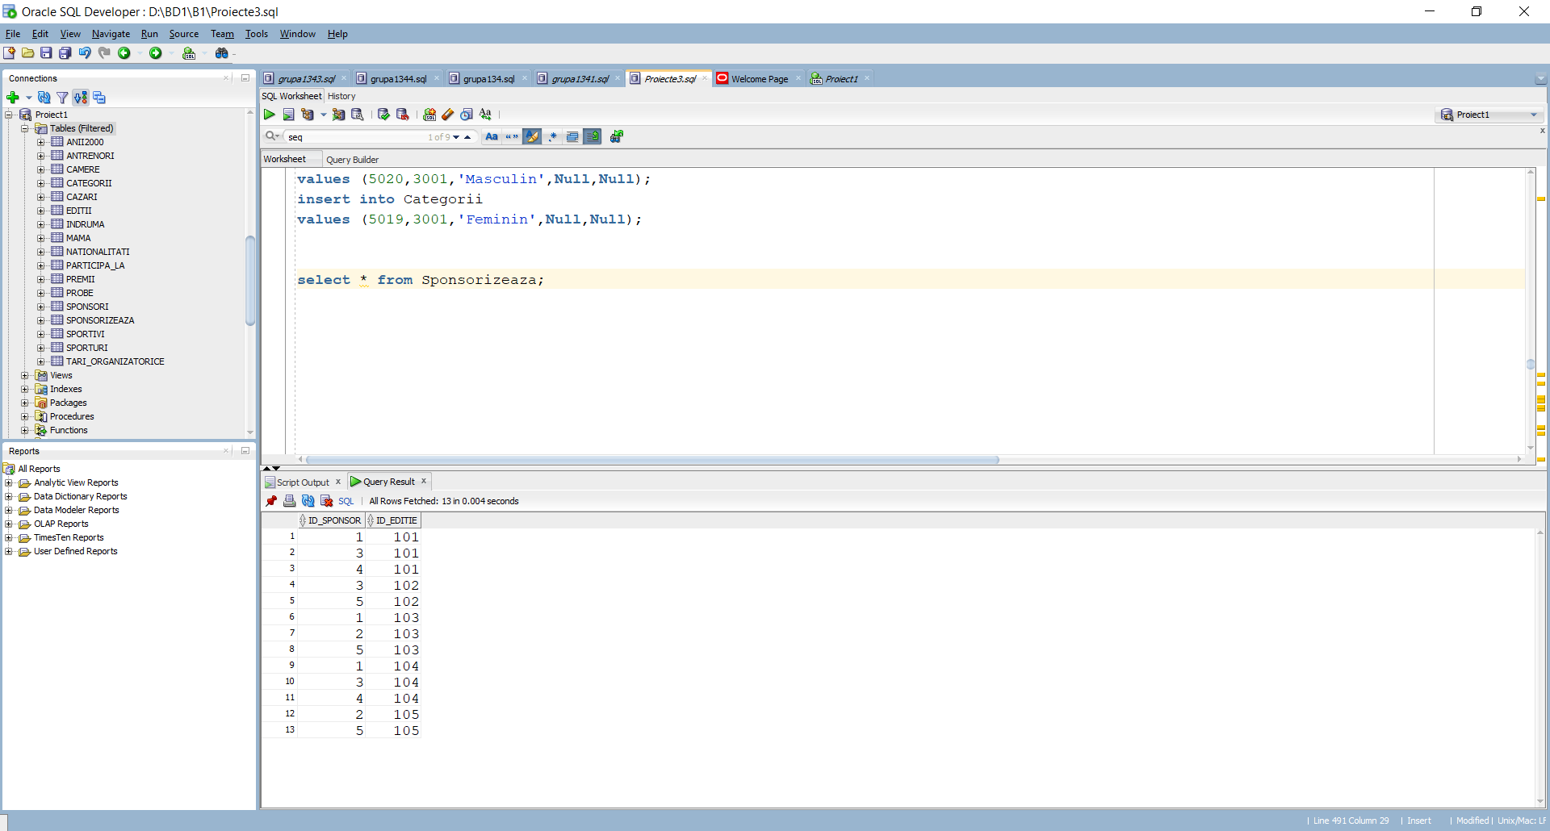

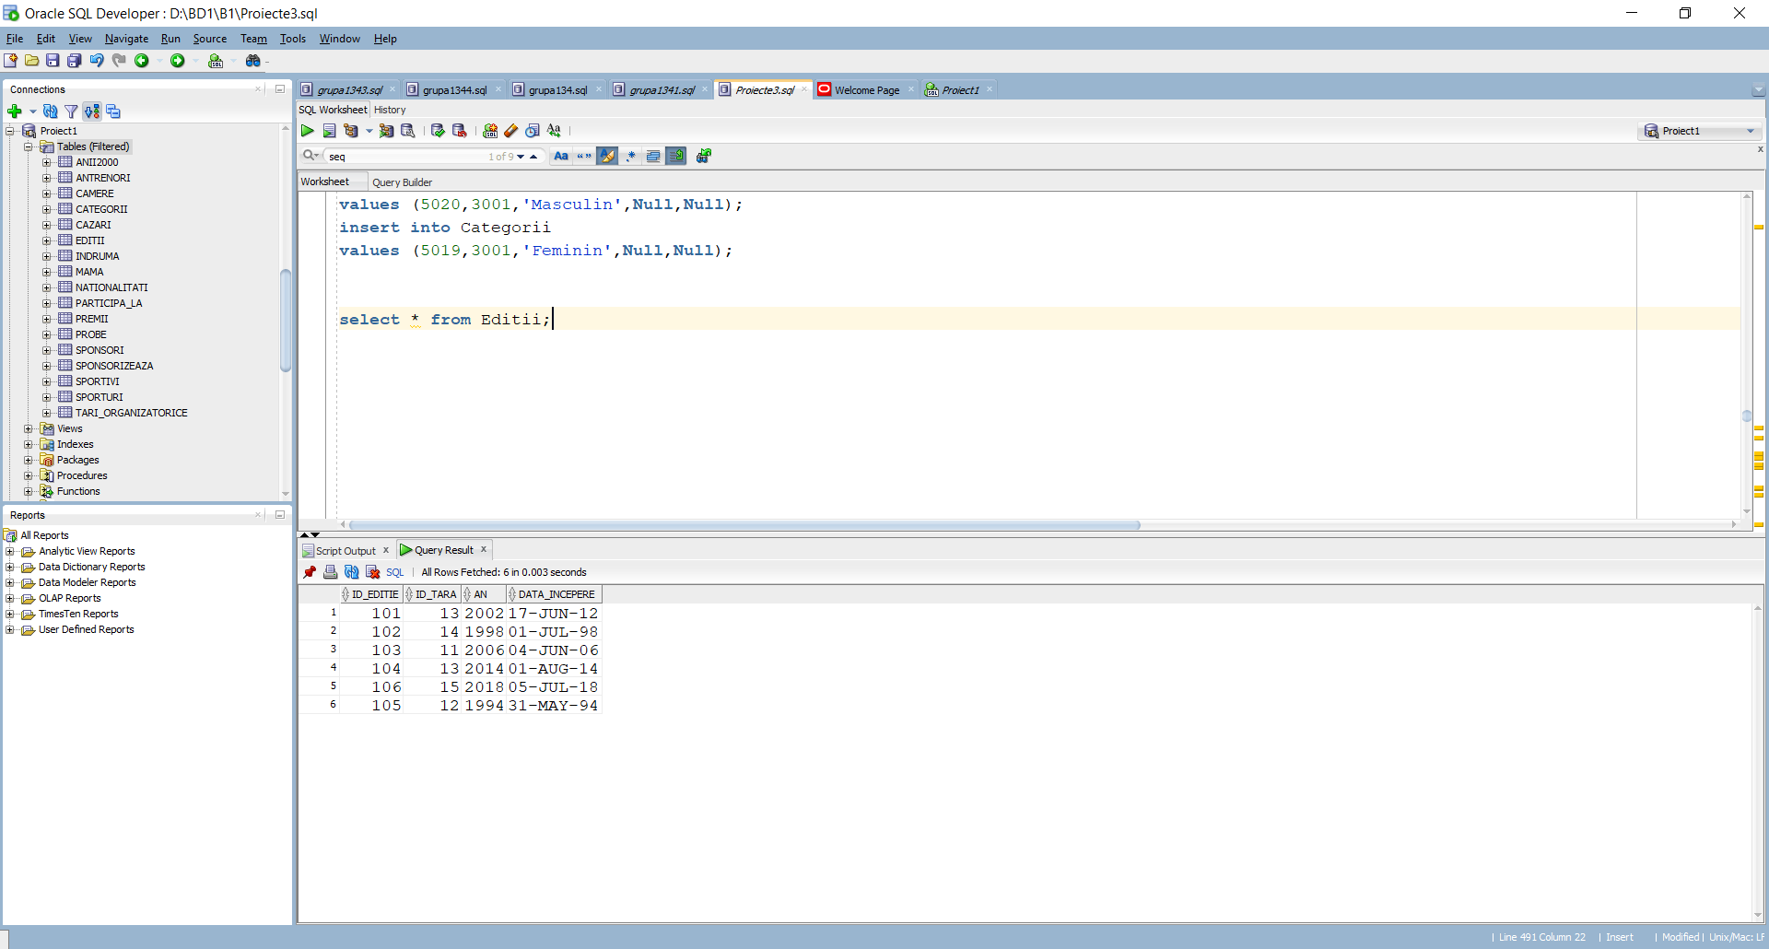

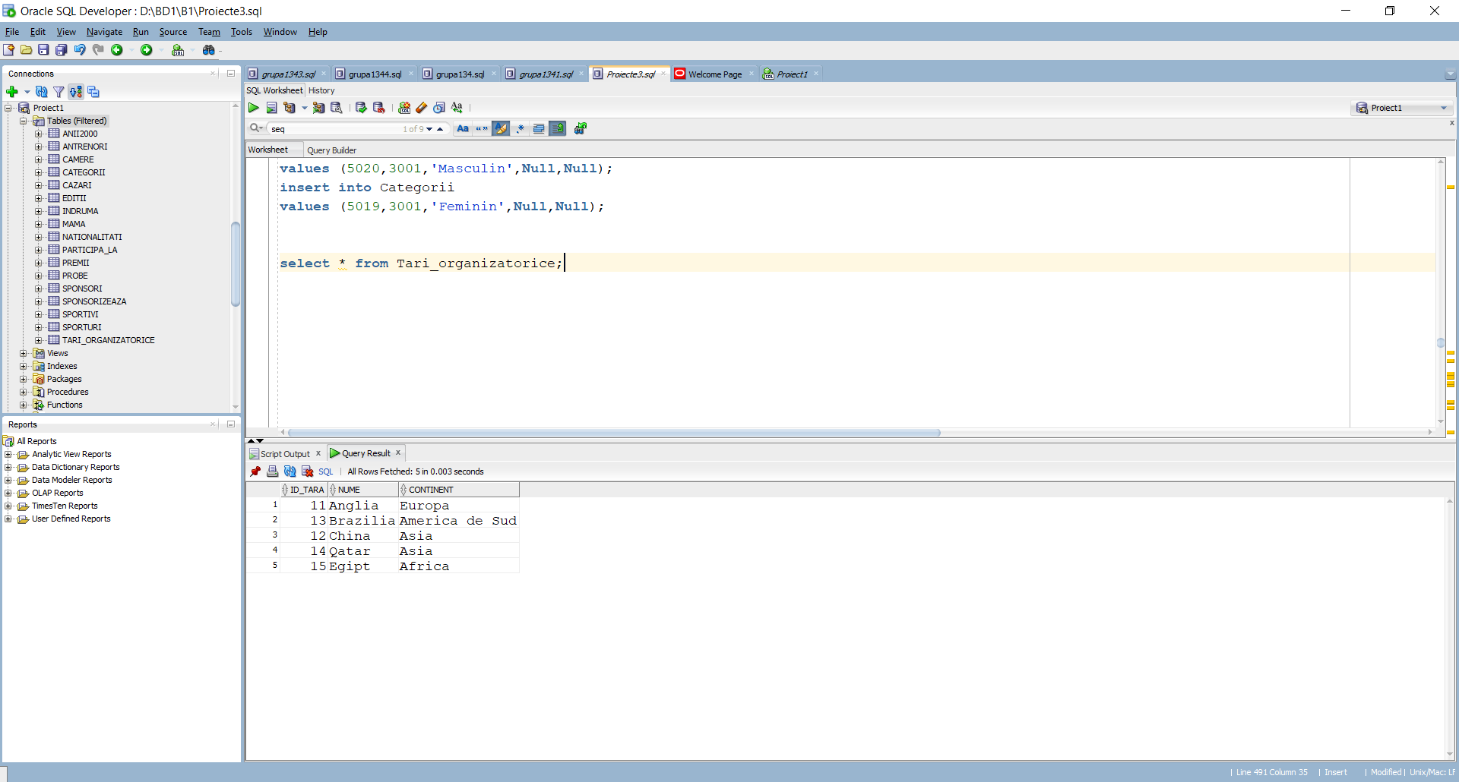

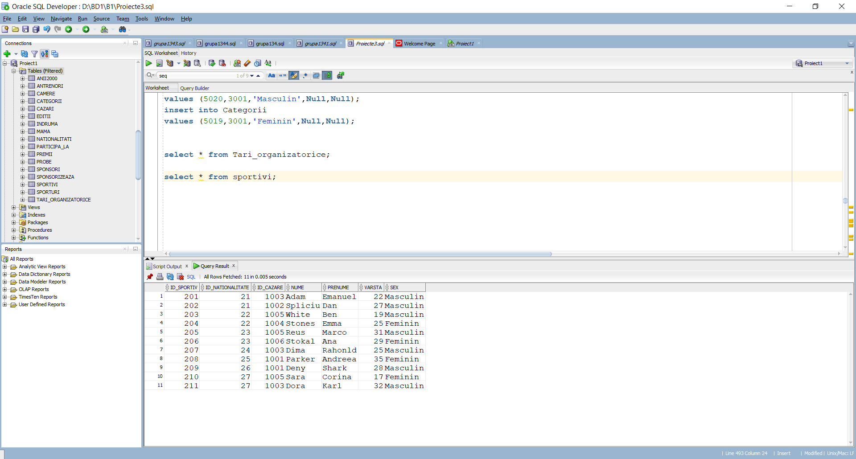

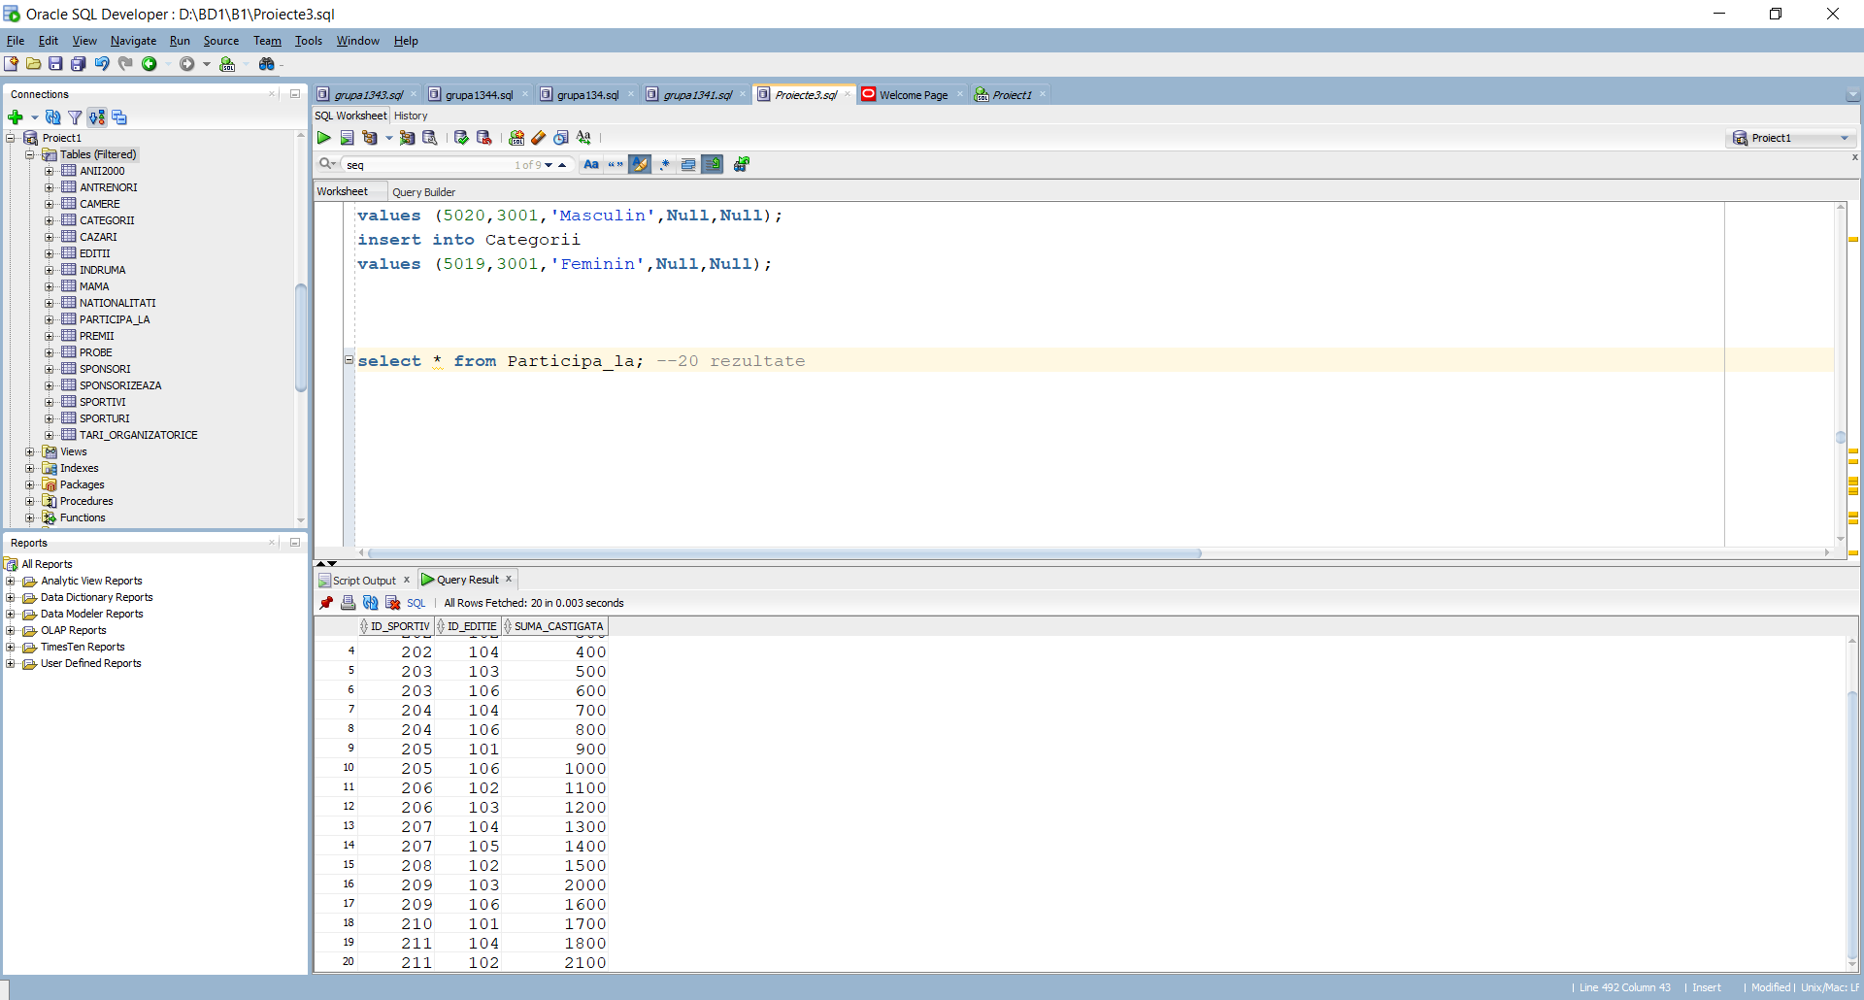

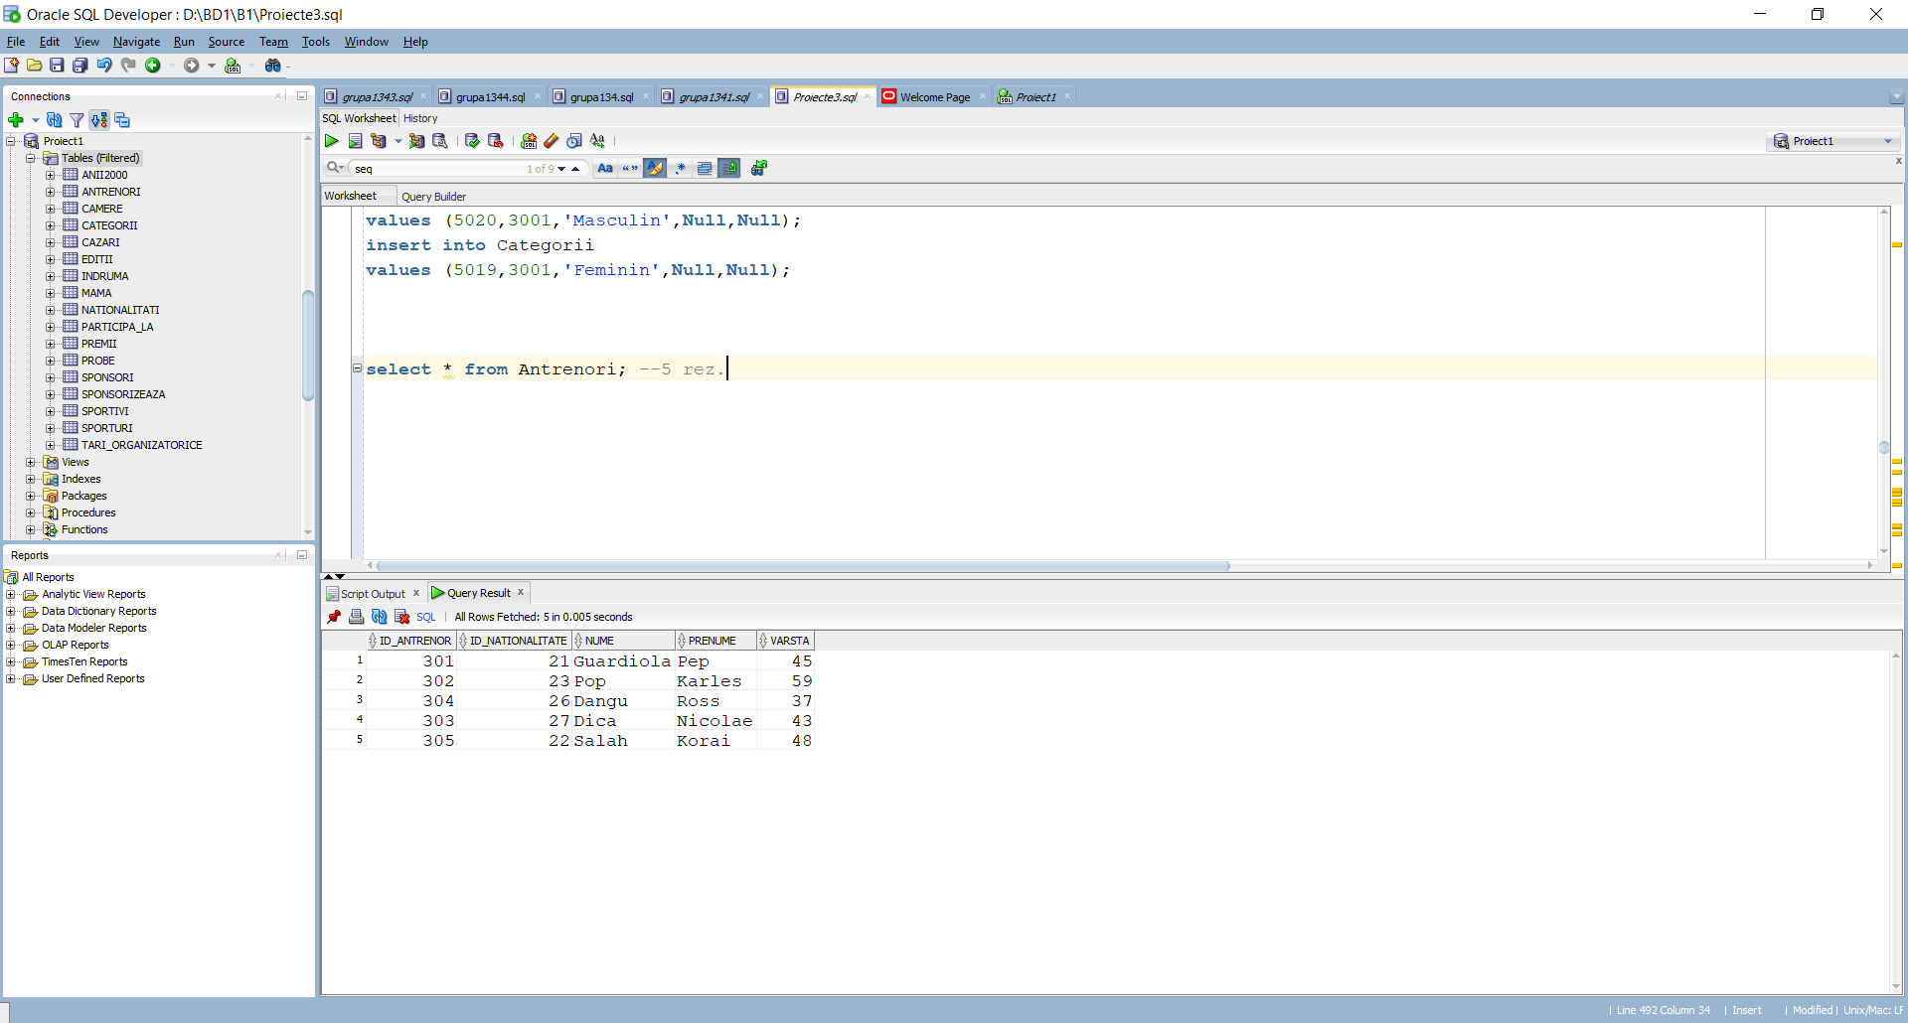

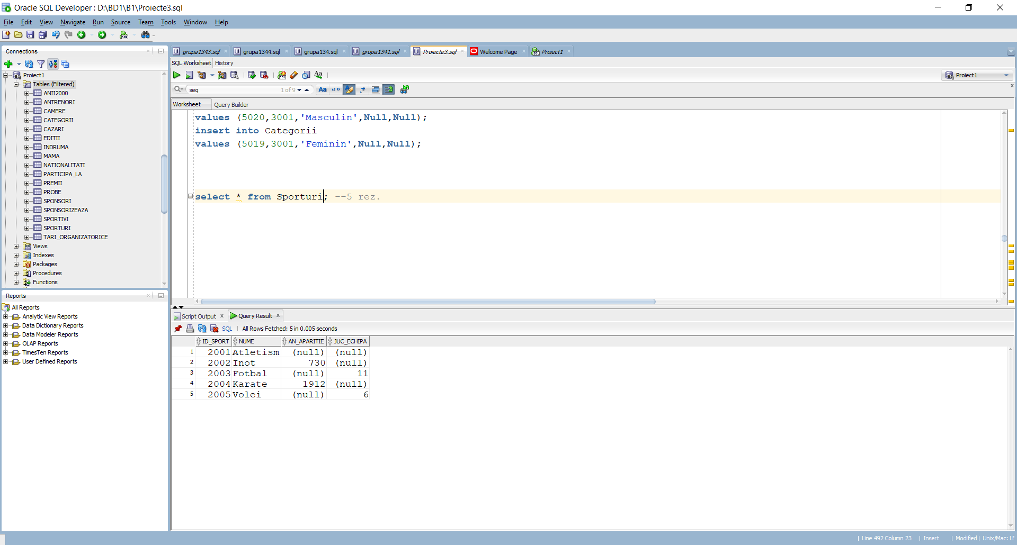

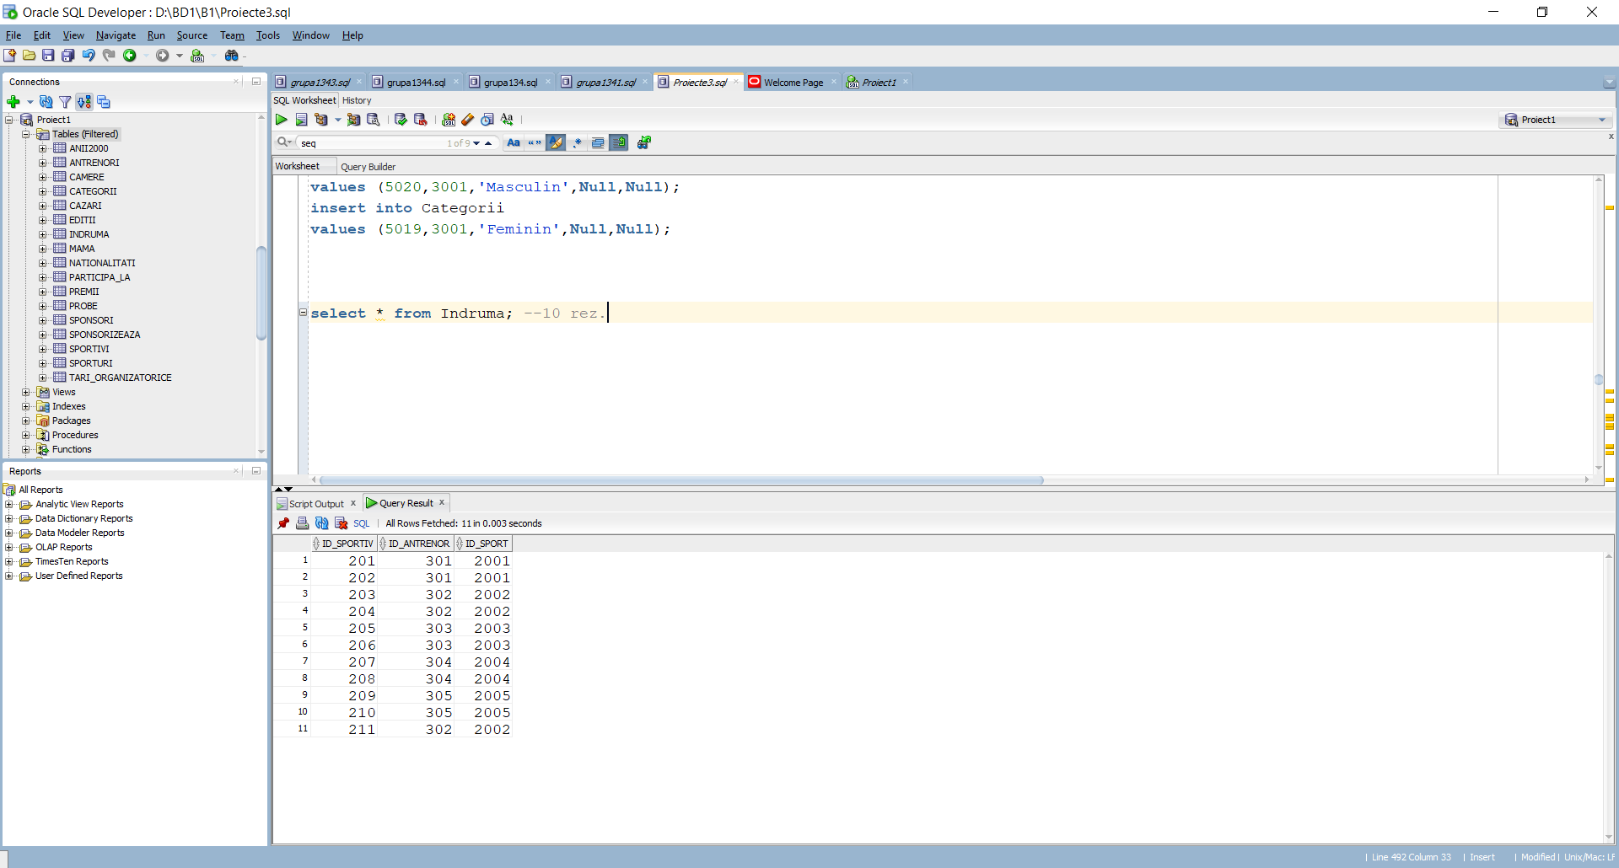

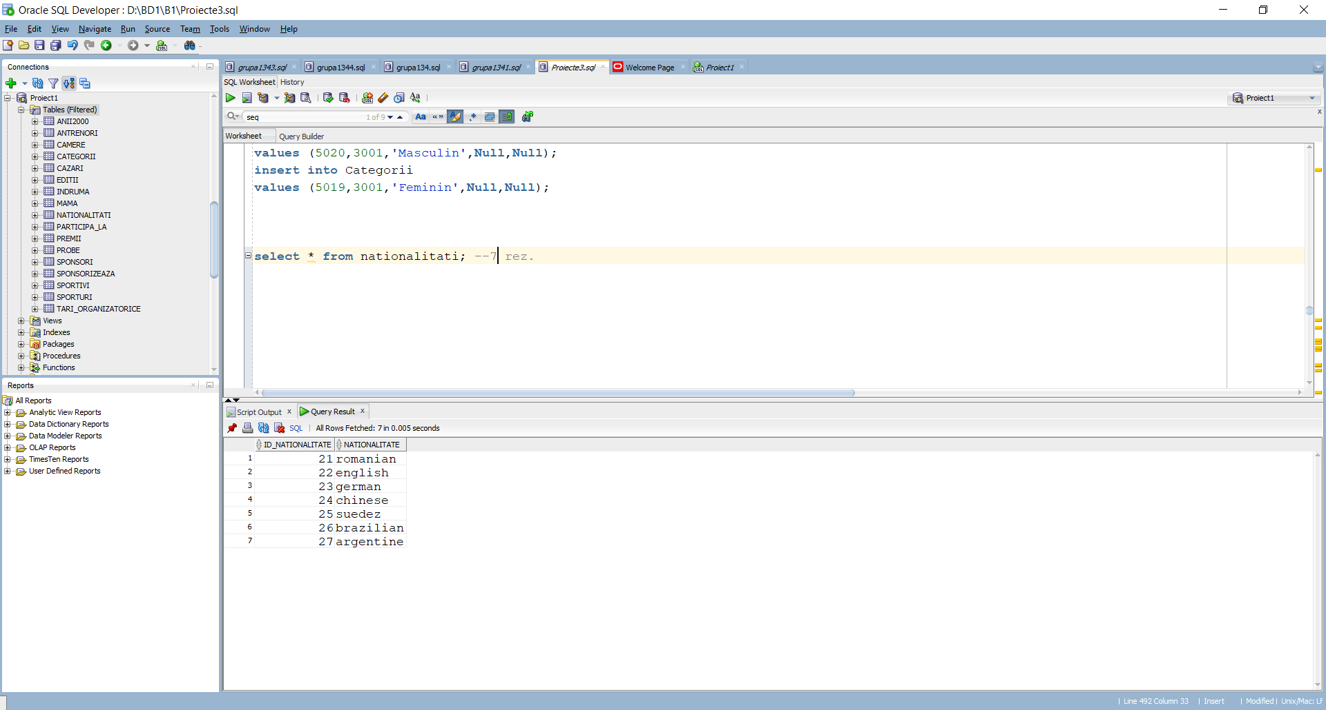

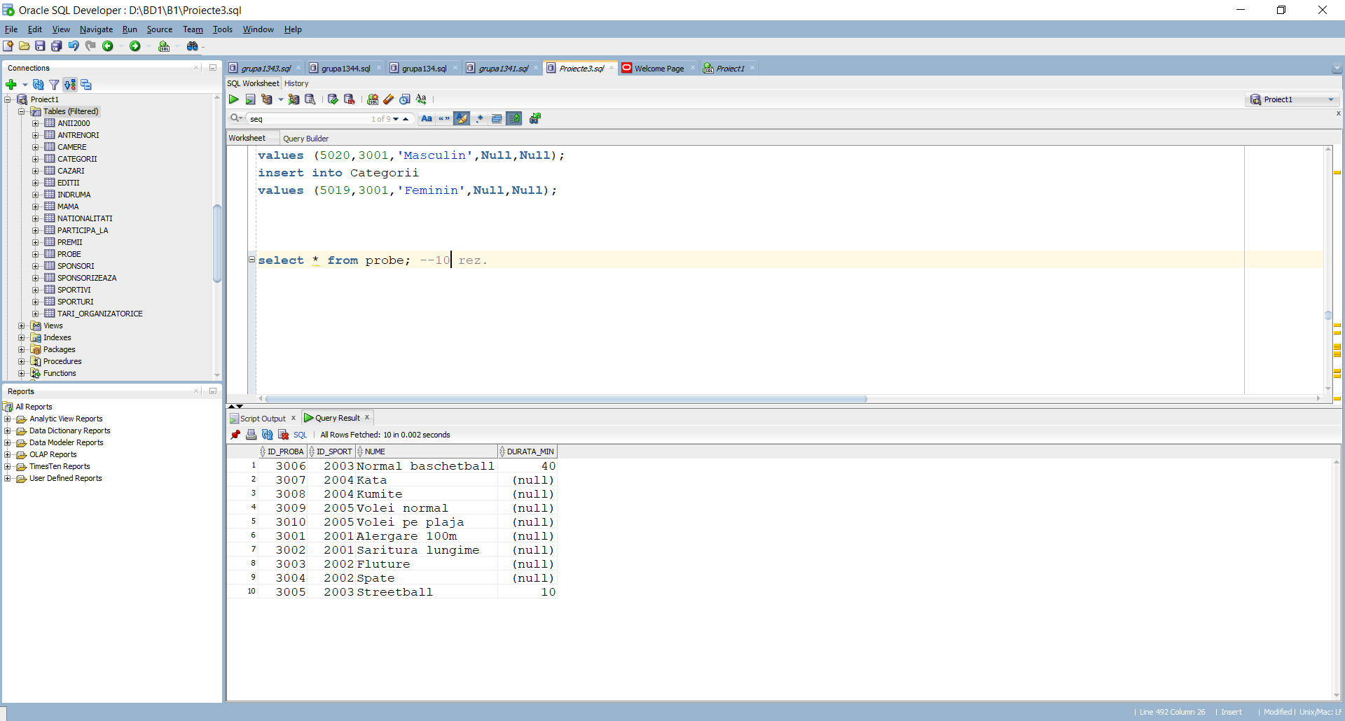

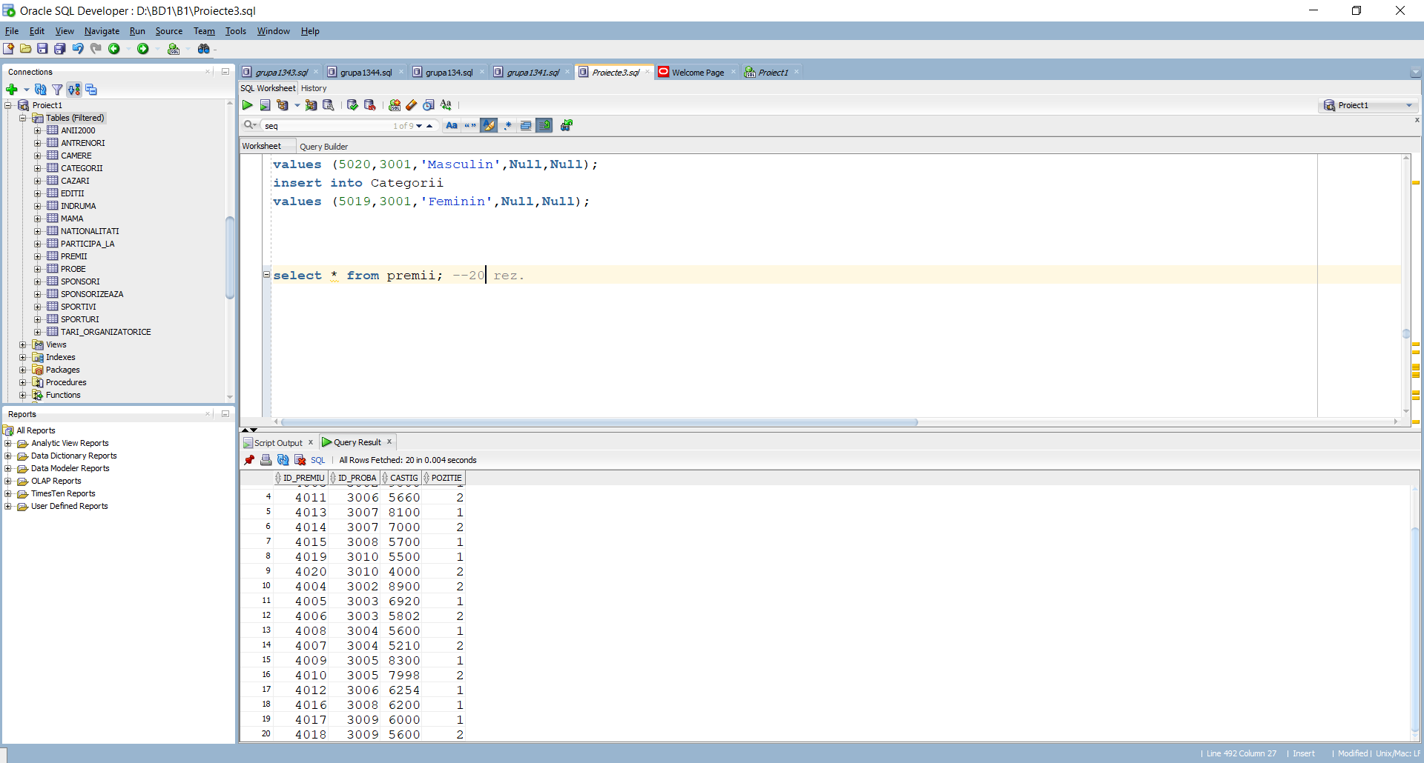

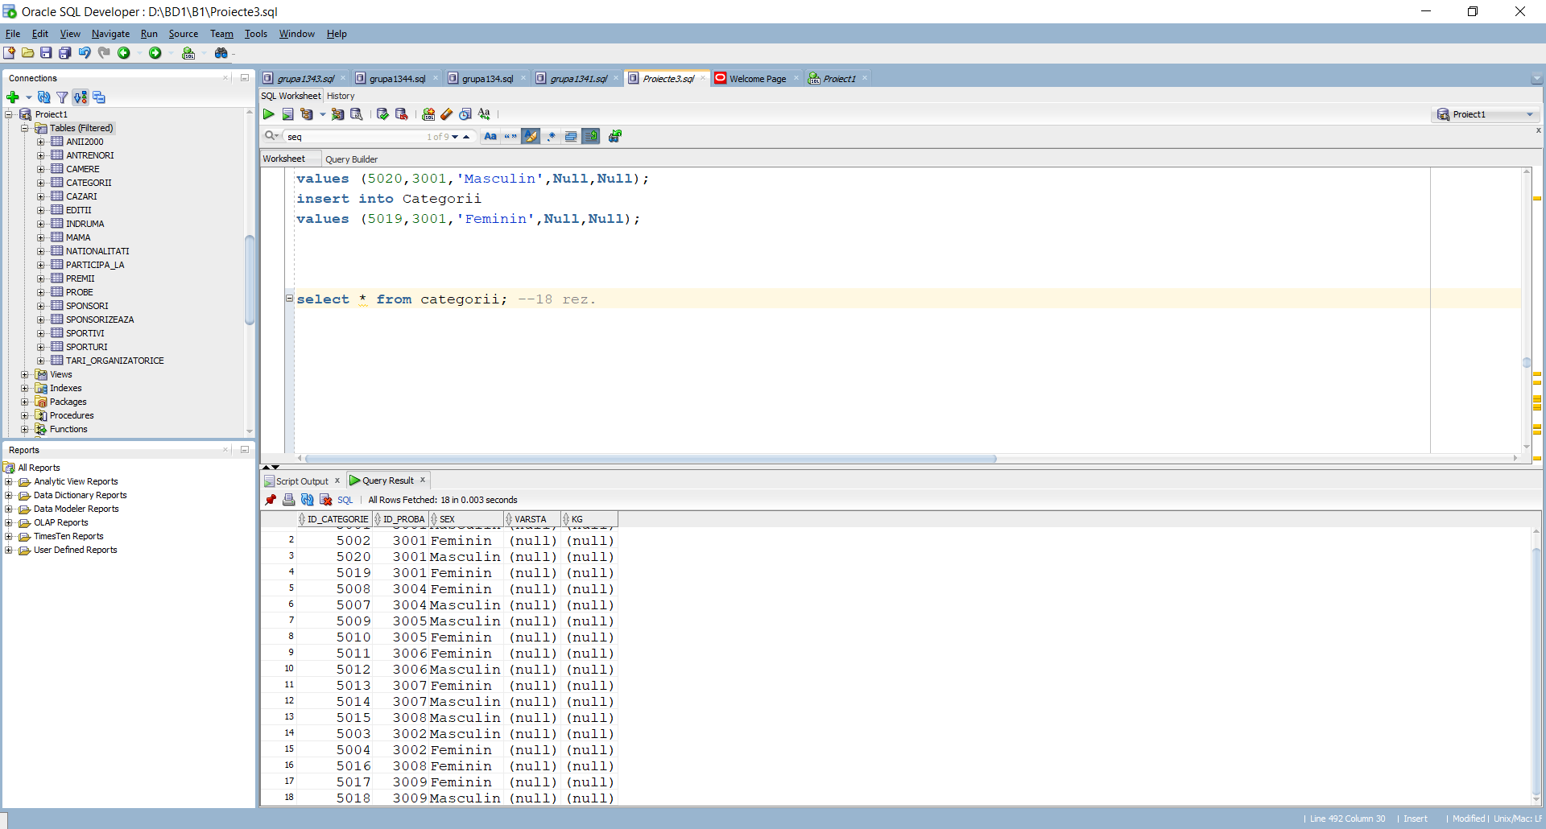

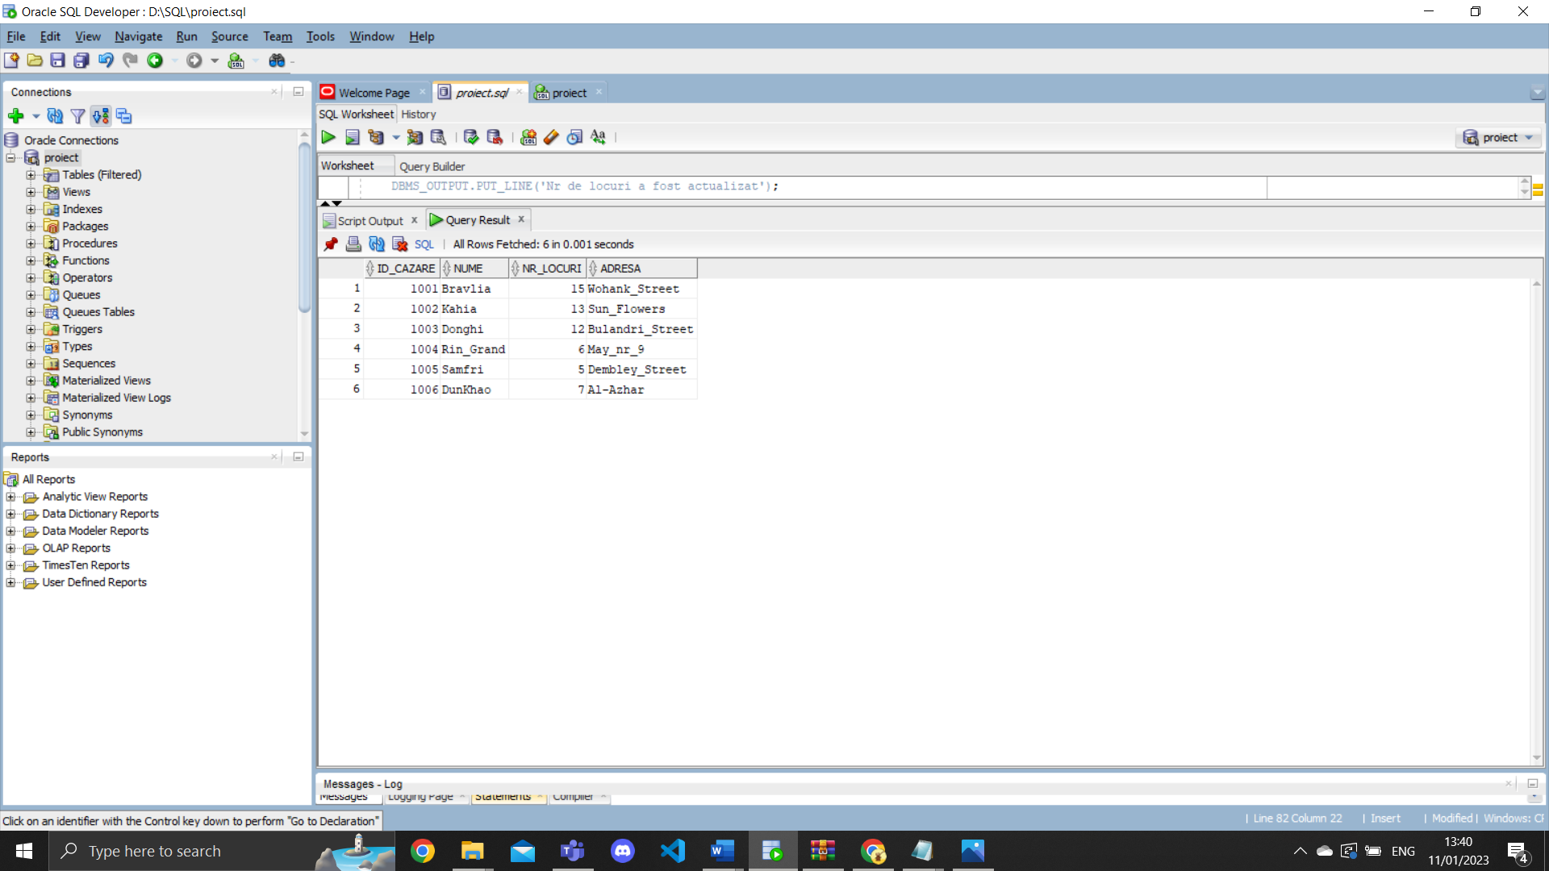

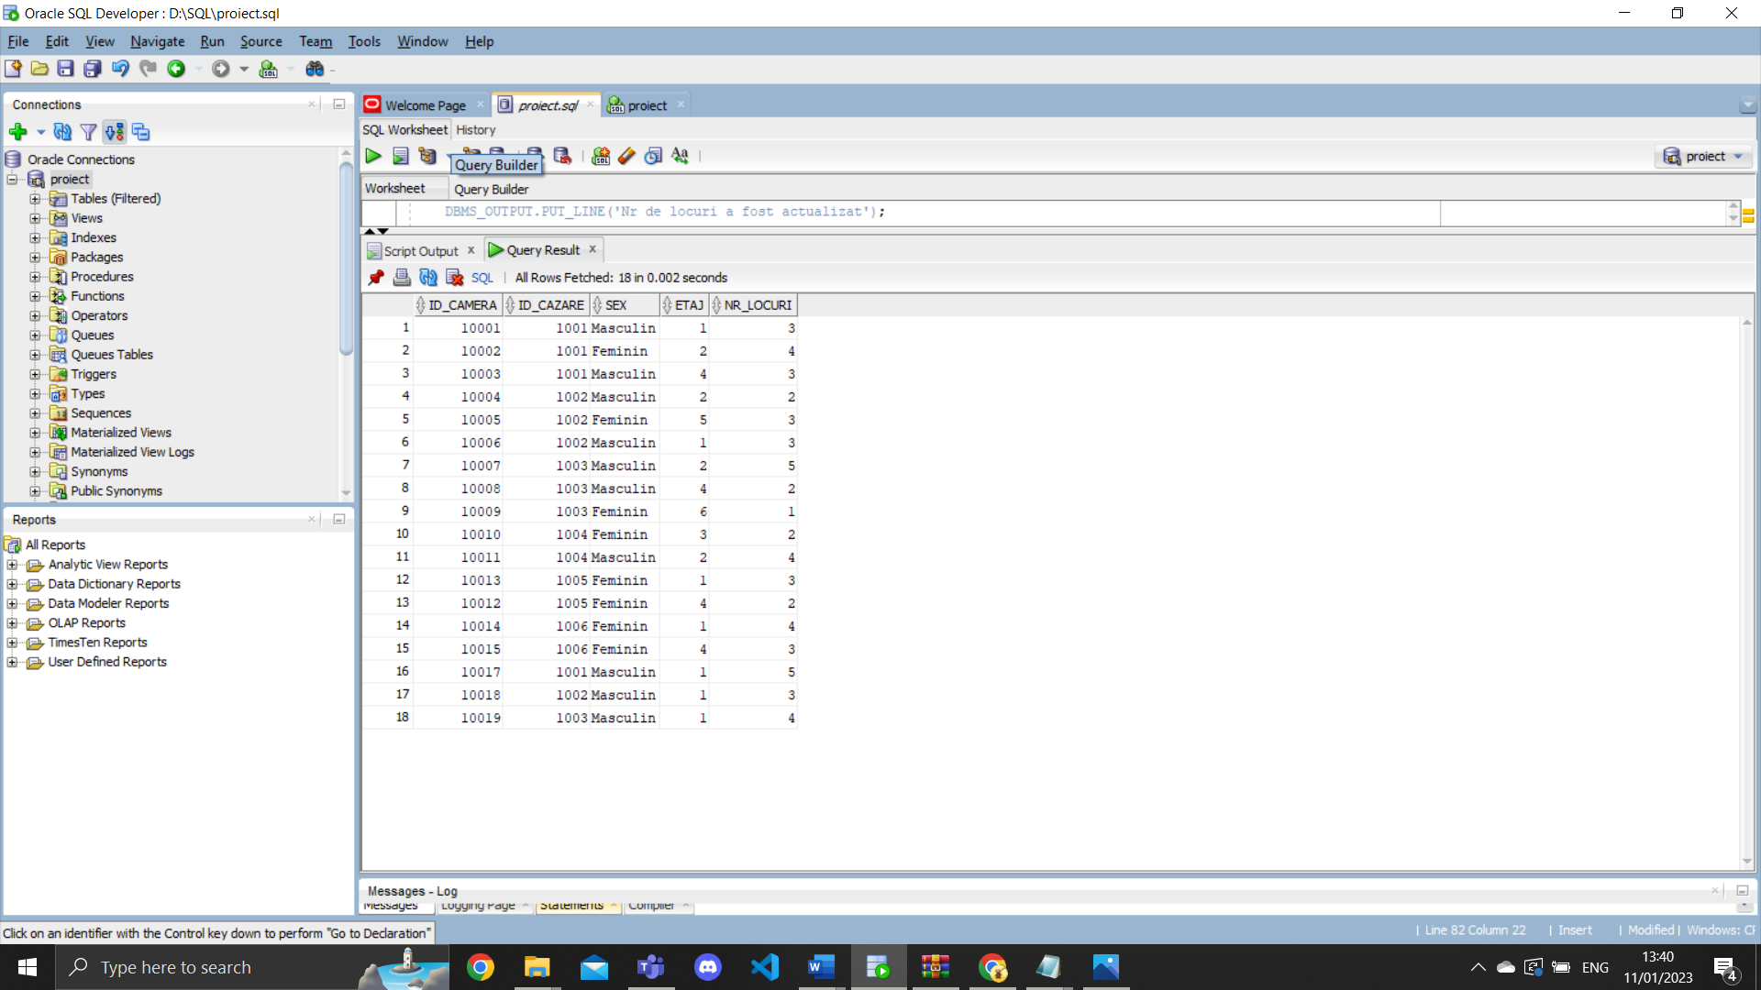

6.Create or Replace Procedure Exercitiul6

(an_editie editii.an%Type)

IS

Type tablou_imbricat is Table of Number;

tablou_sponsori tablou_imbricat:=tablou_imbricat();

Type tablou_indexat is Table of Number Index by PLS_INTEGER ;

suma tablou_indexat;

v_nume sponsori.nume%type;

v_id_sponsor sponsori.id_sponsor%type;

v_suma_oferita sponsori.suma_oferita%type;

BEGIN

select sponsori.id_sponsor bulk collect into tablou_sponsori

from sponsorizeaza,editii,sponsori

where sponsorizeaza.id_editie=editii.id_editie and sponsorizeaza.id_sponsor=sponsori.id_sponsor and editii.an<an_editie;

for i in tablou_sponsori.first..tablou_sponsori.last loop

select sponsori.id_sponsor,sponsori.suma_oferita

into v_id_sponsor,v_suma_oferita

from sponsori

where id_sponsor=tablou_sponsori(i);

if suma.exists(v_id_sponsor) then

suma(v_id_sponsor):=suma(v_id_sponsor)+v_suma_oferita;

else

suma(v_id_sponsor):=v_suma_oferita;

end if;

end loop;

for i in suma.first..suma.last loop

if suma.exists(i) then

select nume

into v_nume

from sponsori

where sponsori.id_sponsor=i;

DBMS_OUTPUT.PUT_LINE(v_nume||' '||suma(i));

end if;

end loop;

END Exercitiul6;

Begin

Exercitiul6(2015);

End;

6.Precizati suma oferita de fiecare sponsor

jocurilor olimpice care s-au desfasurat

inainte de un an specificat afisand Sponsorul si

Suma oferita.

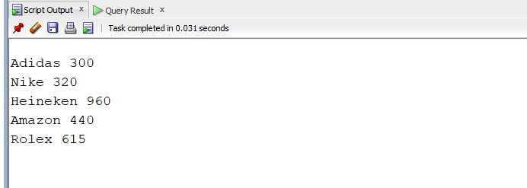

7.Create or Replace PROCEDURE Exercitiul7

(nume_cazare cazari.nume%Type)

IS

CURSOR cursor_sportivi(par cazari.id_cazare%type) IS

select nume,prenume

from sportivi

where id_cazare=par;

v_id_cazare cazari.id_cazare%Type;

Begin

select cazari.id_cazare into v_id_cazare

from cazari

where cazari.nume=nume_cazare;

for i in cursor_sportivi(v_id_cazare) loop

dbms_output.put_line('Nume Sportiv:'||i.nume||' '||i.prenume);

dbms_output.put_line('Editii:');

for j in (select editii.an

from editii,participa_la,sportivi

where editii.id_editie=participa_la.id_editie and participa_la.id_sportiv=sportivi.id_sportiv and i.nume=sportivi.nume)

loop

DBMS_Output.put_line(j.an||' ');

end loop;

DBMS_Output.put_line(' ');

end loop;

End Exercitiul7;

Begin

Exercitiul7('Bravlia');

End;

Begin

Exercitiul7('Bravlia');

End;

7. Dandu-se un nume de cazare,afisati toti sportivii

Care au stat in acea cazare si editiile la care au

Participat fiecare dintre acestia.

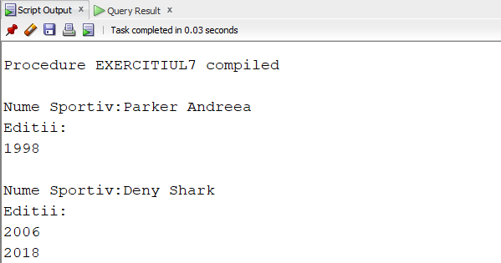

8.Create or Replace Function Exercitiul8(v_nume_sportiv In sportivi.nume%Type,

v_nume_antrenor in antrenori.nume%type)

return sporturi.nume%type

Is

v_id_sportiv sportivi.id_sportiv%type;

v_id_antrenor antrenori.id_antrenor%type;

v_id_sport sporturi.id_sport%type;

v_nume_sport sporturi.nume%type;

Begin

select id_sportiv into v_id_sportiv

from sportivi

where sportivi.nume=v_nume_sportiv;

select antrenori.id_antrenor into v_id_antrenor

from antrenori

where antrenori.nume=v_nume_antrenor;

select Indruma.id_sport into v_id_sport

from indruma

where indruma.id_antrenor=v_id_antrenor and indruma.id_sportiv=v_id_sportiv;

select sporturi.nume into v_nume_sport

from Sporturi

where sporturi.id_sport=v_id_sport;

return v_nume_sport;

EXCEPTION

when no_data_found then

raise_application_error(-20000, 'Sportiv inexistent/Nu exista legatura intre sportiv-antrenor');

when too_many_rows then

raise_application_error(-20001, 'Mai multi sportivi sau mai multi antrenori cu acel nume');

End Exercitiul8;

8.Dandu-se numele unui sportiv si al unui antrenor returnati numele sportului care ii conecteaza pe ei . 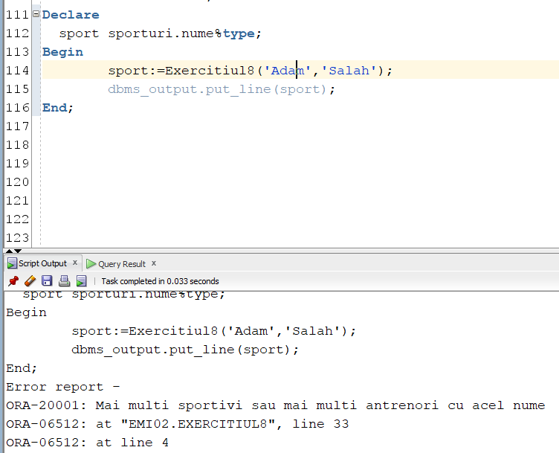

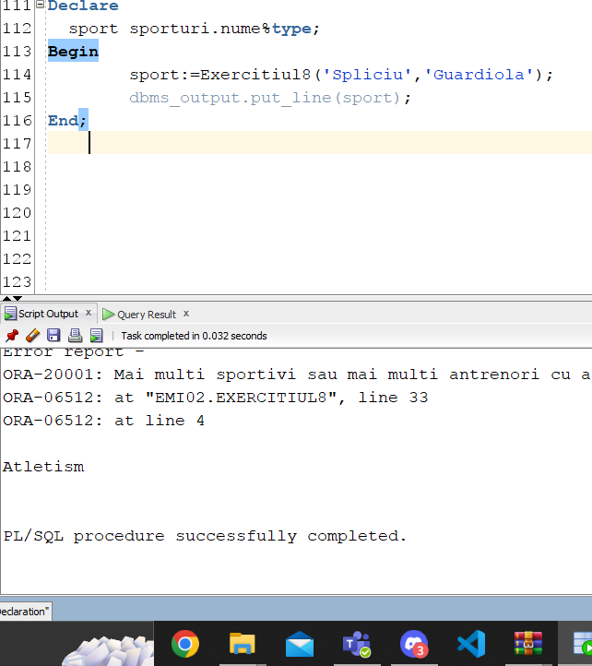

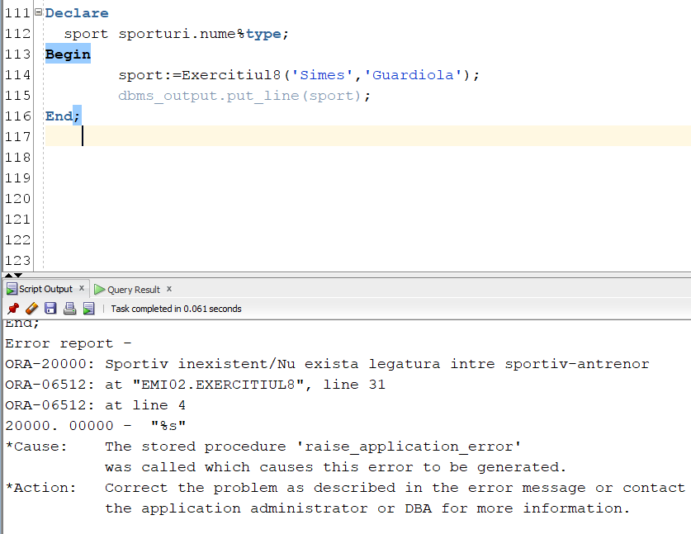

Create or Replace Procedure Exercitiul9(v_nume_sportiv sportivi.nume%type)

Is

type big_variabila is record(sportiv_id sportivi.id_sportiv%type, nume_sportiv sportivi.nume%type,prenume_sportiv sportivi.prenume%type,

nume_sport sporturi.nume%type,categorie_id categorii.id_categorie%type);

variabila big_variabila;

Begin

select sportivi.id_sportiv,sportivi.nume,sportivi.prenume,sporturi.nume,categorii.id_categorie

into variabila

from sportivi,indruma,sporturi,probe,categorii

where v_nume_sportiv=sportivi.nume and sportivi.id_sportiv=indruma.id_sportiv

and indruma.id_sport=sporturi.id_sport and sporturi.id_sport=probe.id_sport and

categorii.id_proba=probe.id_proba and categorii.sex=sportivi.sex and probe.id_proba in(select min(id_proba) from Probe

group by Id_Sport);

DBMS_OUTPUT.PUT_LINE('Sportivul cu numele ' ||

variabila.nume_sportiv || ' ' ||

variabila.prenume_sportiv || ' a concurat la sportul ' ||

variabila.nume_sport|| ' la categoria cu id-ul ' ||variabila.categorie_id);

EXCEPTION

when no_data_found then

raise_application_error(-20000, 'Nu sportiv cu acel nume');

when too_many_rows then

raise_application_error(-20001, 'Exista mai multi sportivi cu acel nume de familie');

End Exercitiul9;

Begin

Exercitiul9('Bla');

End;

9. Dandu-se un sportiv afisati id-ul categoriei la care a partici-

-pat cu id-ul probei cel mai mic.

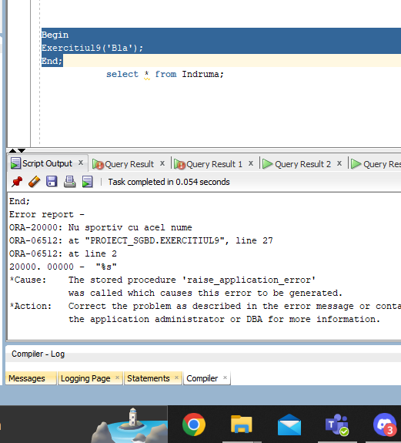

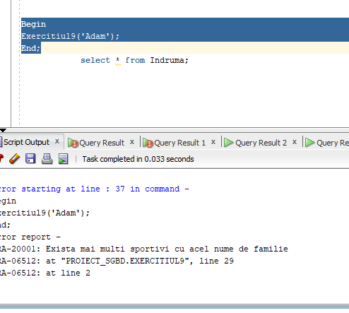

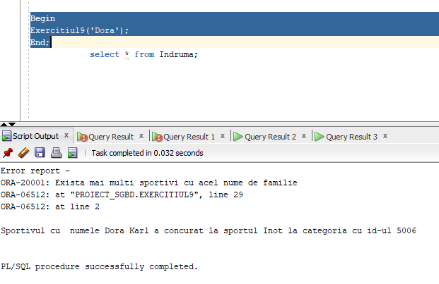

Create or Replace Trigger exercitiul10

Before Insert on Sportivi

Declare

Type tablou_imbricat is Table of Integer;

tablou tablou_imbricat:=tablou_imbricat();

v_count sportivi.varsta%TYPE;

Begin

select varsta bulk collect into tablou from Sportivi;

for i in tablou.first..tablou.last loop

if tablou(i)>=34 then

v_count:=1;

end if;

end loop;

if v_count=1 then

raise_application_error(-20001,'Limita de varsta a participantilor este depasita');

end if;

End;

Begin

insert into Sportivi(Id_Sportiv,Id_Nationalitate,Id_Cazare,Nume,Prenume,Varsta,Sex)

values(223,25,1007,'Bla','Blas',23,'Masculin');

insert into Sportivi(Id_Sportiv,Id_Nationalitate,Id_Cazare,Nume,Prenume,Varsta,Sex)

values(225,23,1002,'Bladsa','Blas',32,'Masculin');

End;

drop trigger exercitiul10;

10.Trigger pentru a elimina sportivii cu varsta de peste 35 ani

inainte de inserarea altora.

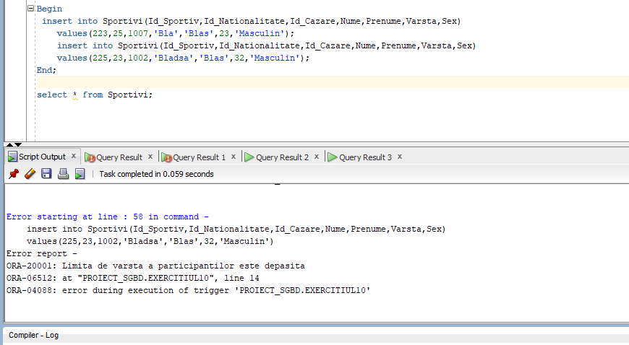

11. Implementati in trigger care este declansat atunci cand o camera noua este adaugata la o cazare si actualizeaza capacitatea totala a cazarii in functie de capacitatea camerei adaugate

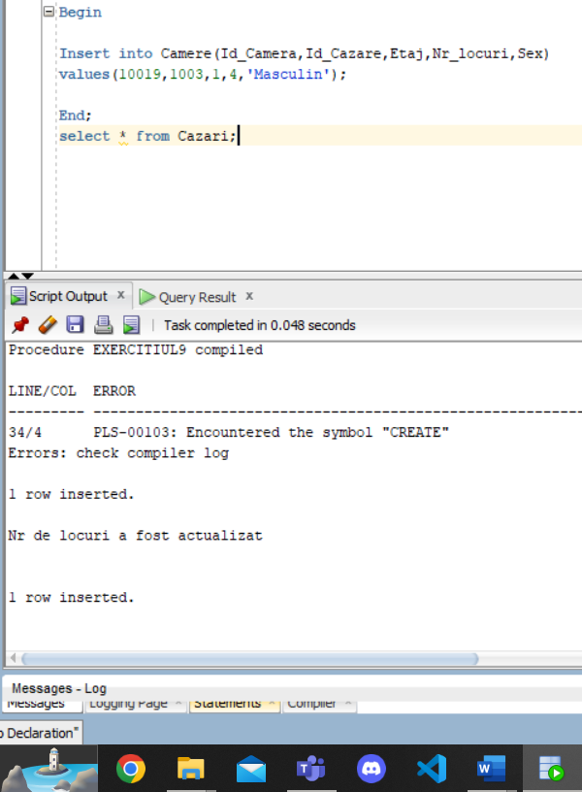

CREATE OR REPLACE TRIGGER Exercitiul11

AFTER INSERT ON camere

FOR EACH ROW

DECLARE

capacitate_noua camere.nr_locuri%type:=0;

BEGIN

select cazari.nr_locuri into capacitate_noua

from cazari

where cazari.id_cazare=:new.id_cazare;

capacitate_noua:=:new.nr_locuri+capacitate_noua;

update cazari

set nr_locuri=capacitate_noua

where id_cazare=:new.id_cazare;

DBMS_OUTPUT.PUT_LINE('Nr de locuri a fost actualizat');

END;

Begin

Insert into Camere(Id_Camera,Id_Cazare,Etaj,Nr_locuri,Sex)

values(10019,1003,1,4,'Masculin');

End;

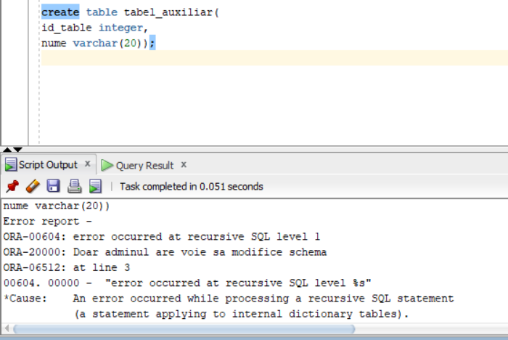

CREATE OR REPLACE TRIGGER Exercitiul12

BEFORE CREATE OR DROP OR ALTER ON SCHEMA

BEGIN

IF USER != UPPER('emi02') THEN

RAISE_APPLICATION_ERROR(-20000,'Doar adminul are voie sa modifice schema');

END IF;

END;

12.Un trigger care sa permita modificarea

Schemei doar de emi02.